

Requirement & Design Specification

**Online Shopping System (OSS)**

**Version: 2.1**

– Hanoi, September 2024 –

# Record of Changes

| **Version** | **Date** | **A* M, D** | **In charge** | **Change Description** |
| --- | --- | --- | --- | --- |
| V1.0 | 16/9 | A | ManhPk | Add screen flow |
| V1.1 | 17/09 | A | HoangLV | Add use case diagram |
| V1.2 | 19/09 | A | DungNV | Add ERD |
| V1.3 | 20/09 | A | DungNV | Add database diagram |
| V1.4 | 25/09 | M | HieuNH | Added use case description iteration 2 |
| V1.5 | 30/09 | A | HieuNH | Add package dỉagram |
| V1.6 | 02/10 | A | ManhPk | Add common function and Design Specifications |
| V1.7 | 05/10 | A | HoangLV | Add common function and Design Specifications |
| V1.8 | 10/10 | A | DungNv | Add common function and Design Specifications |
| V1.9 | 16/10 | A | HieuNH | Add common function and Design Specifications |
| V2.0 | 25/10 | A | ManhPk | Add common function and Design Specifications |
| V2.1 | 02/11 | M | DungNv | Final edit |

*A - Added M - Modified D - Deleted

Contents

Record of Changes

I. Overview

1. User Requirements

1.1 Actors

1.2 Use Cases

2. Overall Functionalities

2.1 Screens Flow

2.2 Screen Descriptions

2.3 Screen Authorization

2.4 Non-UI Functions

3. System High Level Design

3.1 Database Design

3.2 Code Packages

II. Requirement Specifications

1. Common Functions

2.1 UC-2_Login System

2.2 UC-2_Remember Me

2.3 UC-3_Logout

2.4 UC-4_Home Page

2.5 UC-5_Change Password

2.6 UC-6_Forgot Password

2.7 UC-7_Product List

2.8 UC-8_Blog List

2.9 UC-9_Blog Detail

2.10 UC-10_User Profile

2.11 UC-11_User Register

2.12 UC-12_Product Details

2.13 UC-13_Product List (Marketer)

2.14 UC-14_Slider List (Marketer)

2.14 UC-15_Cart completion

2.16 UC-16_Product Details(Marketer)

2.17 UC-17_Add Product (Marketer)

2.18 UC-18_Payment

2.19 UC-19_Cart Details

2.20 UC-20_Cart Contact

2.21 UC-21_My Orders

2.20 UC-20_PostList(Marketer)

2.21 UC-21_Post Details(Marketer)

2.22 UC-22_ Slider Details(Marketer)

2.23 UC-23_Order List (Seller)

2.24 UC-24_Order Detail (Seller)

2.25 UC-25_Sale dashboard (Seller)

2.26 UC-26_Admin dashboard

2.27 UC-27_User List

2.28 UC-28_User Details

2.29 UC-29_FeedBack List

2.30 UC-30_FeedBack Detail

2.31 UC-31_Marketer Dashboard

2.32 UC-32_Customer List

2.33 UC-33_Customer Details

2.34 UC-34_Order List (Warehouser)

2.35 UC-35_Feedback

2.36 UC-36_Setting List

2.37 UC-37_Setting detail

2.38 UC-38_Product List

2.39 UC-39_Order Information

2.40 UC-40_Import Product (Warehouser)

III. Design Specifications

1. System Access

2. User Register

3. Home Page

4. Change Password

5. forgot password

6. User Profile

7. Blog list

8. Blog details

9. Product list

10. Product details

11. Product List (Marketer)

12. Post List (Marketer)

13. Post detail

14. Sliders List

15.Slider detail

16. Product Detail (Marketer)

17. Cart Details

18. Cart Contact

19. My Orders

20. Add Product (Marketer)

21. Order Information

22. Cart completion

23. Payment

24. FeedBack List

25. Marketing Dashboard

26. Customers List

27. Customer Details

28. Feedback

29. Admin Dashboard

30. User List

31. User Details

33. Orders List

34. Orders Detail

35. Sale Dashboard

36. Feedback detail

37. Order List (Warehouser)

38. Setting List (admin)

39. Setting detail (admin)

40. Product List (Warehouser)

41. Import Product(Warehouser)

IV. Appendix

1. Assumptions & Dependencies

2. Limitations & Exclusions

3. Business Rules

4. Non-Functional Requirements

# I. Overview

## 1. User Requirements

### 1.1 Actors

| **#** | **Actor** | **Description** |
| --- | --- | --- |
| 1 | Guest | This system enables Guest to explore and use platform features without needing a formal account in Home Page. |
| 2 | Customer | Customer is a registered user of the Clothing online shopping system who are actual customers or potential customers. As a registered user, the Customer is enabled to create an account, create orders, view product lists, view product details, and engage with various features to find a suitable product |
| 3 | Marketer | Marketer is the entity responsible for managing activities about posts list, post details, sliders list, slider details, products list, product details, customers list, customer details |
| 4 | Sale | Sale role is responsible for managing sale dashboard, orders list, orders details |
| 5 | Sale Manager | Sale Manager has the responsibility to assign the order to other sale and change the order status and the sale notes |
| 6 | Admin | Admin role is responsible for managing admin dashboard, accounts, settings list, setting details |
| 7 | Warehouser | Warehouser role is responsible for managing the warehouse, importing products, packet orders, deliver orders for the transport unit. |

### 1.2 Use Cases

#### a. Diagrams

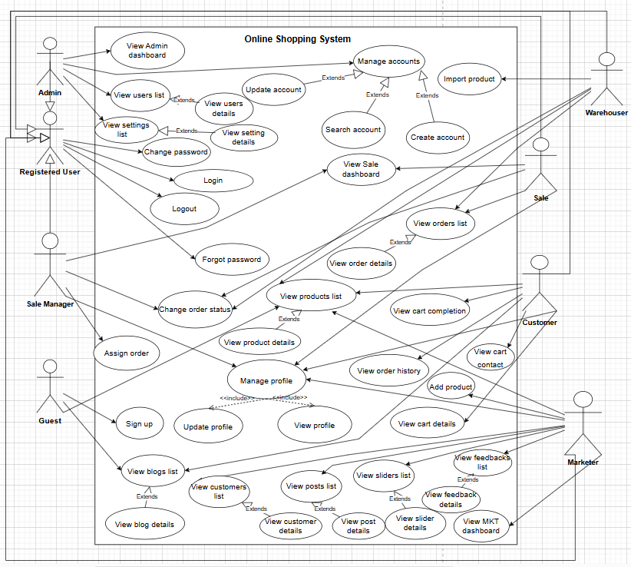

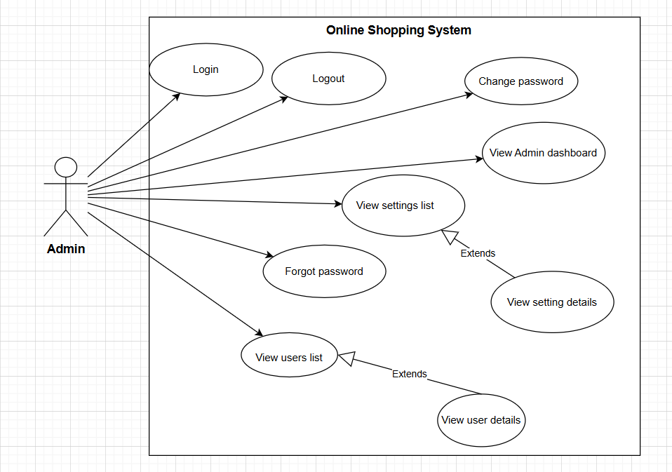

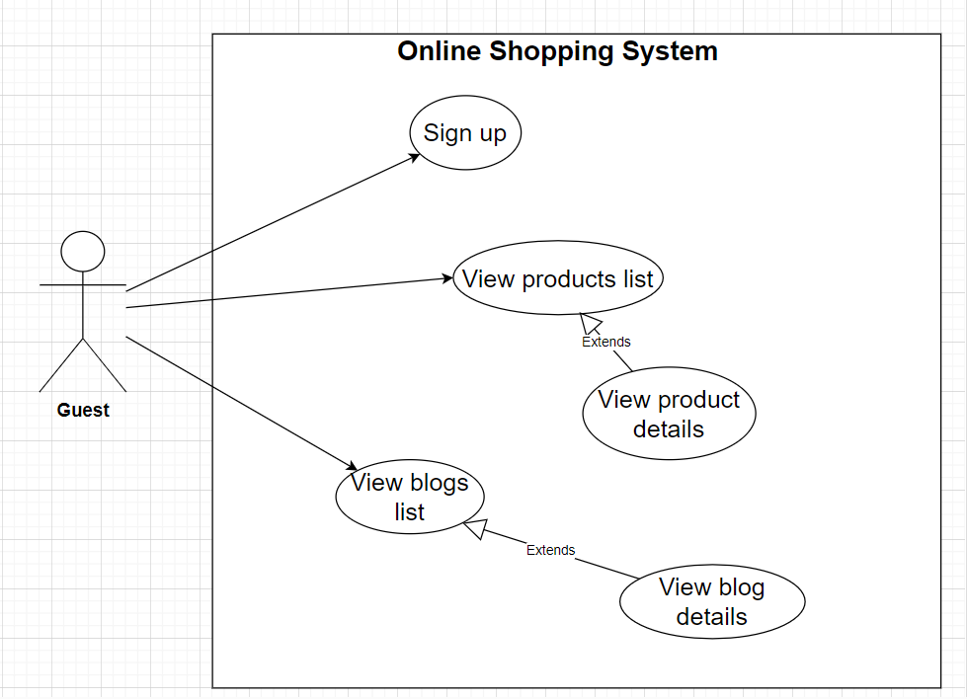

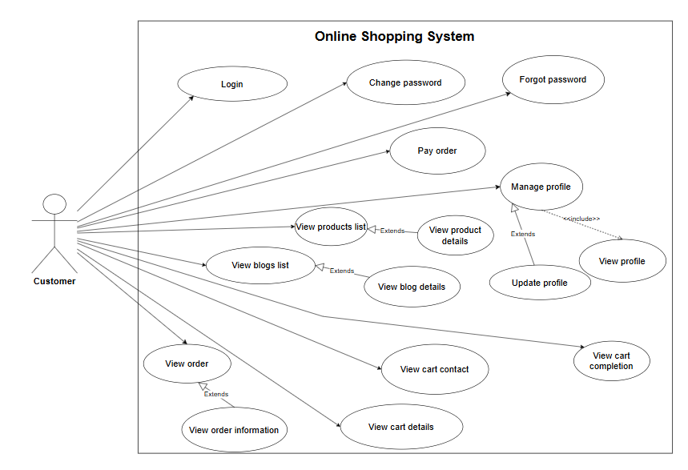

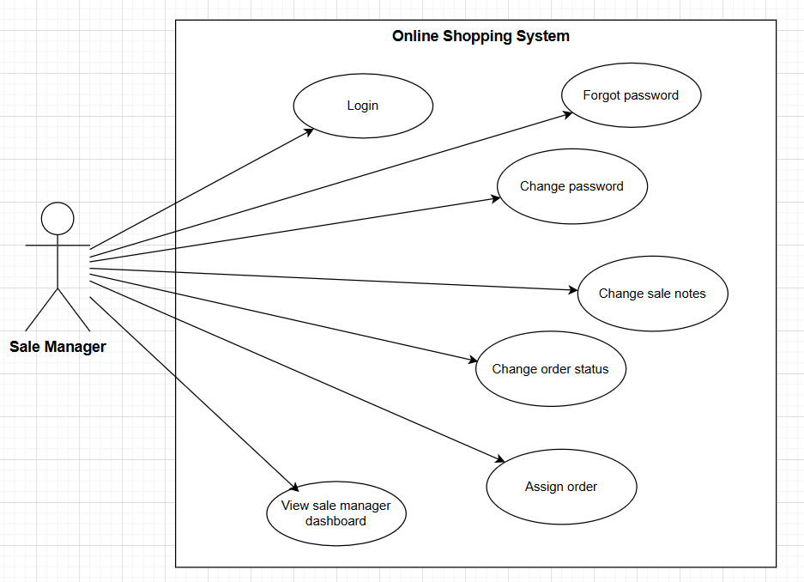

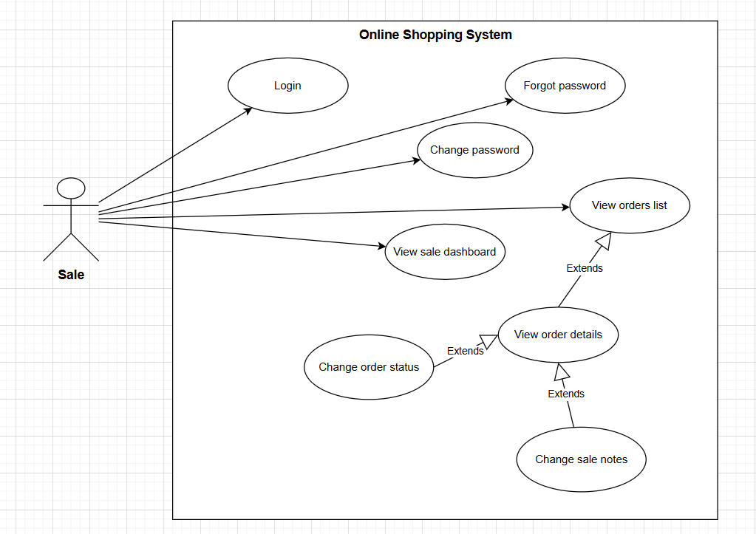

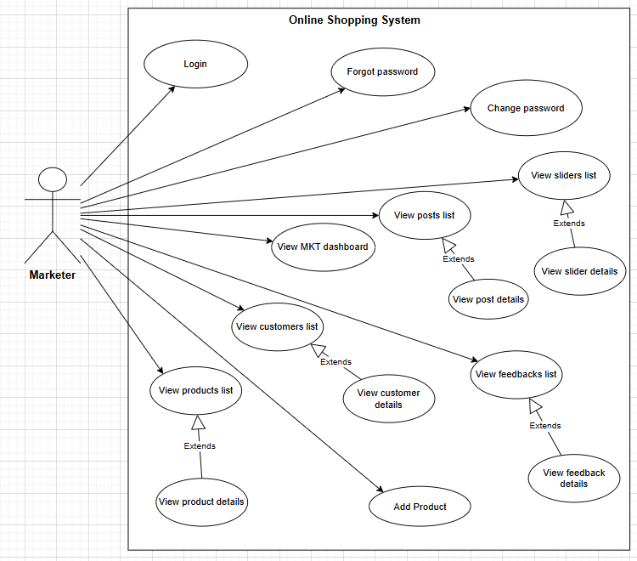

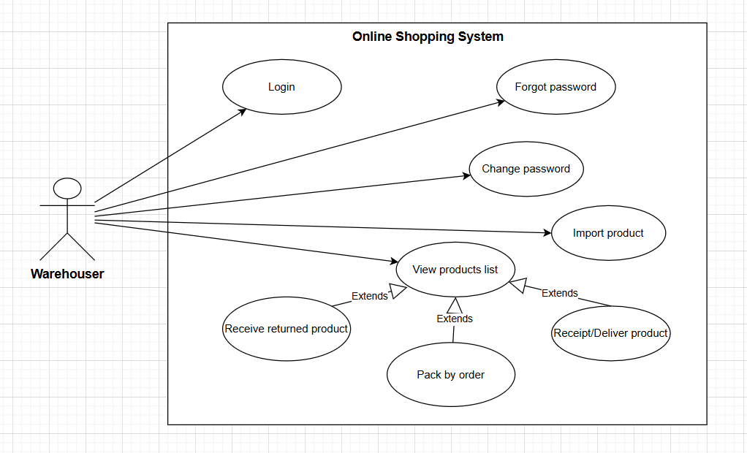

#### b. Descriptions

| **#** | **Feature** | **Use case** | **Use case description** |
| --- | --- | --- | --- |
| 1 | Authentication | RememberMe | Function help user access quickly by using cookie remember password and username |
| Forgot password | This feature allows users to change their password using OTP via Gmail. After entering correct OTP, the user will have the right to create a new password. |
| Verify account | This feature allows users to verify their account via Gmail by sending an OTP code. Once verified, this user has the right to apply for the job. |
| Login | This feature allows user who is registered to login the system |
| Logout | This feature allows users can logout the system |
| Sign up | This feature allows Unauthenticated User register new account to access the system |
| 2 | Manage accounts | Create account | Admin can create an account |
| Update account | Admin can view the list of all user account |
| Change password | User can change the password |
| 3 | Manage profile | View profile | This feature allows user view their profile’s information |
| Update profile | User can update their information |
| 5 | Sale Management | Change order status | This feature allows Sale/Sale Manager change order status |
| Change sale notes | This feature allows Sale/Sale Manager change sale notes |
| Assign order | ​This feature allows Sale Manager assign order to other sale |
| View orders list | Sale/Sale Manager can view list of orders |
| View order details | Sale/Sale Manager can view order details |
| View Sale dashboard | This feature show the trend of success/total orders, and the revenues trends by day for the last 7 days for all or a specific sale person (the start date, end date, sale, order status can be adjustable) |
| 6 | Marketing Management | View posts list | This feature allows Marketing Employer view list of posts |
| View post details | This feature allows Marketing Employer view post details |
| View favorite jobs | View a list of jobs that user care about |
| View customers list | This feature allows Marketing Employer view list of customers |
| View customer details | This feature allows Marketing Employer view customer details |
| View sliders list | This feature allows Marketing Employer view list of sliders |
| View slider details | This feature allows Marketing Employer view slider details |
| View feedbacks list | This feature allows Marketing Employer view list of feedbacks |
| View feedback details | This feature allows Marketing Employer view feedback details |
| View MKT dashboard | This feature shows statistics of posts, products, customers, feedbacks & the trend of new customers by day for the last 7 days (the start date & end date can be adjustable) |
| 7 | Cart management | Cart Details | This feature shows the cart details with list of the user's chosen products and the total order price and the sider with the product search box, product categories, the latest products, and static contacts/links |
| Cart Contact | This feature shows the list of user-chosen product |
| Cart Completion | This feature shows the cart completion notes + the sider with the product search box, product categories, the latest products, and static contacts/links |
| 8 | Product Evaluation | Feedback | Customer can leave a feedback on each of received product |
| 9 | Products List | Products List | This feature shows the products paginatedly |
| Product details | Product details | This feature shows product details |
| 10 | Blogs List | Blogs List | This feature shows the posts paginatedly |
| Blog Details | Blog Details | This feature shows post details |
| 11 | Warehouse management | Product List | This feature shows the products include hold and information product |
| Import product | This feature add product size, color, quantity, import price |
| Order list | This feature shows the orders and change status order |
| Order detail | This feature show detail the order and change status order |

## 2. Overall Functionalities

### 2.1 Screens Flow

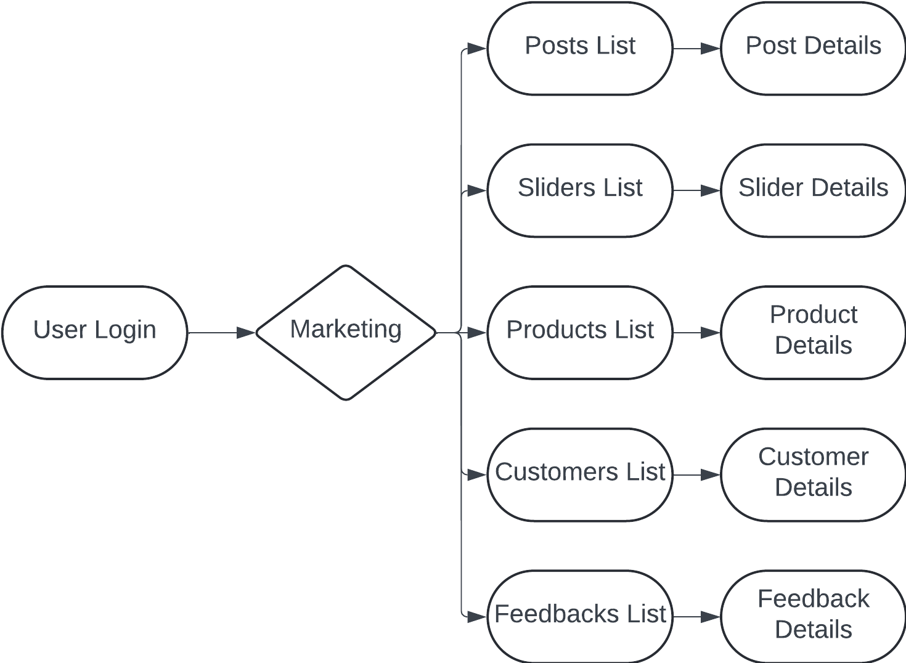 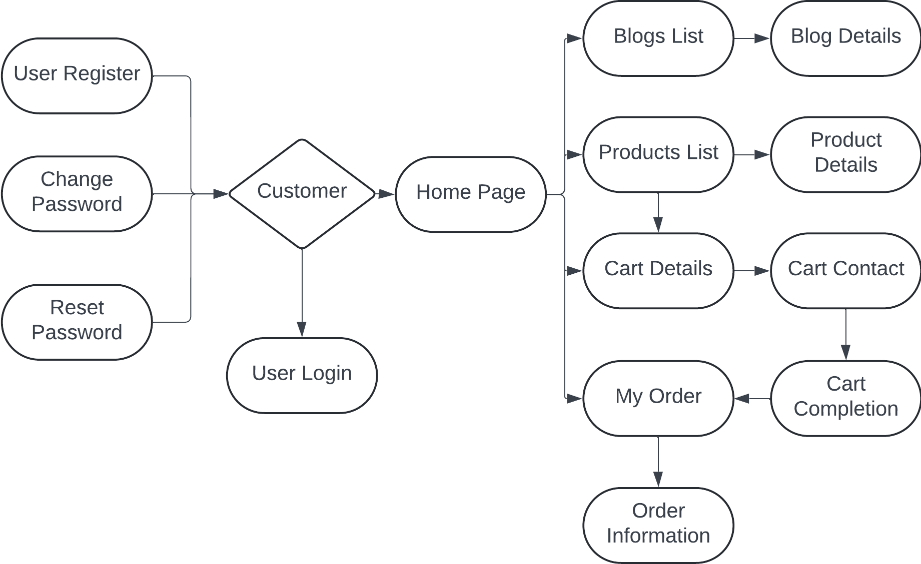

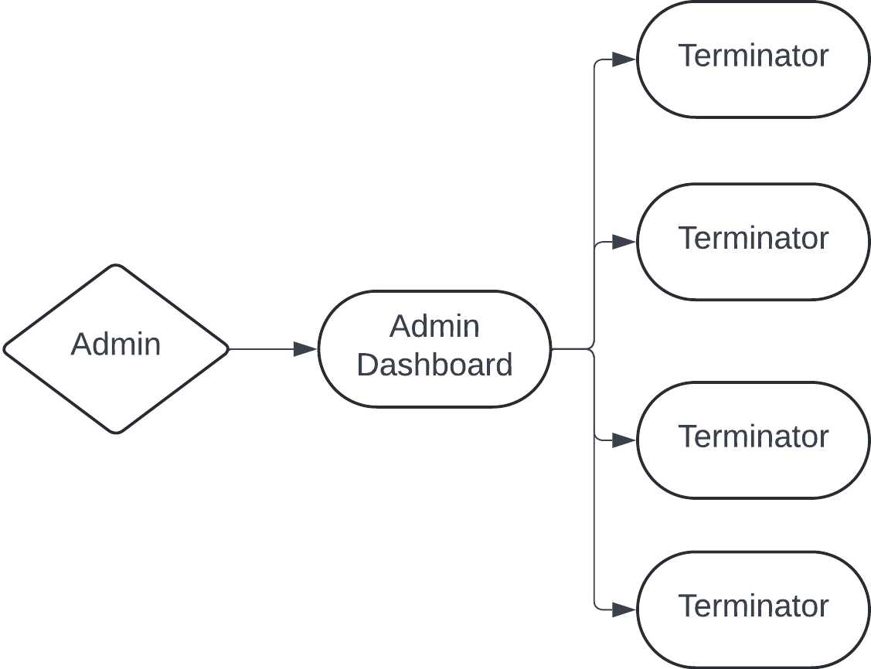

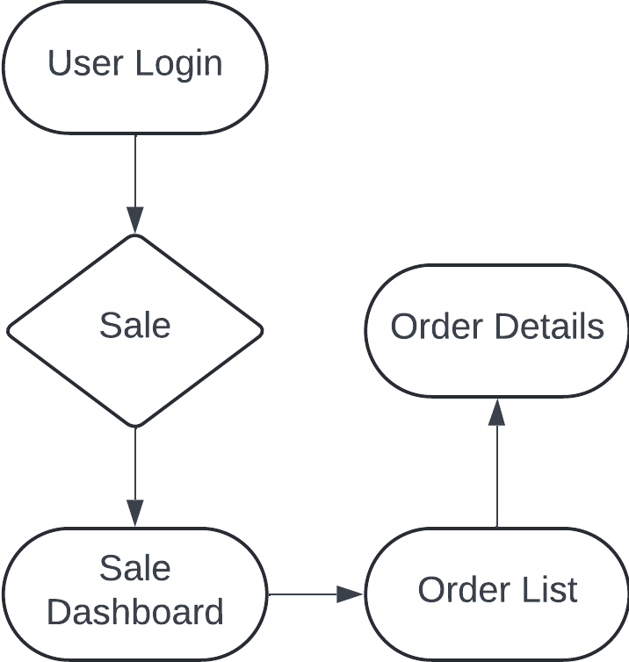

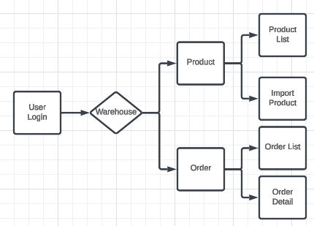

### 

### 2.2 Screen Descriptions

| **#** | **Feature** | **Screen** | **Description** |
| --- | --- | --- | --- |
| 1 | Shop Overview | Home Page | include information of sliders, posts, products |
| 2 | Shop Overview | Blogs List | view existing posts |
| 3 | Shop Overview | Blog Details | show details of a post |
| 4 | Shop Overview | Products List | view existing products |
| 5 | Shop Overview | Product Details | show details of a product |
| 6 | Order Clothes | Cart Details | show and edit details of user’s chosen products |
| 7 | Order Clothes | Cart Contact | display user’s selected products and edit/input receiver information |
| 8 | Order Clothes | Cart Completion | show customers’ completion notes |
| 9 | Product Evaluation | Feedback | rating products and services |
| 10 | User Login | User Login | login with an email and password |
| 11 | User Login | User Register | create a new user |
| 12 | User Login | Reset Password | reset password to default |
| 13 | User Login | Change Password | change the user's password |
| 14 | View Profile | User Profile | view, edit user's profile |
| 15 | Verify Profile | User Authorization | authorize users base on their roles |
| 16 | Order Clothes | My Orders | view submitted orders |
| 17 | Order Clothes | Order Information | edit/cancel orders before it processed |
| 18 | MKT Management | Marketing Dashboard | view statistics and trends of marketing data |
| 19 | MKT Management | Posts List | view existing posts, or edit, filter, search, add new |
| 20 | MKT Management | Post Details | show and edit details of a post |
| 21 | MKT Management | Sliders List | view existing sliders, or edit, filter, search, add new |
| 22 | MKT Management | Slider Details | show and edit details of a slider |
| 23 | View Clothes | Products List | view existing products, or edit, filter, search, add new |
| 24 | View Clothes | Product Details | show and edit details of a product |
| 25 | Manage Customer | Customers List | view existing customers, or edit, filter, search, add new |
| 26 | Manage Customer | Customer Details | show and edit details of a customer |
| 27 | Manage Feedback | Feedbacks List | view existing feedback, or edit, filter, search, add new |
| 28 | Manage Feedback | Feedback Details | show and edit details of a feedback |
| 29 | Sale Management | Sales Dashboard | view statistics and trends of sale data |
| 30 | Sale Management | Orders List | view customers’ order, or sort, filter, search |
| 31 | Sale Management | Order Details | show details and edit status of an order |
| 32 | Admin Management | Admin Dashboard | view statistics and trends of management data |
| 33 | Manage User | Users List | view existing users, or edit, filter, search, add new |
| 34 | Manage User | User Details | show and edit details of a user |
| 35 | Manage System Setting | Settings List | view existing system settings, or edit, filter, search, add new |
| 36 | Manage System Setting | Setting Details | show and edit details of a system setting |
| 37 | Warehouse management | Product List | This feature shows the products include hold and information product |
| 38 | Warehouse management | Import product | This feature add product size, color, quantity, import price |
| 39 | Warehouse management | Order list | This feature shows the orders and change status order |
| 40 | Warehouse management | Order detail | This feature show detail the order and change status order |

### 2.3 Screen Authorization

| **Screen** | **Guest** | **Customer** | **Marketing** | **Sale** | **Sale Manager** | **Admin** | **Warehouser** |
| --- | --- | --- | --- | --- | --- | --- | --- |
| Home Page | x | x |  |  |  |  |  |
| Blogs List | x | x |  |  |  |  |  |
| Blog Details | x | x |  |  |  |  |  |
| Products List | x | x |  |  |  |  |  |
| Product Details | x | x |  |  |  |  |  |
| Cart Details |  | x |  |  |  |  |  |
| Cart Contract |  | x |  |  |  |  |  |
| Cart Completion |  | x |  |  |  |  |  |
| Feedback |  | x |  |  |  |  |  |
| User Login | x | x | x | x | x | x |  |
| User Register | x | x |  |  |  |  |  |
| Reset Password |  | x | x | x | x | x |  |
| Change Password | x | x | x | x | x | x |  |
| User Profile |  | x | x | x | x | x |  |
| User Authorization |  | x |  |  |  |  |  |
| My Order |  | x |  |  |  |  |  |
| Order Information |  | x |  |  |  |  |  |
| MKT DashBoard |  |  | x |  |  |  |  |
| Posts List |  |  | x |  |  |  |  |
| Post Details |  |  | x |  |  |  |  |
| Sliders List  Slider Details |  |  | x |  |  |  |  |
| Product List |  |  | x |  |  |  |  |
| Product Details |  |  | x |  |  |  |  |
| Customers List |  |  | x |  |  |  |  |
| Customer Details |  |  | x |  |  |  |  |
| Feedback Details, List |  |  | x |  |  |  |  |
| Sale Dashboard |  |  |  | x | x |  |  |
| Orders List |  |  |  | x |  |  |  |
| Order Details |  |  |  | x |  |  |  |
| Admin Dashboard |  |  |  |  |  | x |  |
| Users List |  |  |  |  |  | x |  |
| User Details |  |  |  |  |  | x |  |
| Product List |  |  |  |  |  |  | x |
| Import product |  |  |  |  |  |  | x |
| Order list |  |  |  |  |  |  | x |
| Order detail |  |  |  |  |  |  | x |

### 2.4 Non-UI Functions

| **#** | **Feature** | **System Function** | **Description** |
| --- | --- | --- | --- |
| 1 | Email Notification | Third-Party Integrations | send email when customer create a new order and when the order has status success |
| 2 | Encrypt User Password | Security & Data Protection | Encrypts sensitive user data such as passwords |
| 3 | Session Timeout | Security & Data Protection | Automatically logs users out after a period of inactivity to prevent unauthorized access. |
| 4 | Sales dashboard | Analytics & Reporting | Tracks and generates reports on total order, revenue over specific time periods (e.g., daily, weekly, monthly). |
| 5 | Return Request | Customer Support & Feedback | Handles requests for product returns, initiating the process according to the store’s return policy |
| 6 | Generate Shipping Label | Shipping & Delivery | Creates a shipping label for the warehouse team, including sender and receiver information, delivery address, and carrier details |

## 3. System High Level Design

### 3.1 Database Design

#### a. Database Schema

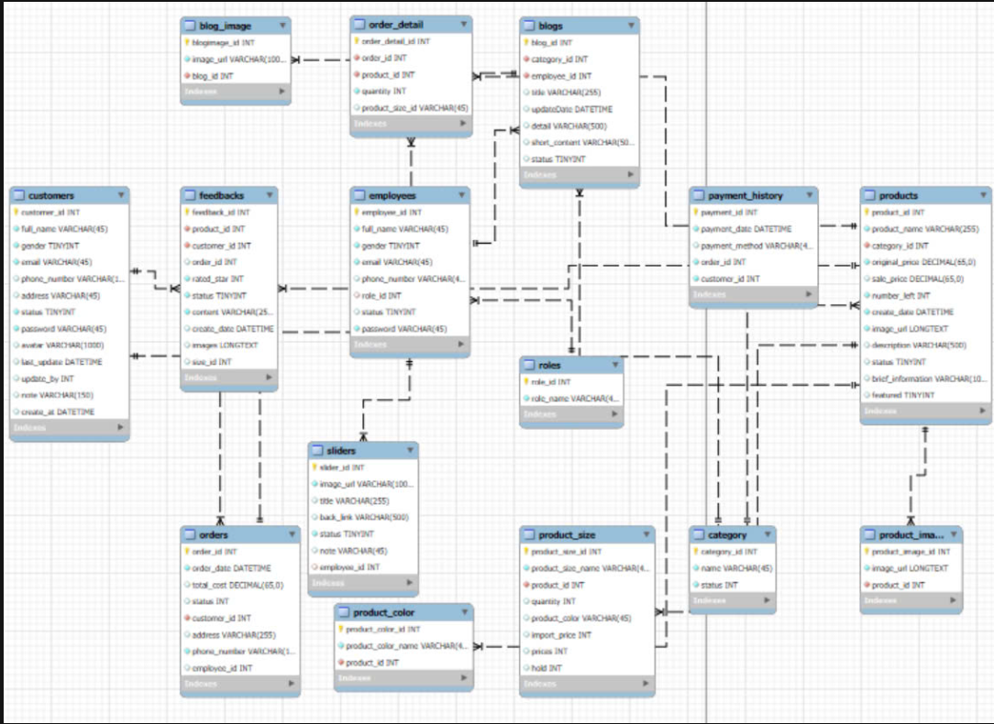

#### b. Table Descriptions

| **No** | **Table** | **Description** |
| --- | --- | --- |
| 01 | customer | Description: Stores customer information  Primary keys: customer_id  Foreign keys: None |
| 02 | address | Description: Stores customer information of address  Primary keys: id  Foreign keys: cus_id |
| 03 | blog_image | Description: Stores blog information of image  Primary keys: blogimage_id  Foreign keys: blog_id |
| 04 | blogs | Description: Stores blog information  Primary keys: blog_id  Foreign keys: category_id, employee_id |
| 05 | category | Description: Contains the different categories for products.  Primary keys: category_id  Foreign keys: role_id |
| 06 | employees | Description: Stores information about employee  Primary keys: employee_id  Foreign keys: None |
| 07 | feedbacks | Description: Stores customer feedback for products, including ratings and comments.  Primary keys: feedback_id  Foreign keys: product_id, customer_id, order_id, size_id |
| 08 | order_detail | Description: Stores order detailed information .  Primary keys: order_detail_id  Foreign keys: order_id, product_id, product_size_id |
| 09 | orders | Description: Stores order information .  Primary keys: order_id  Foreign keys: customer_id, employee_id |
| 10 | payment_history | Description: Stores payment_history information .  Primary keys: payment_id  Foreign keys: order_id, customer_id |
| 11 | product_image | Description: Stores product_image information .  Primary keys: product_image_id  Foreign keys: product_id |
| 12 | product_size | Description: Stores product_size information .  Primary keys: product_size_id  Foreign keys: product_id |
| 13 | products | Description: Stores product information .  Primary keys: product_id  Foreign keys: category_id, |
| 14 | roles | Description: Stores role information .  Primary keys: role_id  Foreign keys: NONE |
| 15 | sliders | Description: Stores slider information .  Primary keys: slider_id  Foreign keys: employee_id |
| 16 | status | Description: Stores status information .  Primary keys: status_id  Foreign keys: None |

### 3.2 Code Packages

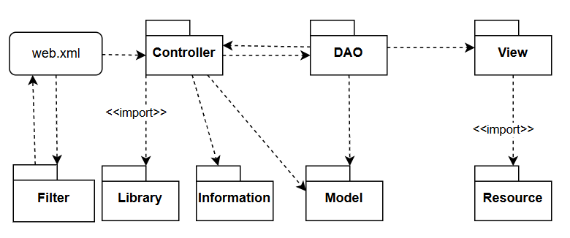

***Package descriptions***

| **No** | **Package** | **Description** |
| --- | --- | --- |
| 01 | Controller | This package contains the Servlets that handle the user requests. |
| 02 | View | The View package contains the presentation logic. It represents the user interface and renders the data sent by the controller. |
| 03 | Model | The Model package represents the application's business logic and handles the interaction with the data source |
| 04 | DAO | The DAO package is responsible for interacting with the database. |
| 05 | Information | The Information package contains config |
| 06 | Resource | The Resource package contains Views .jsp, images, library |
| 07 | Library | The Library package contains a collection of reusable code, utilities, and third-party dependencies that are used throughout the application. |
| 08 | Filter | A component that can intercept and process requests or responses before they reach the other components. |

# II. Requirement Specifications

## 1. Common Functions

### 2.1 UC-1_Login System

| UC ID and Name: | **UC-1_Login System** | | |
| --- | --- | --- | --- |
| Created By: | HieuNH | Date Created: | 19/09/2024 |
| Primary Actor: | Customer, Admin, Marketer, Sale, Sale Manager, Warehouser | Secondary Actors: | None |
| Trigger: | User clicks Login button from the page header | | |
| Description: | As a user, I want to be able to log into the system so that I can use the system’s authenticated features and access my personalized account. | | |
| Preconditions: | PRE-1. Can connect to server  PRE-2. User has registered account  PRE-3. Internet is stable | | |
| Postconditions: | POST-1. The user is successfully authenticated and allowed access to the system.  POST-2. The user is redirected to the home page or a landing page that is appropriate for their role and permissions. | | |
| Normal Flow | In the login page, user inputs email and passwords.  Actor clicks “Login” button and System redirects to the home page  Actor can click “Remember Me” to remember email and password | | |
| Alternative Flows: | None | | |
| Exceptions: | E1: The email or password is not correct format and the System informs an error message to remind the user to input the correct format  E2: The email or password is not correct and the System informs “email or password is invalid”  E3: The email input not exist in system and the system informs “Email does not exist” | | |
| Priority: | High | | |
| Frequency of Use: | Usually | | |
| Business Rules: | BR1, BR2 | | |
| Other Information: | None | | |
| Assumptions: | AS-01 | | |

### 2.2 UC-2_Remember Me

| UC ID and Name: | **UC-2_Remember Account** | | |
| --- | --- | --- | --- |
| Created By: | HieuNH | Date Created: | 19/09/2024 |
| Primary Actor: | Customer, Admin, Marketer, Sale, Sale Manager | Secondary Actors: | None |
| Trigger: | The user selects the "Remember Me" option on the login page | | |
| Description: | This use case helps users access quickly by remember password and email | | |
| Preconditions: | PRE-1. The user must have previously logged into the system. | | |
| Postconditions: | POST-1. The system securely stores the necessary data to facilitate automatic login for users who have selected the "Remember Me" option.  POST-2. The user can access the system without re-entering their credentials | | |
| Normal Flow | Click/Unclick to save/unsave checkbox remember | | |
| Alternative Flows: | 1." Remember Me" Option Not Selected:  If the user does not select the "Remember Me" option during the login process.  The system will not remember email and password | | |
| Exceptions: | System unavailable: If the system is unavailable, the saving information cannot be saved. | | |
| Priority: | High | | |
| Frequency of Use: | Often | | |
| Business Rules: | None | | |
| Other Information: | The "Remember Me" feature enhances user experience by remember email and password | | |
| Assumptions: | None | | |

### 2.3 UC-3_Logout

| UC ID and Name: | **UC-3_Logout** | | |
| --- | --- | --- | --- |
| Created By: | HieuNH | Date Created: | 19/09/2024 |
| Primary Actor: | Customer, Admin, Marketer, Sale, Sale Manager | Secondary Actors: | None |
| Trigger: | The user logout by clicking the “Logout” button | | |
| Description: | This use case allows users can logout the system | | |
| Preconditions: | PRE-1. The user must have previously logged into the system. | | |
| Postconditions: | POST-1. The user's session is successfully terminated, and they are logged out of the system.  POST-2. Redirect to the home page. | | |
| Normal Flow | User clicks the “Logout” button and redirects to Home Page | | |
| Alternative Flows: | None | | |
| Exceptions: | System unavailable: If the system is unavailable, the saving information cannot be saved. | | |
| Priority: | High | | |
| Frequency of Use: | Often | | |
| Business Rules: | None | | |
| Other Information: | Logout process should be swift and not cause any noticeable delay to the user.  Ensure that user sessions are properly terminated upon logout to prevent unauthorized access to user accounts. | | |
| Assumptions: | None | | |

### 2.4 UC-4_Home Page

### 

| UC ID and Name: | **UC-4_Home Page** | | |
| --- | --- | --- | --- |
| Created By: | HieuNH | Date Created: | 19/09/2024 |
| Primary Actor: | Customer, Guest | Secondary Actors: | None |
| Trigger: | The user navigates to the home page of the online shop. | | |
| Description: | This use case allows users to view the home page of the online clothing shop, where they can browse products | | |
| Preconditions: | * PRE-1: The user must have an active internet connection. * PRE-2: The user may or may not be logged into the system. | | |
| Postconditions: | POST-1: The user can view featured products.  POST-2: The user can navigate to product categories, blogs, and the shopping cart. | | |
| Normal Flow | The user enters the URL of the online shop.  The system displays the home page with the following components:   * A logo at the top. * A navigation menu with links to various sections (Home, Categories, Blog, Contact). * A search box for product searches. * A carousel slider showcasing featured promotions. * A grid of new arrival products. * A section displaying the top 3 blogs. * Footer with additional links and information.   The user can interact with the elements on the page (e.g., clicking on products, accessing blog posts, using the search function). | | |
| Alternative Flows: | AF-1: User is not logged in.   * The system displays options to log in or create an account.   AF-2: User performs a search.   * The user enters a keyword in the search box. * The system redirects the user to the search results page. | | |
| Exceptions: | **System Unavailable:** If the system is unavailable, the home page cannot be displayed, and an error message is shown.  **Network Error:** If there is a network issue, the home page may load slowly or not at all. | | |
| Priority: | High | | |
| Frequency of Use: | Very often | | |
| Business Rules: | BR3 | | |
| Other Information: | The home page should load quickly and be responsive on various devices.  The design should be visually appealing and easy to navigate.  Ensure accessibility standards are met for all users. | | |
| Assumptions: | Users are familiar with basic web navigation.  Users have an interest in shopping for clothing online. | | |

### 2.5 UC-5_Change Password

| UC ID and Name: | **UC-5_Change Password** | | |
| --- | --- | --- | --- |
| Created By: | HoangLV | Date Created: | 19/09/2024 |
| Primary Actor: | Customer, Sale, Sale Manager, Marketer, Admin | Secondary Actors: | None |
| Trigger: | The user clicks option “Change Password” on the selection. | | |
| Description: | The user changes their password by entering the right old one, the new password must meet the complex conditions of the system. | | |
| Preconditions: | * PRE-1. The user is logged in to the system. * PRE-2. The system and the Internet is stable | | |
| Postconditions: | POST-1. The user's password is successfully changed in the database and encrypted by MD5,SHA1.  POST-2. The system displays the message for the user. | | |
| Normal Flow | * The user enters the old password in the “Old Password” text box * The user enters the new password in the “New Password” text box. * The user re-enter new password in the “Confirm New Password” text box. * New password is updated in the database of the user’s account * The system display the message for user | | |
| Alternative Flows: | None | | |
| Exceptions: | E1: Internal server error  E2. Invalid password: If the new password doesn't meet complexity requirements, the system displays an error message explaining the requirements.  E3. Incorrect current password: If the user enters an incorrect current password, the system displays an error message.  E1. Attempt too many times: If the user's account is locked due to 5 failed password attempts, they must wait 1 day before changing the password. | | |
| Priority: | High | | |
| Frequency of Use: | Low: Users rarely change their passwords, only when required to change them regularly every 6 months or when they suspect the password has been leaked. | | |
| Business Rules: | BR1,BR4 | | |
| Other Information: | The system should respond to change password requests within 3 seconds under normal load conditions. | | |
| Assumptions: | AS-1,AS-5 | | |

### 2.6 UC-6_Forgot Password

### 

| UC ID and Name: | **UC-6_Forgot Password** | | |
| --- | --- | --- | --- |
| Created By: | HoangLV | Date Created: | 19/09/2024 |
| Primary Actor: | Customer, Sale, Sale Manager, Marketer, Admin | Secondary Actors: | None |
| Trigger: | The user clicks on the "Forgot Password" link or button on the login page. | | |
| Description: | This feature allows users to change their password by OTP via Gmail | | |
| Preconditions: | * PRE-1. The user must have a registered account with the system. * PRE-2. The user must have forgotten their password or needs to update it for security reasons. | | |
| Postconditions: | POST-1. The user's password is successfully reset to the new password.  POST-2. The user can log in to the system using their new password. | | |
| Normal Flow | * User clicks “Forgot Password” and enters email * When the user clicks “Get new password” the system will send OTP to Gmail and redirect to the OTP Submitting page to submit OTP code * Redirect to another page to enter a new password * Click “Reset” to save new password and direct to Login page | | |
| Alternative Flows: | None | | |
| Exceptions: | E1. If the user's email address is not registered in the system, the "Forgot Password" process cannot proceed  E2. If user enters wrong OTP code, user will receive an error message notification | | |
| Priority: | High | | |
| Frequency of Use: | Often. | | |
| Business Rules: | BR1,BR4 | | |
| Other Information: | The Web must be absolutely secure by encrypting important data with BCrypt and using digital signatures in data transmission. | | |
| Assumptions: | AS-1,AS-5 | | |

### 

### 2.7 UC-7_Product List

#### 

| UC ID and Name: | **UC-5_Product_List** | | |
| --- | --- | --- | --- |
| Created By: | DungNV | Date Created: | 19/09/2024 |
| Primary Actor: | Customer | Secondary Actors: | None |
| Trigger: | User clicks on Search button from the page header | | |
| Description: | As a user, I want to be able to view products | | |
| Preconditions: | PRE-1. Can connect to server  PRE-2. Internet is stable | | |
| Postconditions: | POST-1. The user is redirected to the products list page. | | |
| Normal Flow | User click on Search button from the page header | | |
| Alternative Flows: | None | | |
| Exceptions: | **System Unavailable:** If the system is unavailable, the home page cannot be displayed, and an error message is shown.  **Network Error:** If there is a network issue, the home page may load slowly or not at all. | | |
| Priority: | High | | |
| Frequency of Use: | Usually | | |
| Business Rules: | none | | |
| Other Information: | The product list page should load quickly and be responsive on various devices.  Ensure accessibility standards are met for all user | | |
| Assumptions: | Users are familiar with basic web navigation.  Users have an interest in shopping for clothing online. | | |

### 

### 2.8 UC-8_Blog List

#### 

| UC ID and Name: | **UC-8_Blog_List** | | |
| --- | --- | --- | --- |
| Created By: | ManhPK | Date Created: | 19/09/2024 |
| Primary Actor: | customer | Secondary Actors: | None |
| Trigger: | User clicks on Blog button from the page header | | |
| Description: | As a user, I want to be able to view blog | | |
| Preconditions: | PRE-1. Can connect to server  PRE-2. Internet is stable | | |
| Postconditions: | POST-1. The user is redirected to the blog list page. | | |
| Normal Flow | User click on Blog button from the page header | | |
| Alternative Flows: | None | | |
| Exceptions: | **System Unavailable:** If the system is unavailable, the home page cannot be displayed, and an error message is shown.  **Network Error:** If there is a network issue, the home page may load slowly or not at all. | | |
| Priority: | Normal | | |
| Frequency of Use: | Sometimes | | |
| Business Rules: | none | | |
| Other Information: | The blog list page should load quickly and be responsive on various devices.  Ensure accessibility standards are met for all user | | |
| Assumptions: | none | | |

### 

### 2.9 UC-9_Blog Detail

#### 

| UC ID and Name: | **UC-8_Blog_List** | | |
| --- | --- | --- | --- |
| Created By: | ManhPK | Date Created: | 19/09/2024 |
| Primary Actor: | customer | Secondary Actors: | None |
| Trigger: | User clicks on Read more button from Blog List page | | |
| Description: | As a user, I want to all informations about the Blog | | |
| Preconditions: | PRE-1. Can connect to server  PRE-2. Internet is stable | | |
| Postconditions: | POST-1. The user is redirected to the blog detail page. | | |
| Normal Flow | User click on Blog button from the page header | | |
| Alternative Flows: | None | | |
| Exceptions: | **System Unavailable:** If the system is unavailable, the home page cannot be displayed, and an error message is shown.  **Network Error:** If there is a network issue, the home page may load slowly or not at all. | | |
| Priority: | Normal | | |
| Frequency of Use: | Sometimes | | |
| Business Rules: | none | | |
| Other Information: | The blog detail page should load quickly and be responsive on various devices.  Ensure accessibility standards are met for all user | | |
| Assumptions: | none | | |

### 

### 

### 2.10 UC-10_User Profile

| UC ID and Name: | **UC-8_Blog_List** | | |
| --- | --- | --- | --- |
| Created By: | ManhPK | Date Created: | 19/09/2024 |
| Primary Actor: | Customer | Secondary Actors: | None |
| Trigger: | User clicks on Profile button from the page header | | |
| Description: | As a user, I want to and edit profile | | |
| Preconditions: | PRE-1. Can connect to server  PRE-2. Internet is stable | | |
| Postconditions: | POST-1. The user is redirected to the user profile page. | | |
| Normal Flow | User click on profile button from the page header | | |
| Alternative Flows: | None | | |
| Exceptions: | **System Unavailable:** If the system is unavailable, the home page cannot be displayed, and an error message is shown.  **Network Error:** If there is a network issue, the home page may load slowly or not at all. | | |
| Priority: | High | | |
| Frequency of Use: | Usually | | |
| Business Rules: | none | | |
| Other Information: | The user profile page should load quickly and be responsive on various devices.  Ensure accessibility standards are met for all user | | |
| Assumptions: | none | | |

### 

### 

### 2.11 UC-11_User Register

| UC ID and Name: | **UC-11_User_Register** | | |
| --- | --- | --- | --- |
| Created By: | LinhPK | Date Created: | 16/09/2024 |
| Primary Actor: | Customer | Secondary Actors: | None |
| Trigger: | User clicks on Sign Up at the login screen | | |
| Description: | As a user, I want to create a new account | | |
| Preconditions: | PRE-1. Can connect to server  PRE-2. Internet is stable | | |
| Postconditions: | POST-1. The user is redirected to the register screen. | | |
| Normal Flow | User clicks on Sign Up at the login screen  The screen displayed the following data for user to input: full name, password, gender, email, phone number, address | | |
| Alternative Flows: | None | | |
| Exceptions: | **Password Error:** The password does not match up with the business rule.  **Email Existed:** The input email already existed in the database | | |
| Priority: | High | | |
| Frequency of Use: | Usually | | |
| Business Rules: | BR4 | | |
| Other Information: |  | | |
| Assumptions: | none | | |

### 

### 2.12 UC-12_Product Details

| UC ID and Name: | **UC-12_Product Details** | | |
| --- | --- | --- | --- |
| Created By: | LinhPK | Date Created: | 18/09/2024 |
| Primary Actor: | Customer | Secondary Actors: | None |
| Trigger: | User clicks on a specific product on the screen | | |
| Description: | As a user, I want to see the details of a product | | |
| Preconditions: | PRE-1. Can connect to server  PRE-2. Internet is stable | | |
| Postconditions: | POST-1. The user is redirected to the product details screen. | | |
| Normal Flow | User clicks on a product on the screen  The screen displayed the product details such as name, image, price, user can choose size and color, can add product to cart | | |
| Alternative Flows: | None | | |
| Exceptions: |  | | |
| Priority: | Normal | | |
| Frequency of Use: | Usually | | |
| Business Rules: | none | | |
| Other Information: |  | | |
| Assumptions: | none | | |

### 2.13 UC-13_Product List (Marketer)

#### 

| UC ID and Name: | **UC-13_Product_List** | | |
| --- | --- | --- | --- |
| Created By: | HieuNH | Date Created: | 04/10/2024 |
| Primary Actor: | Marketer | Secondary Actors: | None |
| Trigger: | Marketer wants to view product list | | |
| Description: | As a marketer, I want to be able to view products | | |
| Preconditions: | PRE-1. Can connect to server  PRE-2. Internet is stable | | |
| Postconditions: | POST-1. The marketer is redirected to the products list page.  POST-2. The employee can view list product, filter and search or hide/show product | | |
| Normal Flow | Marketer access product list page via url  System display list products paging  Marketer can view detail, search, filter, sort, edit or add redirect to product | | |
| Alternative Flows: | None | | |
| Exceptions: | System Unavailable: If the system is unavailable, the home page cannot be displayed, and an error message is shown.  Network Error: If there is a network issue, the home page may load slowly or not at all. | | |
| Priority: | High | | |
| Frequency of Use: | Usually | | |
| Business Rules: | None | | |
| Other Information: | The product list page should load quickly and be responsive on various devices. | | |
| Assumptions: | Employers are familiar with basic web navigation. | | |

### 2.14 UC-14_Slider List (Marketer)

#### 

| UC ID and Name: | **UC-13_Slider_List** | | |
| --- | --- | --- | --- |
| Created By: | DungNV | Date Created: | 24/09/2024 |
| Primary Actor: | Marketer | Secondary Actors: | None |
| Trigger: | Marketer wants to view Slider list | | |
| Description: | As a marketer, I want to be able to view sliders | | |
| Preconditions: | PRE-1. Can connect to server  PRE-2. Internet is stable | | |
| Postconditions: | POST-1. The marketer is redirected to the Sliders list page. | | |
| Normal Flow | Marketer access sliders list page via url  System display list slider paging  Marketer can view detail, redirect to slider detail | | |
| Alternative Flows: | None | | |
| Exceptions: | System Unavailable: If the system is unavailable, the home page cannot be displayed, and an error message is shown.  Network Error: If there is a network issue, the home page may load slowly or not at all. | | |
| Priority: | High | | |
| Frequency of Use: | Usually | | |
| Business Rules: | None | | |
| Other Information: | The sliders list page should load quickly and be responsive on various devices. | | |
| Assumptions: | Users are familiar with basic web navigation. | | |

### 

### 2.14 UC-15_Cart completion

#### 

| UC ID and Name: | **UC-13_Cart_completion** | | |
| --- | --- | --- | --- |
| Created By: | DungNV | Date Created: | 05/10/2024 |
| Primary Actor: | Customer | Secondary Actors: | None |
| Trigger: | Customers want to check out their cart | | |
| Description: | Customer can view their cart completion | | |
| Preconditions: | PRE-1. Can connect to server  PRE-2. Internet is stable  PRE-3. Customer cart has at least 1 product | | |
| Postconditions: | POST-1. Customer is redirected to the Cart completion page.  POST-2. Customer is received a mail confirm about their order | | |
| Normal Flow | Customer check out their order at Cart contact page  System display Cart completion screen  Customer can view detail of their order | | |
| Alternative Flows: | None | | |
| Exceptions: | System Unavailable: If the system is unavailable, the home page cannot be displayed, and an error message is shown.  Network Error: If there is a network issue, the home page may load slowly or not at all. | | |
| Priority: | High | | |
| Frequency of Use: | Usually | | |
| Business Rules: | None | | |
| Other Information: | The cart completion page should load quickly and be responsive on various devices. | | |
| Assumptions: | Users are familiar with basic web navigation.  Users have an interest in shopping for clothing online. | | |

### 2.16 UC-16_Product Details(Marketer)

| UC ID and Name: | **UC-16_Product Details** | | |
| --- | --- | --- | --- |
| Created By: | HieuNh | Date Created: | 04/10/2024 |
| Primary Actor: | Marketer | Secondary Actors: | None |
| Trigger: | Marketer clicks on Edit button to view or edit a specific product on the screen | | |
| Description: | As a marketer, I want to see the details of a product to edit or view. | | |
| Preconditions: | PRE-1. Can connect to server  PRE-2. Internet is stable | | |
| Postconditions: | POST-1. The marketer is redirected to the product details screen.  POST-2. The employee can view or update about product. | | |
| Normal Flow | User clicks on a product on the screen  The screen displayed the product details such as name, image, price, user can choose size and color, can add product to cart | | |
| Alternative Flows: | None | | |
| Exceptions: | None | | |
| Priority: | Medium | | |
| Frequency of Use: | Medium | | |
| Business Rules: | Sale price must less than original price  Product name, description, bref information cannot contain space | | |
| Other Information: | None | | |
| Assumptions: | none | | |

### 2.17 UC-17_Add Product (Marketer)

| UC ID and Name: | **UC-17_Add Product** | | |
| --- | --- | --- | --- |
| Created By: | HieuNh | Date Created: | 04/10/2024 |
| Primary Actor: | Marketer | Secondary Actors: | None |
| Trigger: | Marketer clicks on Add button at list product to create new product on the screen | | |
| Description: | As a marketer, I want to see the details of a product to edit or view. | | |
| Preconditions: | PRE-1. Can connect to server  PRE-2. Internet is stable | | |
| Postconditions: | POST-1. The marketer is redirected to the add product screen.  POST-2. The employee can add new product. | | |
| Normal Flow | Marketer clicks on Add new product at list product screen  The system display new information product so that MKT input or upload  Marketer click to Add, information of new product saved to database  The system display success message | | |
| Alternative Flows: | None | | |
| Exceptions: | None | | |
| Priority: | Medium | | |
| Frequency of Use: | Medium | | |
| Business Rules: | Sale price must less than original price  Product name, description, bref information cannot contain space  Must input all field information about product | | |
| Other Information: | None | | |
| Assumptions: | none | | |

### 2.18 UC-18_Payment

| UC ID and Name: | **UC-18_Payment** | | |
| --- | --- | --- | --- |
| Created By: | HieuNh | Date Created: | 04/10/2024 |
| Primary Actor: | Customer | Secondary Actors: | None |
| Trigger: | User choose payment method and click to Pay button at cart contract screen | | |
| Description: | As a customer, I want to payment my order about product | | |
| Preconditions: | PRE-1. Can connect to server  PRE-2. Internet is stable | | |
| Postconditions: | POST-1. The user is redirected to the payment screen corresponding choosen.  POST-2. The user can payment for product. | | |
| Normal Flow | Customer choose payment method and click to Pay button at cart contract screen  The user is redirected to the payment screen corresponding choosen.  If payment success redirect to cart completion screen | | |
| Alternative Flows: | None | | |
| Exceptions: | None | | |
| Priority: | High | | |
| Frequency of Use: | High | | |
| Business Rules: | None | | |
| Other Information: | None | | |
| Assumptions: | Customer have knowledge payment online | | |

### 2.19 UC-19_Cart Details

| UC ID and Name: | **UC-17_Cart Details** | | |
| --- | --- | --- | --- |
| Created By: | HoangLV | Date Created: | 04/10/2024 |
| Primary Actor: | Customer | Secondary Actors: | None |
| Trigger: | User redirects to Cart Details | | |
| Description: | User clicks Cart/Add to Cart to add new item to cart and redirect to Cart Details | | |
| Preconditions: | PRE-1. Can connect to server  PRE-2. Internet is stable | | |
| Postconditions: | POST-1. The user is redirected to Cart Details screen.  POST-2. System displays list chosen products | | |
| Normal Flow | * User clicks Cart/Add to Cart in Home Page or in product details * System redirects to Cart Details screen * User can choose and view product chosen list | | |
| Alternative Flows: | None | | |
| Exceptions: | None | | |
| Priority: | High | | |
| Frequency of Use: | High | | |
| Business Rules: | None | | |
| Other Information: | None | | |
| Assumptions: | A1. User choose more product than the allowed quantity  A2. User has chosen product list but does not click check out | | |

### 2.20 UC-20_Cart Contact

| UC ID and Name: | **UC-17_Cart Contact** | | |
| --- | --- | --- | --- |
| Created By: | Hoanglv | Date Created: | 04/10/2024 |
| Primary Actor: | Customer | Secondary Actors: | None |
| Trigger: | User redirects to Cart Contact screen | | |
| Description: | User clicks Check out button and redirect to Cart Contact screen | | |
| Preconditions: | PRE-1. Can connect to server  PRE-2. Internet is stable | | |
| Postconditions: | POST-1. The user is redirected to Cart Contact.  POST-2. The user filled all required field and click pay to redirect to Payment screen | | |
| Normal Flow | * User clicks Check Out button * System redirects to Cart Contact screen * User fills all required field and clicks Pay button | | |
| Alternative Flows: | None | | |
| Exceptions: | None | | |
| Priority: | High | | |
| Frequency of Use: | High | | |
| Business Rules: | None | | |
| Other Information: | None | | |
| Assumptions: | A1. User choose more product than the allowed quantity  A2. User clicks Check Out when does not fill all required field | | |

### 2.21 UC-21_My Orders

| UC ID and Name: | **UC-17_My Orders** | | |
| --- | --- | --- | --- |
| Created By: | Hoanglv | Date Created: | 04/10/2024 |
| Primary Actor: | Customer | Secondary Actors: | None |
| Trigger: | User view order list | | |
| Description: | User clicks My orders in avatar’s drop list and view order list | | |
| Preconditions: | PRE-1. Can connect to server  PRE-2. Internet is stable | | |
| Postconditions: | POST-1. The user can view order list | | |
| Normal Flow | * User click My orders in avatar drop list * System redirects to My orders screen * User views order list | | |
| Alternative Flows: | None | | |
| Exceptions: | None | | |
| Priority: | High | | |
| Frequency of Use: | High | | |
| Business Rules: | None | | |
| Other Information: | None | | |
| Assumptions: | A1. User does not have order in order list | | |

### 

### 2.20 UC-20_PostList(Marketer)

| UC ID and Name: | **UC-20_My Orders** | | |
| --- | --- | --- | --- |
| Created By: | ManhPK | Date Created: | 05/10/2024 |
| Primary Actor: | Marketer | Secondary Actors: | None |
| Trigger: | Marketer wants to view Postlist | | |
| Description: | As a marketer, I want to be able to view Post | | |
| Preconditions: | PRE-1. Can connect to server  PRE-2. Internet is stable | | |
| Postconditions: | POST-1. The marketer is redirected to the Post list page. | | |
| Normal Flow | Marketer access postlist page via url  System display list post paging  Marketer can view detail, redirect to post detail | | |
| Alternative Flows: | None | | |
| Exceptions: | System Unavailable: If the system is unavailable, the home page cannot be displayed, and an error message is shown.  Network Error: If there is a network issue, the home page may load slowly or not at all. | | |
| Priority: | High | | |
| Frequency of Use: | Usually | | |
| Business Rules: | None | | |
| Other Information: | The post list page should load quickly and be responsive on various devices. | | |

### 2.21 UC-21_Post Details(Marketer)

| UC ID and Name: | **UC-21_Post Details** | | |
| --- | --- | --- | --- |
| Created By: | ManhPK | Date Created: | 05/10/2024 |
| Primary Actor: | Marketer | Secondary Actors: | None |
| Trigger: | Marketer clicks on Edit button to view or edit a specific post on the screen | | |
| Description: | As a marketer, I want to see the details of a post to edit or view. | | |
| Preconditions: | PRE-1. Can connect to server  PRE-2. Internet is stable | | |
| Postconditions: | POST-1. The marketer is redirected to the post details screen.  POST-2. The employee can view or update about post. | | |
| Normal Flow | User clicks on a post on the screen  The screen displayed the post details such as name, image, title,... user can edit information about post | | |
| Alternative Flows: | None | | |
| Exceptions: | None | | |
| Priority: | Medium | | |
| Frequency of Use: | Medium | | |
| Business Rules: | none | | |
| Other Information: | None | | |
| Assumptions: | none | | |

### 2.22 UC-22_ Slider Details(Marketer)

| UC ID and Name: | **UC-22_Detail Details** | | |
| --- | --- | --- | --- |
| Created By: | ManhPK | Date Created: | 05/10/2024 |
| Primary Actor: | Marketer | Secondary Actors: | None |
| Trigger: | Marketer clicks on Edit button to view or edit a specific slide on the screen | | |
| Description: | As a marketer, I want to see the details of a slider to edit or view. | | |
| Preconditions: | PRE-1. Can connect to server  PRE-2. Internet is stable | | |
| Postconditions: | POST-1. The marketer is redirected to the sliderdetails screen.  POST-2. The employee can view or update about slider. | | |
| Normal Flow | User clicks on a post on the screen  The screen displayed the post slider such as backlink, image, title,... user can edit information about post | | |
| Alternative Flows: | None | | |
| Exceptions: | None | | |
| Priority: | Medium | | |
| Frequency of Use: | Medium | | |
| Business Rules: | none | | |
| Other Information: | None | | |
| Assumptions: | none | | |

### 2.23 UC-23_Order List (Seller)

#### 

| UC ID and Name: | **UC-23_Order List** | | |
| --- | --- | --- | --- |
| Created By: | DungNV | Date Created: | 03/10/2024 |
| Primary Actor: | Seller | Secondary Actors: | None |
| Trigger: | Seller wants to view order list | | |
| Description: | As a sale, I want to be able to view order | | |
| Preconditions: | PRE-1. Can connect to server  PRE-2. Internet is stable | | |
| Postconditions: | POST-1. The Seller is redirected to the Order list page. | | |
| Normal Flow | Seller access order list page via url  System display list order paging  Seller can view detail, redirect to order detail | | |
| Alternative Flows: | None | | |
| Exceptions: | System Unavailable: If the system is unavailable, the order list page cannot be displayed, and an error message is shown.  Network Error: If there is a network issue, the order list may load slowly or not at all. | | |
| Priority: | High | | |
| Frequency of Use: | Usually | | |
| Business Rules: | None | | |
| Other Information: | The order list page should load quickly and be responsive on various devices. | | |
| Assumptions: | Users are familiar with basic web navigation. | | |

### 2.24 UC-24_Order Detail (Seller)

#### 

| UC ID and Name: | **UC-24_Order Detail** | | |
| --- | --- | --- | --- |
| Created By: | DungNV | Date Created: | 04/10/2024 |
| Primary Actor: | Seller | Secondary Actors: | None |
| Trigger: | Seller wants to view order detail | | |
| Description: | As a seller, I want to be able to view order detail | | |
| Preconditions: | PRE-1. Can connect to server  PRE-2. Internet is stable | | |
| Postconditions: | POST-1. The Seller is redirected to the Order detail page. | | |
| Normal Flow | Seller access order detail page via click on order ID in order list page  System display order detail  Seller can view detail, update order information | | |
| Alternative Flows: | None | | |
| Exceptions: | System Unavailable: If the system is unavailable, the order detail page cannot be displayed, and an error message is shown.  Network Error: If there is a network issue, the order detail page may load slowly or not at all. | | |
| Priority: | High | | |
| Frequency of Use: | Usually | | |
| Business Rules: | None | | |
| Other Information: | The order detail page should load quickly and be responsive on various devices. | | |
| Assumptions: | Users are familiar with basic web navigation. | | |

### 2.25 UC-25_Sale dashboard (Seller)

#### 

| UC ID and Name: | **UC-25_Sale dashboard** | | |
| --- | --- | --- | --- |
| Created By: | DungNV | Date Created: | 15/10/2024 |
| Primary Actor: | Seller | Secondary Actors: | None |
| Trigger: | Seller wants to view trend of success/total orders, and the revenues trends by day | | |
| Description: | As a seller, I want to be able to view trend of success/total orders, and the revenues trends by day | | |
| Preconditions: | PRE-1. Can connect to server  PRE-2. Internet is stable | | |
| Postconditions: | POST-1. The Seller is redirected to the Sale dashboard page. | | |
| Normal Flow | Seller access Sale dashboard page via url  System display Sale dashboard page  Seller can trend of success/total orders, and the revenues trends by day | | |
| Alternative Flows: | None | | |
| Exceptions: | System Unavailable: If the system is unavailable, the Sale dashboard page cannot be displayed, and an error message is shown.  Network Error: If there is a network issue, the Sale dashboard page may load slowly or not at all. | | |
| Priority: | High | | |
| Frequency of Use: | Usually | | |
| Business Rules: | None | | |
| Other Information: | The Sale dashboard page should load quickly and be responsive on various devices. | | |
| Assumptions: | Users are familiar with basic web navigation. | | |

### 2.26 UC-26_Admin dashboard

#### 

| UC ID and Name: | **UC-26_Admin dashboard** | | |
| --- | --- | --- | --- |
| Created By: | HoangLV | Date Created: | 15/10/2024 |
| Primary Actor: | Admin | Secondary Actors: | None |
| Trigger: | User wants to view statistics of new orders , revenues, customers , feedbacks & the trend of order counts | | |
| Description: | As Admin role, I want to be able to view statistics of new orders , revenues, customers , feedbacks & the trend of order counts | | |
| Preconditions: | PRE-1. Can connect to server  PRE-2. Internet is stable | | |
| Postconditions: | POST-1. The Admin is redirected to the Admin dashboard page. | | |
| Normal Flow | * User accesses to Admin dashboard page via url * System display Admin dashboard page * User can view statistics of new orders , revenues, customers , feedbacks & the trend of order counts | | |
| Alternative Flows: | None | | |
| Exceptions: | System Unavailable: If the system is unavailable, the Admin dashboard page cannot be displayed, and an error message is shown.  Network Error: If there is a network issue, the Admin dashboard page may load slowly or not at all. | | |
| Priority: | High | | |
| Frequency of Use: | Usually | | |
| Business Rules: | None | | |
| Other Information: | The Admin dashboard page should load quickly and be responsive on various devices. | | |
| Assumptions: | Users are familiar with basic web navigation. | | |

### 2.27 UC-27_User List

#### 

| UC ID and Name: | **UC-27_User List** | | |
| --- | --- | --- | --- |
| Created By: | Hoanglv | Date Created: | 15/10/2024 |
| Primary Actor: | Admin | Secondary Actors: | None |
| Trigger: | Admin wants to view user list | | |
| Description: | As a Admin, I want to be able to view user list | | |
| Preconditions: | PRE-1. Can connect to server  PRE-2. Internet is stable | | |
| Postconditions: | POST-1. The Admin is redirected to the User list page. | | |
| Normal Flow | * Admin accesses user list page via url * System displays list users paging * Admin can view detail, redirect to user detail | | |
| Alternative Flows: | None | | |
| Exceptions: | System Unavailable: If the system is unavailable, the user list page cannot be displayed, and an error message is shown.  Network Error: If there is a network issue, the user list may load slowly or not at all. | | |
| Priority: | High | | |
| Frequency of Use: | Usually | | |
| Business Rules: | None | | |
| Other Information: | The user list page should load quickly and be responsive on various devices. | | |
| Assumptions: | Users are familiar with basic web navigation. | | |

### 2.28 UC-28_User Details

#### 

| UC ID and Name: | **UC-28_User Details** | | |
| --- | --- | --- | --- |
| Created By: | HoangLV | Date Created: | 15/10/2024 |
| Primary Actor: | Admin | Secondary Actors: | None |
| Trigger: | Admin wants to view user details | | |
| Description: | As a Admin, I want to be able to view user details | | |
| Preconditions: | PRE-1. Can connect to server  PRE-2. Internet is stable | | |
| Postconditions: | POST-1. The Admin is redirected to the User details page. | | |
| Normal Flow | * Admin accesses user details page via click on user ID in user list page * System displays user details * User can view details, update order information | | |
| Alternative Flows: | None | | |
| Exceptions: | System Unavailable: If the system is unavailable, the user details page cannot be displayed, and an error message is shown.  Network Error: If there is a network issue, the user details page may load slowly or not at all. | | |
| Priority: | High | | |
| Frequency of Use: | Usually | | |
| Business Rules: | None | | |
| Other Information: | The user details page should load quickly and be responsive on various devices. | | |
| Assumptions: | Users are familiar with basic web navigation. | | |

### 

### 2.29 UC-29_FeedBack List

#### 

| UC ID and Name: | **UC-29_User Details** | | |
| --- | --- | --- | --- |
| Created By: | ManhPK | Date Created: | 15/10/2024 |
| Primary Actor: | Marketer | Secondary Actors: | None |
| Trigger: | Marketer wants to view feedback list | | |
| Description: | As a Marketer, I want to be able to view feedback list | | |
| Preconditions: | PRE-1. Can connect to server  PRE-2. Internet is stable | | |
| Postconditions: | POST-1. The Marketer is redirected to the FeedBack list page. | | |
| Normal Flow | * Marketer accesses feedback list page via url * System displays list feedback list paging * Marketercan view detail, redirect to feedback detail | | |
| Alternative Flows: | None | | |
| Exceptions: | System Unavailable: If the system is unavailable, the marketer dashboard page cannot be displayed, and an error message is shown.  Network Error: If there is a network issue, the marketer dashboard page may load slowly or not at all. | | |
| Priority: | High | | |
| Frequency of Use: | Usually | | |
| Business Rules: | None | | |
| Other Information: | The feedback details page should load quickly and be responsive on various devices. | | |
| Assumptions: | Users are familiar with basic web navigation. | | |

### 

### 2.30 UC-30_FeedBack Detail

#### 

| UC ID and Name: | **UC-30_User Details** | | |
| --- | --- | --- | --- |
| Created By: | ManhPK | Date Created: | 15/10/2024 |
| Primary Actor: | Marketer | Secondary Actors: | None |
| Trigger: | Marketer wants to view feedback detail | | |
| Description: | As a Marketer, I want to be able to view feedback detail | | |
| Preconditions: | PRE-1. Can connect to server  PRE-2. Internet is stable | | |
| Postconditions: | POST-1. The Marketer is redirected to the FeedBack list page. | | |
| Normal Flow | * Marketer accesses feedback detail page via url * System displays feedback detailpaging * Marketercan view detail, redirect to feedback detail | | |
| Alternative Flows: | None | | |
| Exceptions: | System Unavailable: If the system is unavailable, the marketer dashboard page cannot be displayed, and an error message is shown.  Network Error: If there is a network issue, the marketer dashboard page may load slowly or not at all. | | |
| Priority: | High | | |
| Frequency of Use: | Usually | | |
| Business Rules: | None | | |
| Other Information: | The feedback details page should load quickly and be responsive on various devices. | | |
| Assumptions: | Users are familiar with basic web navigation. | | |

### 

### 2.31 UC-31_Marketer Dashboard

| UC ID and Name: | **UC-31_Marketer dashboard** | | |
| --- | --- | --- | --- |
| Created By: | HieuNH | Date Created: | 15/10/2024 |
| Primary Actor: | Marketer | Secondary Actors: | None |
| Trigger: | Marketer wants to view trend of customer, and the total post, customer, products, feedbacks | | |
| Description: | As a marketer, I want to be able to view trend of customers, and the total post, customer, products, feedbacks | | |
| Preconditions: | PRE-1. Can connect to server  PRE-2. Internet is stable | | |
| Postconditions: | POST-1. The marketer is redirected to the marketer dashboard page. | | |
| Normal Flow | Marketer access Marketerdashboard page via url  System display Marketer dashboard page  View trend of customers, and the total post, customer, products, feedbacks | | |
| Alternative Flows: | None | | |
| Exceptions: | System Unavailable: If the system is unavailable, the Marketer dashboard page cannot be displayed, and an error message is shown.  Network Error: If there is a network issue, the Marketer dashboard page may load slowly or not at all. | | |
| Priority: | High | | |
| Frequency of Use: | Usually | | |
| Business Rules: | None | | |
| Other Information: | The Marketer dashboard page should load quickly and be responsive on various devices. | | |
| Assumptions: | Users are familiar with basic web navigation. | | |

### 

### 2.32 UC-32_Customer List

#### 

| UC ID and Name: | **UC-32_Customer List** | | |
| --- | --- | --- | --- |
| Created By: | HieuNH | Date Created: | 15/10/2024 |
| Primary Actor: | Marketer | Secondary Actors: | None |
| Trigger: | Marketer wants to view customer list | | |
| Description: | As a Marketer, I want to be able to view customer list | | |
| Preconditions: | PRE-1. Can connect to server  PRE-2. Internet is stable | | |
| Postconditions: | POST-1. The Marketer is redirected to the customer list page. | | |
| Normal Flow | * Marketer accesses user list page via url * System displays list customer paging * Marketer can view detail, redirect to customer detail | | |
| Alternative Flows: | None | | |
| Exceptions: | System Unavailable: If the system is unavailable, the user list page cannot be displayed, and an error message is shown.  Network Error: If there is a network issue, the user list may load slowly or not at all. | | |
| Priority: | Medium | | |
| Frequency of Use: | Usually | | |
| Business Rules: | None | | |
| Other Information: | The customer list page should load quickly and be responsive on various devices. | | |
| Assumptions: | Users are familiar with basic web navigation. | | |

### 2.33 UC-33_Customer Details

#### 

| UC ID and Name: | **UC-33_Customer Details** | | |
| --- | --- | --- | --- |
| Created By: | HieuNH | Date Created: | 15/10/2024 |
| Primary Actor: | Marketer | Secondary Actors: | None |
| Trigger: | Marketer wants to view customer detail | | |
| Description: | As a Marketer, I want to be able to view customer detail | | |
| Preconditions: | PRE-1. Can connect to server  PRE-2. Internet is stable | | |
| Postconditions: | POST-1. The Marketer is redirected to the customer detail list page. | | |
| Normal Flow | * Marketer accesses customer detail page via click to view button at customer list * System displays customer detail * Marketer can view detail, update note customer | | |
| Alternative Flows: | None | | |
| Exceptions: | System Unavailable: If the system is unavailable, the marketer dashboard page cannot be displayed, and an error message is shown.  Network Error: If there is a network issue, the marketer dashboard page may load slowly or not at all. | | |
| Priority: | Medium | | |
| Frequency of Use: | Usually | | |
| Business Rules: | None | | |
| Other Information: | The customer details page should load quickly and be responsive on various devices. | | |
| Assumptions: | Users are familiar with basic web navigation. | | |

### 2.34 UC-34_Order List (Warehouser)

#### 

| UC ID and Name: | **UC-34_Order List** | | |
| --- | --- | --- | --- |
| Created By: | HieuNH | Date Created: | 03/10/2024 |
| Primary Actor: | Warehouser | Secondary Actors: | None |
| Trigger: | Warehouser wants to view order list | | |
| Description: | As a Warehouser, I want to be able to view order, update new status order | | |
| Preconditions: | PRE-1. Can connect to server  PRE-2. Internet is stable | | |
| Postconditions: | POST-1. The Warehouser is redirected to the Order list page. | | |
| Normal Flow | Warehouser access order list page via url  System display list order paging  Warehouser can update new status order | | |
| Alternative Flows: | None | | |
| Exceptions: | System Unavailable: If the system is unavailable, the order list page cannot be displayed, and an error message is shown.  Network Error: If there is a network issue, the order list may load slowly or not at all. | | |
| Priority: | High | | |
| Frequency of Use: | Usually | | |
| Business Rules: | None | | |
| Other Information: | The order list page should load quickly and be responsive on various devices. | | |
| Assumptions: | Users are familiar with basic web navigation. | | |

### 

### 2.35 UC-35_Feedback

#### 

| UC ID and Name: | **UC-35_Feedback** | | |
| --- | --- | --- | --- |
| Created By: | HieuNH | Date Created: | 03/10/2024 |
| Primary Actor: | Customer | Secondary Actors: | None |
| Trigger: | Customer wants to feedback product | | |
| Description: | As a Customer, I want to be able to feedback product | | |
| Preconditions: | PRE-1. Can connect to server  PRE-2. Internet is stable | | |
| Postconditions: | POST-1. The Customer is redirected to the feedback page.  POST-2: Customer can feedback about product ordered success | | |
| Normal Flow | Customer access order list page via url  Customer can feedback product ordered success | | |
| Alternative Flows: | None | | |
| Exceptions: | System Unavailable: If the system is unavailable, the order list page cannot be displayed, and an error message is shown.  Network Error: If there is a network issue, the order list may load slowly or not at all. | | |
| Priority: | High | | |
| Frequency of Use: | Usually | | |
| Business Rules: | None | | |
| Other Information: | The feedback page should load quickly and be responsive on various devices. | | |
| Assumptions: | Users are familiar with basic web navigation. | | |

### 

### 2.36 UC-36_Setting List

#### 

| UC ID and Name: | **UC-35_Setting list** | | |
| --- | --- | --- | --- |
| Created By: | DungNv | Date Created: | 29/10/2024 |
| Primary Actor: | Admin | Secondary Actors: | None |
| Trigger: | Admin want to view setting | | |
| Description: | As a admin, I want to be able to edit, view setting | | |
| Preconditions: | PRE-1. Can connect to server  PRE-2. Internet is stable  PRE-3. User has account admin role | | |
| Postconditions: | POST-1. The Admin is redirected to the setting list page.  POST-2: Admin can view and edit setting | | |
| Normal Flow | admin access setting list page via url  admin can can view and edit setting | | |
| Alternative Flows: | None | | |
| Exceptions: | System Unavailable: If the system is unavailable, the setting list page cannot be displayed, and an error message is shown.  Network Error: If there is a network issue, the setting list may load slowly or not at all. | | |
| Priority: | Low | | |
| Frequency of Use: | Usually | | |
| Business Rules: | None | | |
| Other Information: | The setting list should load quickly and be responsive on various devices. | | |
| Assumptions: | Users are familiar with basic web navigation. | | |

### 

### 2.37 UC-37_Setting detail

#### 

| UC ID and Name: | **UC-35_Setting detail** | | |
| --- | --- | --- | --- |
| Created By: | DungNV | Date Created: | 29/10/2024 |
| Primary Actor: | Admin | Secondary Actors: | None |
| Trigger: | Admin want to view and edit setting | | |
| Description: | As a admin, I want to be able to edit, view setting | | |
| Preconditions: | PRE-1. Can connect to server  PRE-2. Internet is stable  PRE-3. User has account admin role | | |
| Postconditions: | POST-1. The Admin is redirected to the setting detail page.  POST-2: Admin can view and edit setting | | |
| Normal Flow | admin access setting detail page via click on edit on setting list  admin can can view and edit setting | | |
| Alternative Flows: | None | | |
| Exceptions: | System Unavailable: If the system is unavailable, the setting detail page cannot be displayed, and an error message is shown.  Network Error: If there is a network issue, the setting detail may load slowly or not at all. | | |
| Priority: | Low | | |
| Frequency of Use: | Usually | | |
| Business Rules: | None | | |
| Other Information: | The setting detail should load quickly and be responsive on various devices. | | |
| Assumptions: | Users are familiar with basic web navigation. | | |

### 2.38 UC-38_Product List

#### 

| UC ID and Name: | **UC-38_Product_List** | | |
| --- | --- | --- | --- |
| Created By: | HieuNH | Date Created: | 04/10/2024 |
| Primary Actor: | Warehouser | Secondary Actors: | None |
| Trigger: | Warehouser wants to view product list | | |
| Description: | As a Warehouser, I want to be able to view products | | |
| Preconditions: | PRE-1. Can connect to server  PRE-2. Internet is stable | | |
| Postconditions: | POST-1. The Warehouser is redirected to the products list page.  POST-2. The employee can view list product, filter and search or hide/show product | | |
| Normal Flow | Warehouse raccess product list page via url  System display list products paging  Warehouser can view detail, search, filter, sort, edit or add redirect to product | | |
| Alternative Flows: | None | | |
| Exceptions: | System Unavailable: If the system is unavailable, the home page cannot be displayed, and an error message is shown.  Network Error: If there is a network issue, the home page may load slowly or not at all. | | |
| Priority: | High | | |
| Frequency of Use: | Usually | | |
| Business Rules: | None | | |
| Other Information: | The product list page should load quickly and be responsive on various devices. | | |
| Assumptions: | Employers are familiar with basic web navigation. | | |

### 2.39 UC-39_Order Information

#### 

| UC ID and Name: | **UC-39_Order Information** | | |
| --- | --- | --- | --- |
| Created By: | ManhPK | Date Created: | 04/10/2024 |
| Primary Actor: | Customer | Secondary Actors: | None |
| Trigger: | Customer wants to view order | | |
| Description: | As a Customer, I want to be able to view order | | |
| Preconditions: | PRE-1. Can connect to server  PRE-2. Internet is stable | | |
| Postconditions: | POST-1. The Warehouser is redirected to the products list page.  POST-2. The employee can view list product, filter and search or hide/show product | | |
| Normal Flow | Warehouse raccess product list page via url  System display list products paging  Warehouser can view detail, search, filter, sort, edit or add redirect to product | | |
| Alternative Flows: | None | | |
| Exceptions: | System Unavailable: If the system is unavailable, the home page cannot be displayed, and an error message is shown.  Network Error: If there is a network issue, the home page may load slowly or not at all. | | |
| Priority: | High | | |
| Frequency of Use: | Usually | | |
| Business Rules: | None | | |
| Other Information: | The product list page should load quickly and be responsive on various devices. | | |
| Assumptions: | Employers are familiar with basic web navigation. | | |

### 2.40 UC-40_Import Product (Warehouser)

| UC ID and Name: | **UC-40_Import Product** | | |
| --- | --- | --- | --- |
| Created By: | HieuNH | Date Created: | 04/10/2024 |
| Primary Actor: | Warehouser | Secondary Actors: | None |
| Trigger: | Warehouser clicks on Import button at list product to import product on the screen | | |
| Description: | As a Warehouser, I want to see the details of a product to import or update. | | |
| Preconditions: | PRE-1. Can connect to server  PRE-2. Internet is stable | | |
| Postconditions: | POST-1. The Warehouser is redirected to the import product screen.  POST-2. The employee can import product. | | |
| Normal Flow | Warehouser clicks on import product at list product screen  The system display information product so that Warehouser input size, color, quantity, and import price  Warehouser click to import information of product saved to database  The system display success message | | |
| Alternative Flows: | None | | |
| Exceptions: | None | | |
| Priority: | High | | |
| Frequency of Use: | High | | |
| Business Rules: | Must input all field information about product | | |
| Other Information: | None | | |
| Assumptions: | none | | |

### 

# III. Design Specifications

### 3.1. System Access

#### 1. User Login

##### UI Design

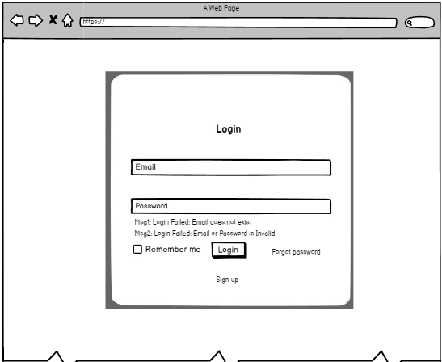

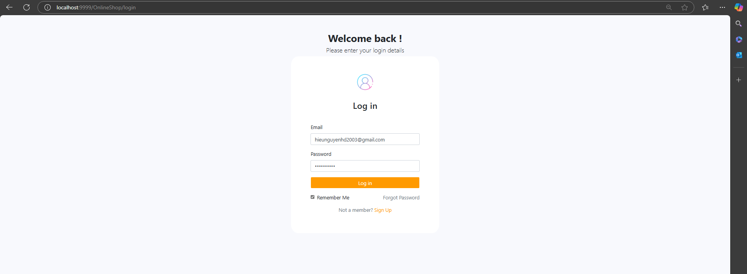

| **Field Name** | **Field Type** | **Description** |
| --- | --- | --- |
| Email* | Text Box | This is for a user to input a valid email address for logging in |
| Password* | Password Box | This is for a user to input the password for logging in |
| Login | Button | User clicks to authenticate him/herself into the system with the provided email & password |
| Forgot Password | Button | Redirect to forgot password |
| SignUp | Button | Redirect to create a new account |
| Remember me | Button | The user clicks to remember the email and password |
| Msg1 | Label | Display when email doesn’t exist in system |
| Msg2 | Label | Display when email or password incorrect |

##### Database Access

| **Table** | **CRUD** | **Description** |
| --- | --- | --- |
| Customers | R | Verify Email & Password information |
| Employees | R | Verify Email & Password information |

***SQL Commands:***

1/ Customer role: Verify Email & Password information

SELECT *

FROM customers WHERE email = ? AND password = ?

2/ Check whether mail existed in the system or not

SELECT COUNT(*) FROM customers WHERE email = ?

3/ Employee role: Verify email & password

SELECT * FROM employees WHERE email = ? AND password = ?

4/ Check whether mail existed in the system or not

SELECT COUNT(*) FROM employees WHERE email = ?

#### 2. User Register

**UI Design**

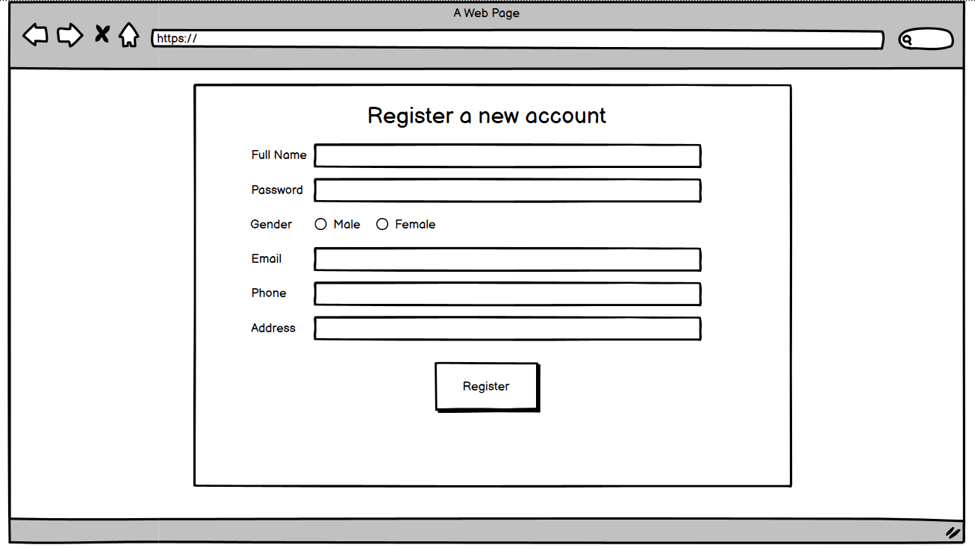

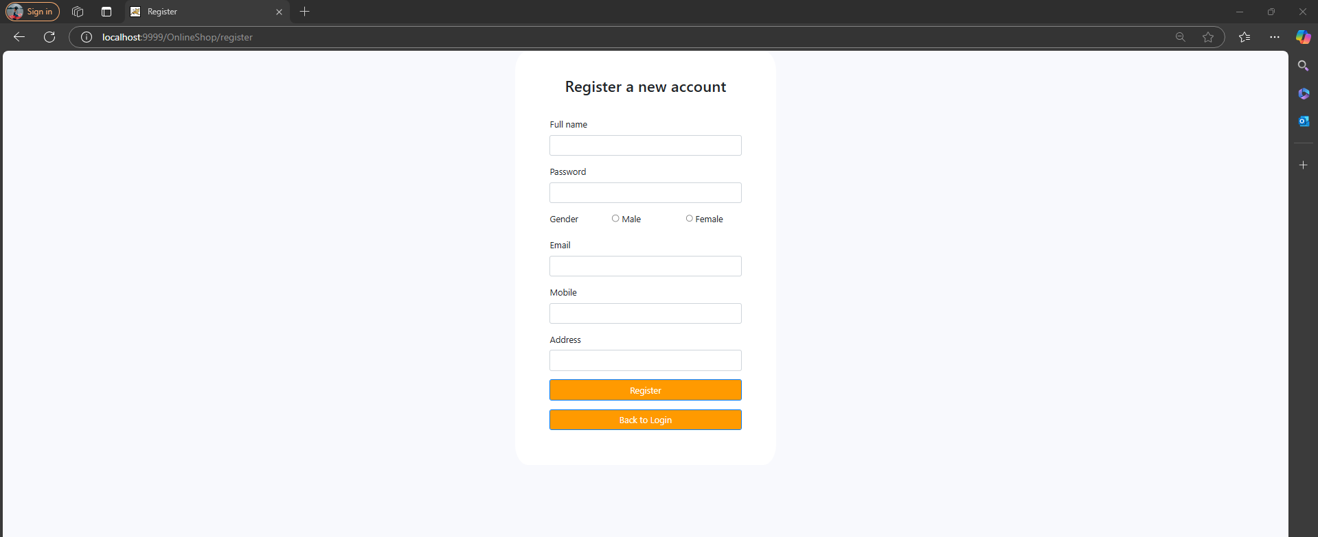

| **Field Name** | **Field Type** | **Description** |
| --- | --- | --- |
| Full Name* | Text Box | User inputs his/ her full name |
| Password* | Password Box | User setups password |
| Gender* | Radio Button | User chooses gender |
| Email* | Text Box | User inputs his/ her email for login |
| Phone* | Text Box | User inputs his/ her phone number |
| Address* | Text Box | User inputs his/ her address |

##### Database Access

| **Table** | **CRUD** | **Description** |
| --- | --- | --- |
| Customers | C | Setup a new customer account |

***SQL Commands:***

1/ Create a new customer

INSERT INTO Customers (customer_id, full_name, gender, email, phone_number, address, status, password)

VALUES (1, 'LinhNK', 1, 'linhnk@fpt.edu.com', '1234567890', '123 My Dinh', 1, ‘123’);

#### 3. Home Page

##### UI Design

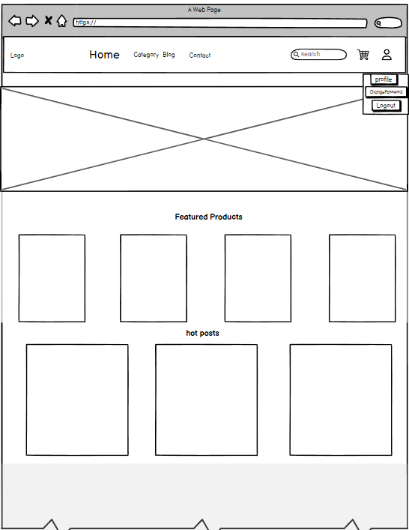

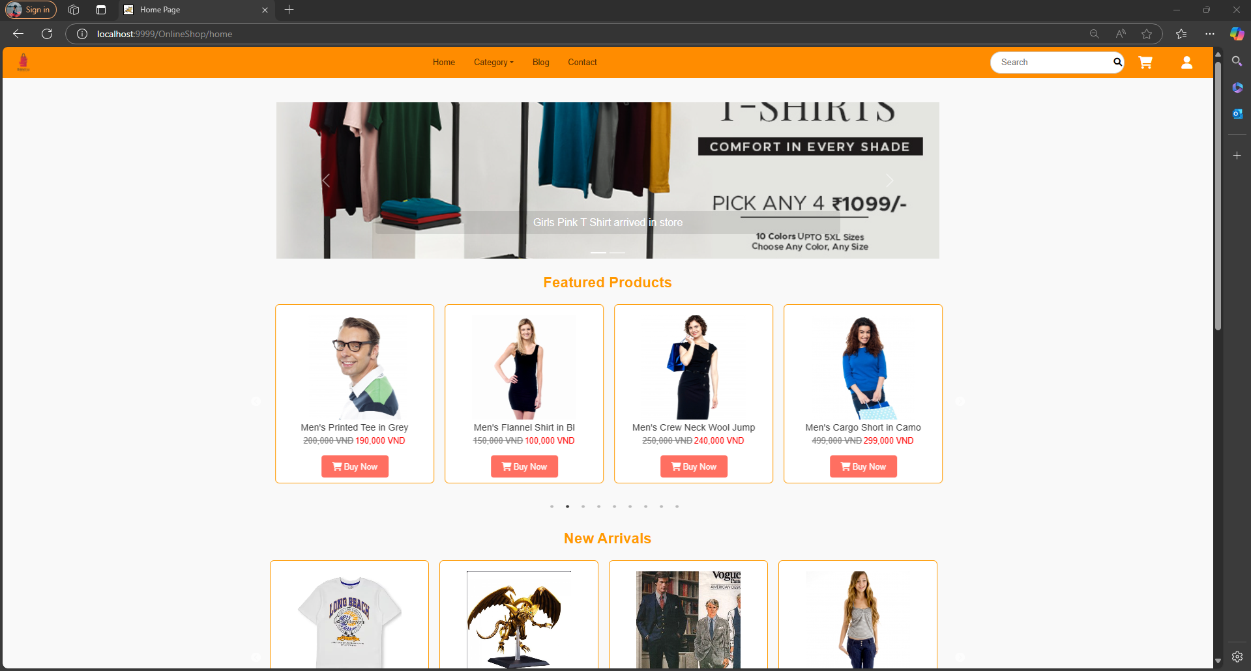

| **Field Name** | **Field Type** | **Description** |
| --- | --- | --- |
| Search | TextBox | Allow to search using the name values |
| Search | Button | Click to refresh the list with the defined filter(s) and search phrase. |
| Cart | Button | Click to open the cart page |
| User | Button | Click to open the login page |
| Profile | Button | Click to open the profile page |
| Change Password | Button | Click to change the password |
| Logout | Button | Click to logout |
| Home | Button | Click to redirect to the home page |
| Category | Button | Click to view products by category |
| Blog | Button | Click on the blog list |

##### Database Access

| **Table** | **CRUD** | **Description** |
| --- | --- | --- |
| Products | R | the list of 4 current products |
| Sliders | R | the list sliders |
| Blogs | R | the list top 3 current blogs |
| Blog_image | R | display an image of the blog |
| Category | R | display category to redirect to category-specific |

***SQL Commands:***

1/ Query the list of 4 featured products

SELECT *

FROM products

ORDER BY product_id DESC

LIMIT 4;

2/ Query the list sliders

Select * from sliders where status = true

3/ Query the list of the top 3 hot posts

SELECT *

FROM blogs

ORDER BY updateDate DESC

LIMIT 3;

4/ Query get image blog

SELECT b.blog_id, b.title, b.detail, b.updateDate, bi.image_url

FROM blogs b

LEFT JOIN blog_image bi ON b.blog_id = bi.blog_id

ORDER BY b.updateDate DESC

LIMIT 3

#### 4. Change Password

##### UI Design

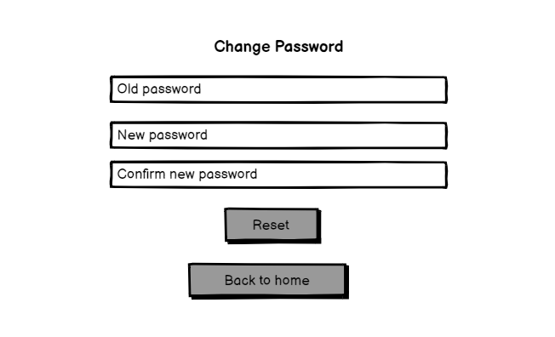

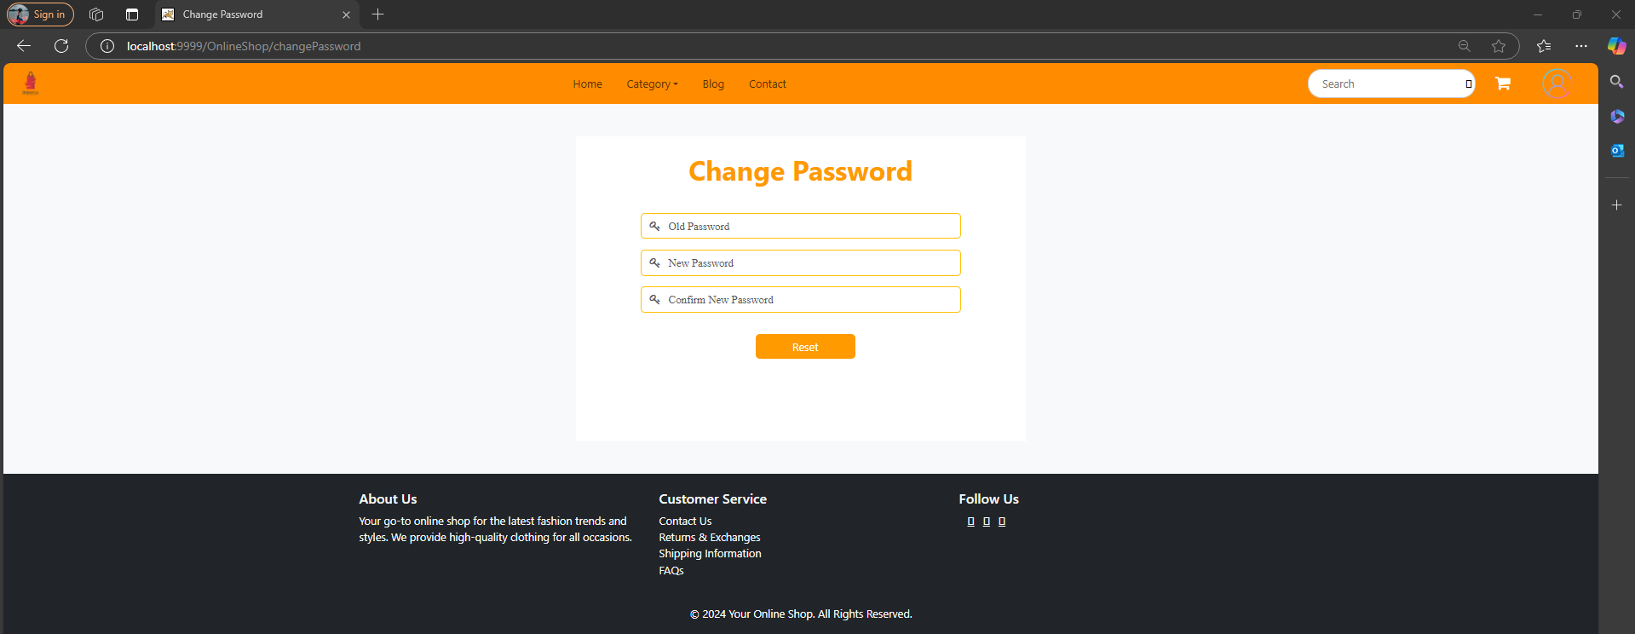

| **Field Name** | **Field Type** | **Description** |
| --- | --- | --- |
|  |  |  |
| Old password | Text Box | User input old password |
| New password | Text Box | User input new password |
|  |  |  |
| Confirm new password | Text Box | User confirm new password |
| Reset | Button | User click button to reset password |
| Back to home | Button | User click button to return to Home Page |

##### Database Access

| **Table** | **CRUD** | **Description** |
| --- | --- | --- |
| Customer | R,U | Password information |

***SQL Commands:***

1/ Verify Password information

SELECT password

FROM customer WHERE email = ?

2/Update Password

UPDATE `online_shop`.`customers` Set password = ? where email = ?

#### 5. forgot password

##### UI Design

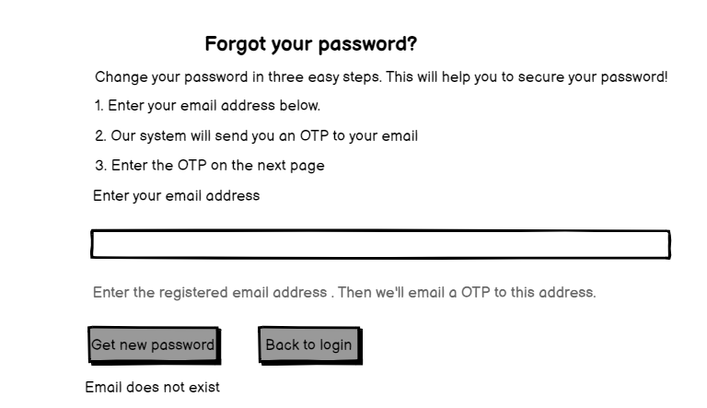

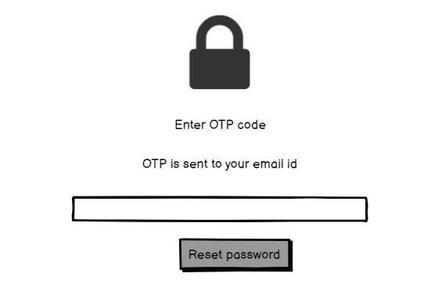

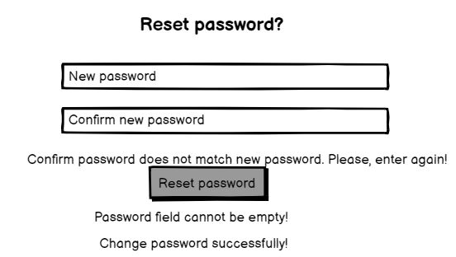

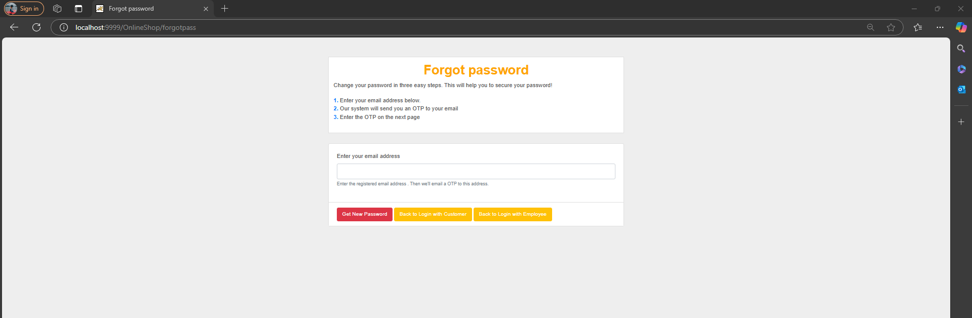

| **Field Name** | **Field Type** | **Description** |
| --- | --- | --- |
|  |  |  |
| Email | Text Box | User input email |
| OTP | Text Box | User input OTP |
| New password | Text Box | User input new password |
| Confirm new password | Text Box | User confirm new password |
| Get new pass | Button | User click button to get new pass |
| Back to login | Button | User click button to back to login |
| Reset password | Button | User click button to reset password |
|  |  |  |

##### Database Access

| **Table** | **CRUD** | **Description** |
| --- | --- | --- |
| Customer | R,U | Password information |
| Employee | R,U | Password information |

***SQL Commands:***

SELECT COUNT(*) FROM Employees where Email = ?

SELECT COUNT(*) FROM Customers where Email = ?

UPDATE Customers SET Password = ? WHERE Email = ?

UPDATE Employees SET Password = ? WHERE Email = ?

SELECT COUNT(*) FROM Employees where Email = ?

SELECT COUNT(*) FROM Customers where Email = ?

#### 6. User Profile

##### UI Design

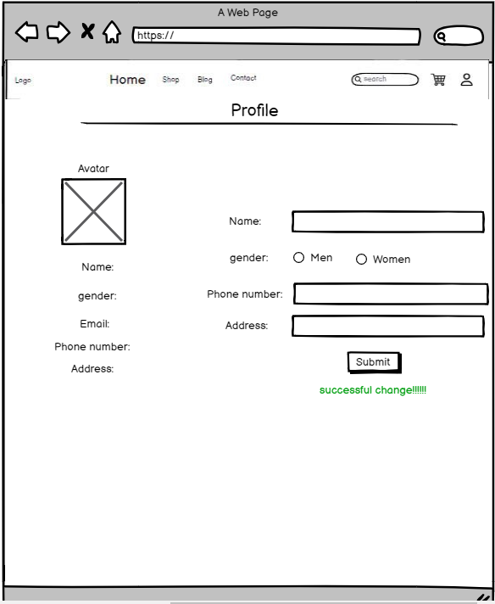

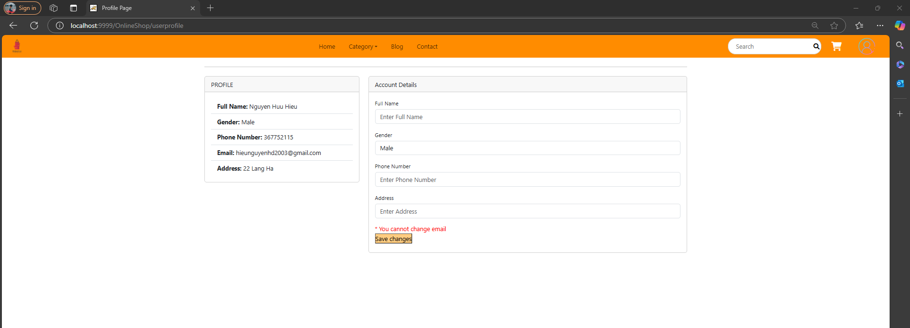

| **Field Name** | **Field Type** | **Description** |
| --- | --- | --- |
| Name | Text Box  String (45) | User input new name |
| gender | Radio Button | User input gender |
| Phone number | Text Box  String (10) | User input new phone number |
| Address | Text Box  String (45) | User input new address |
| submit | Button | The user clicks the button to save the changes. |

##### Database Access

| **Table** | **CRUD** | **Description** |
| --- | --- | --- |
| Customer | R,U | User information |

***SQL Commands:***

1/ display information

SELECT full_name, gender, email, phone_number, address

FROM customers

Where email = '?’

2/Update information

UPDATE customers

SET full_name = ?',

gender = '?',

phone_number = ?,

address = '?'

WHERE email = '?’

#### 7. Blog list

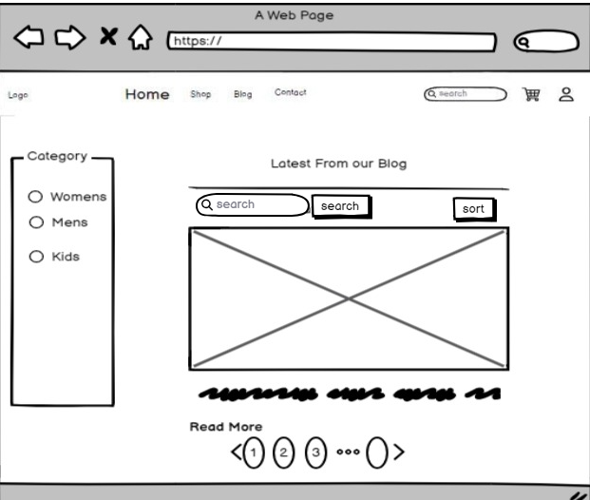

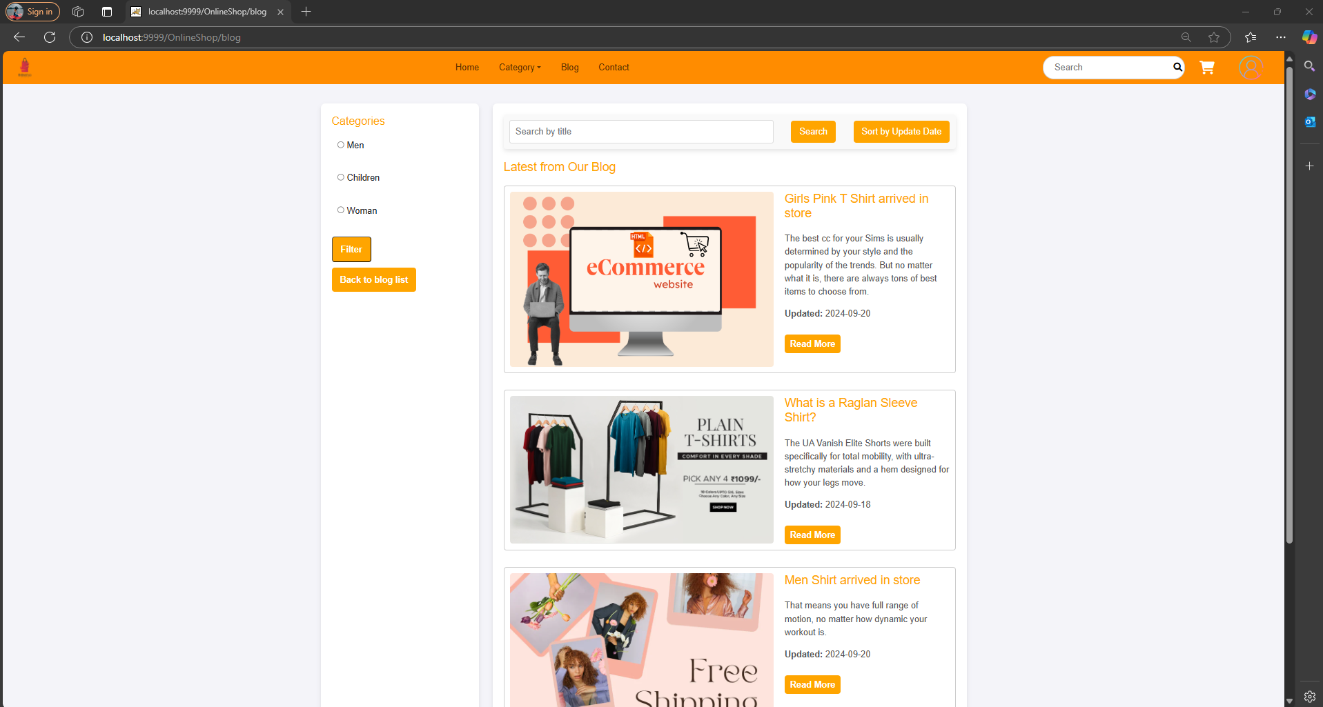

| **Field Name** | **Field Type** | **Description** |
| --- | --- | --- |
| Category | Radio Button | select category by type |
| Read More | Button | go to blog details |
| pagination | button | see more blogs |

##### Database Access

| **Table** | **CRUD** | **Description** |
| --- | --- | --- |
| blogs | R | list of recent blogs and some blog content |
| category | R | list of category |

##### SQL Commands:

1/ display some blog content

SELECT SUBSTRING(detail, 1, n) AS short_detail

FROM blog;

#### 8. Blog details

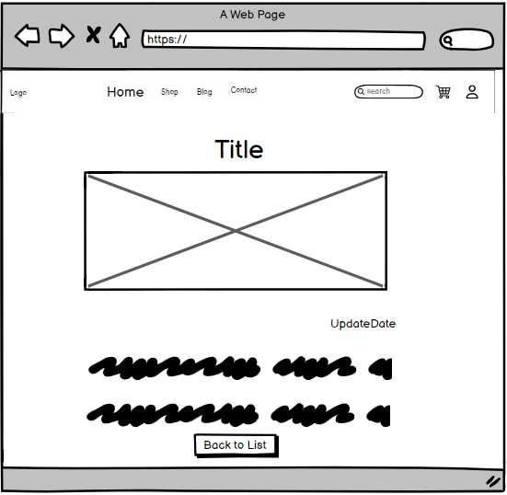

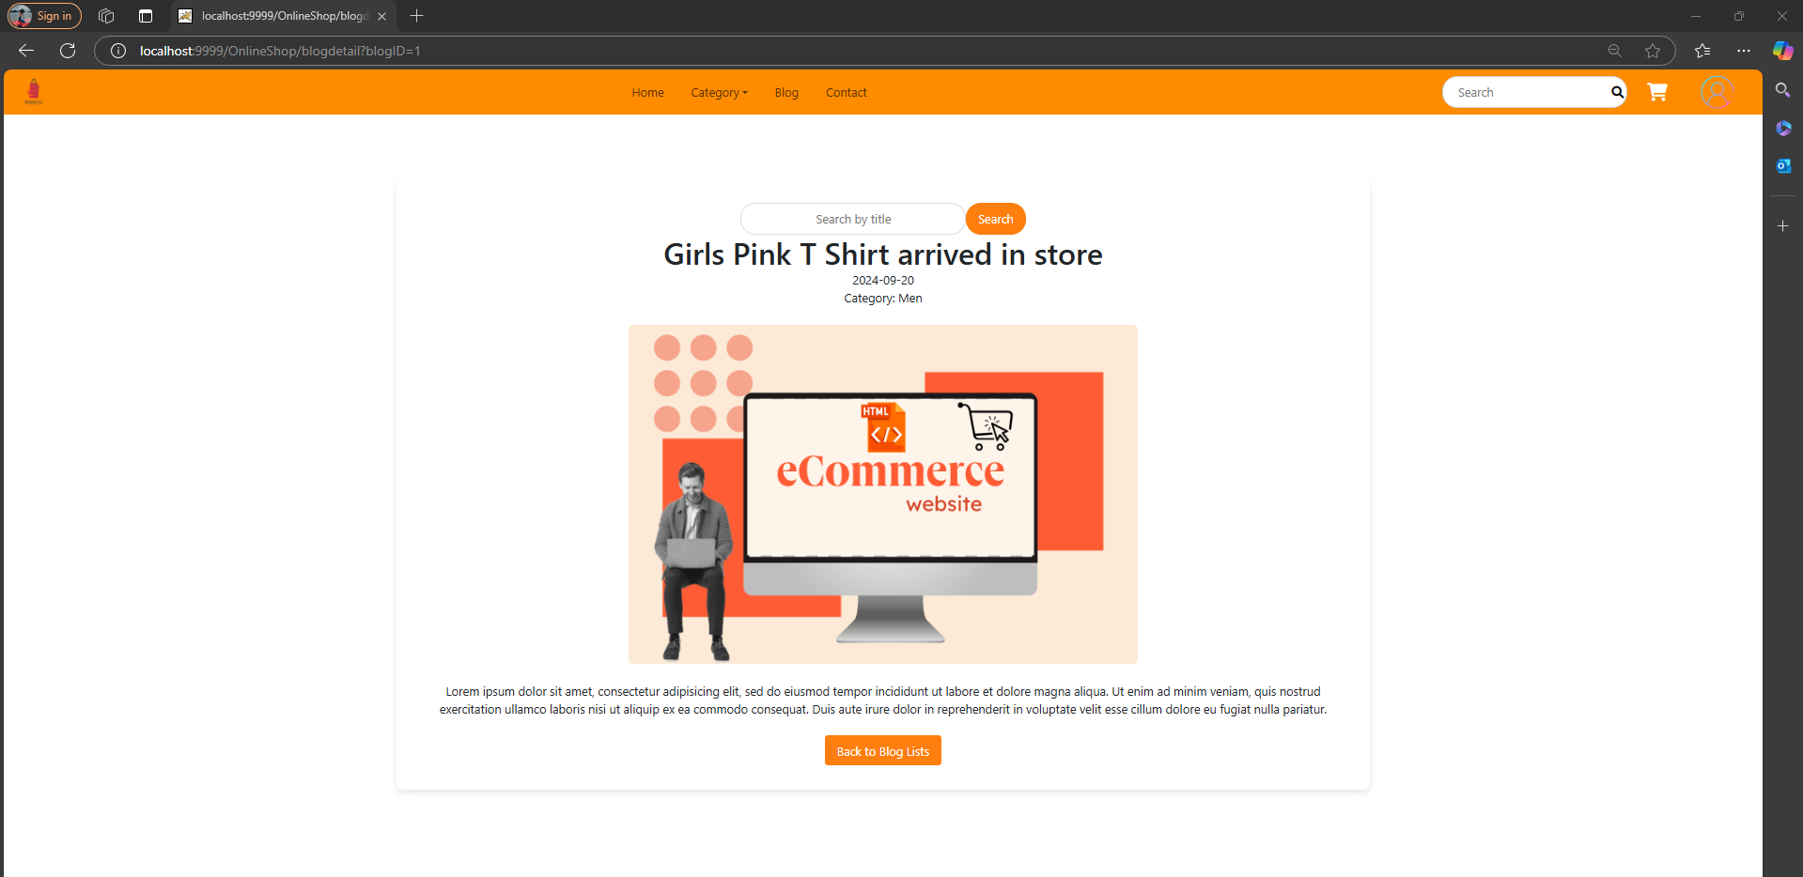

| **Field Name** | **Field Type** | **Description** |
| --- | --- | --- |
| Back to List | Button | back to list blog |

##### Database Access

| **Table** | **CRUD** | **Description** |
| --- | --- | --- |
| blogs | R | display title, updateDate, detail about blog |

##### SQL Commands:

1/ display blog

SELECT title, updateDate, detail

FROM blogs WHERE title = '?';

#### 9. Product list

**UI Design**

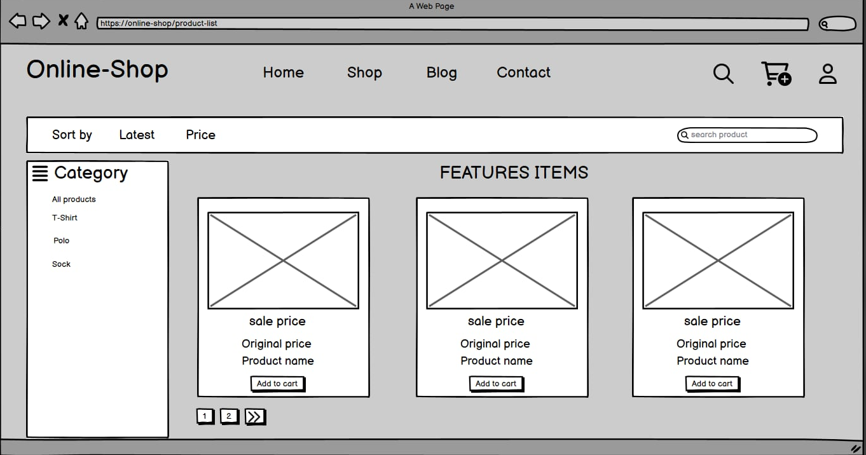

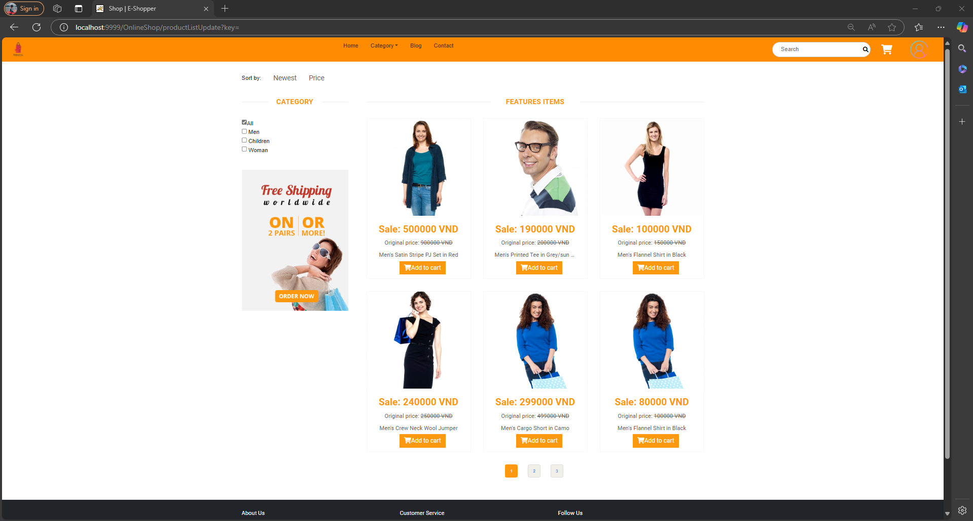

| **Field Name** | **Field Type** | **Description** |
| --- | --- | --- |
| Search product | Text Box  String (20) | User input search product name |
| Category list | List | User click item in list to see product in each category |
| Button latest | button | User click to sort product by date |
| Button Price | Button | User click to sort product by price |
| Add to cart button | Button | User click to add product to cart page |

##### Database Access

| **Table** | **CRUD** | **Description** |
| --- | --- | --- |
| products | R | products information |
| category | R | categories information |

##### Sql commands

1/ Get all products

SELECT * from online_shop.products

2/ Get all category

SELECT * FROM online_shop.category

3/Get category by id

SELECT * FROM online_shop.category where category_id='+id+'

4/Sort product by date create

SELECT * FROM online_shop.products order by create_date desc

5/ Sort product by price

SELECT * FROM online_shop.products order by sale_price

6/ Get product by key

SELECT * FROM online_shop.products where product_name like '%"+key+"%'"

7/ Get product by category id

SELECT * FROM online_shop.products where 1=1 and category_id='"+cid+"'"

8/ Get all products by array category id

SELECT * FROM online_shop.products where 1=1 and category_id in (array category_id)

#### 10. Product details

**UI Design**

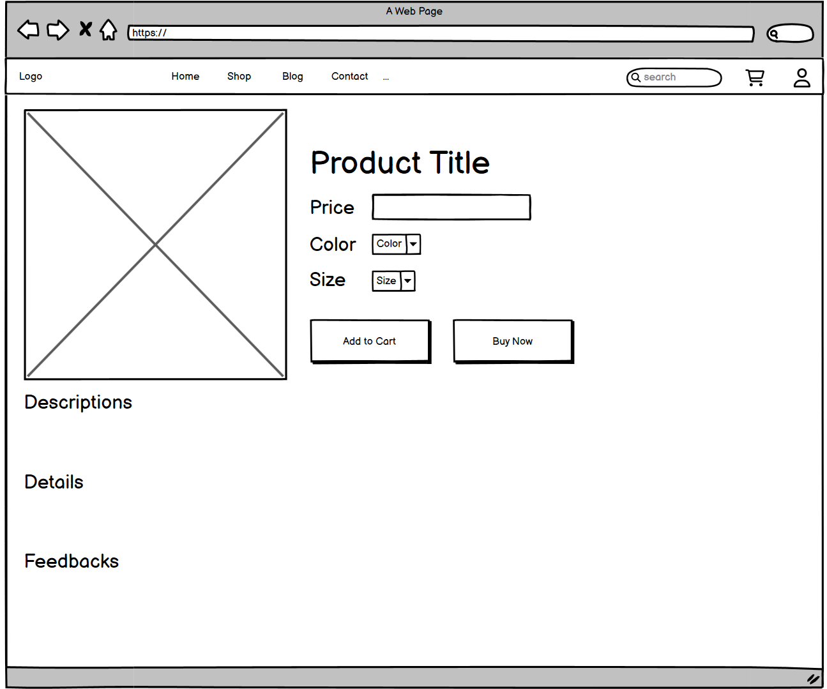

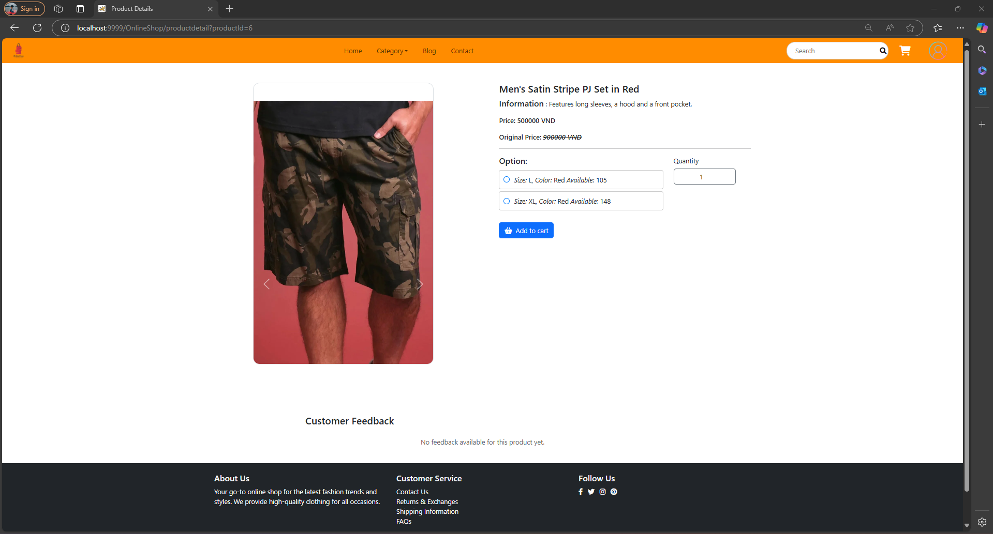

| **Field Name** | **Field Type** | **Description** |
| --- | --- | --- |
| Color | Drop Box | Include different colors of the product |
| Size | Drop Box | Include different sizes of the product |
| Add to Cart | Button | Add the product to the shopping cart |
| Buy Now | Button | Move to payment screen to buy the product |

##### Database Access

| **Table** | **CRUD** | **Description** |
| --- | --- | --- |
| Products | R | View details about a specific product |

##### Sql commands

1. Get product by Id

SELECT * FROM products WHERE product_id = 1;

#### 

#### 11. Product List (Marketer)

**UI Design**

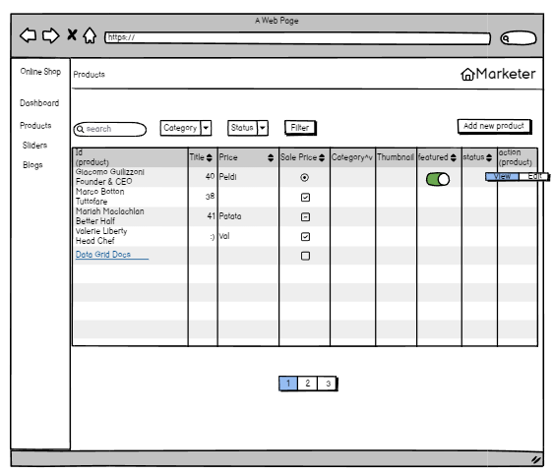

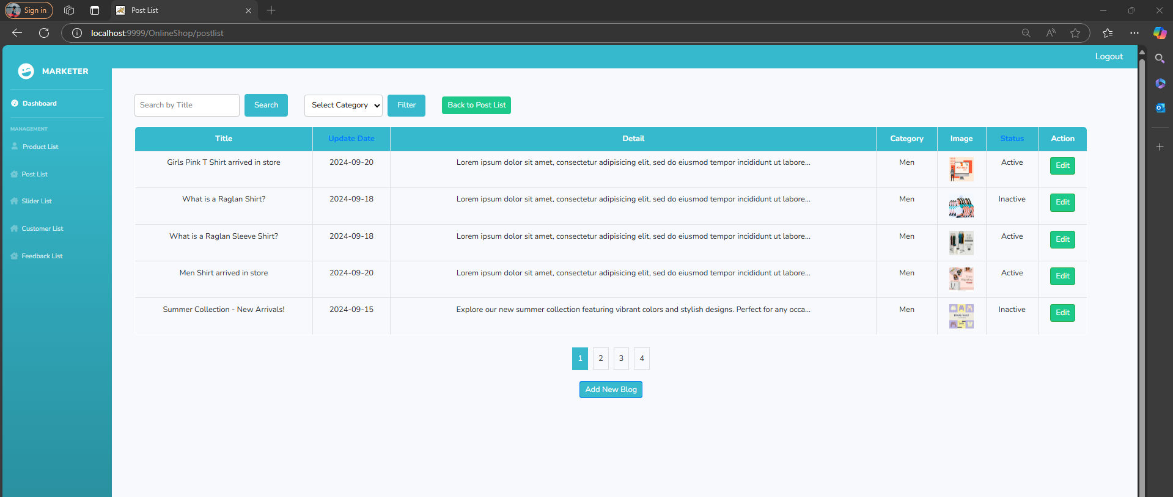

| **Field Name** | **Field Type** | **Description** |
| --- | --- | --- |
| Search | Textbox | Input value title, brief info |
| Category | ComboBox | Include different categories of the product |
| Status | ComboBox | Include different status of the product |
| Filter | Button | filter by category/status |
| Add new product | Button | Add new the product |
| View | Button | View product specific |
| Edit | Button | Edit product specific |
| Hide/Show | Button | Hide/Show product |

##### Database Access

| **Table** | **CRUD** | **Description** |
| --- | --- | --- |
| Products | R | View about a specific product |
| Category | R | View category |

##### Sql commands

1. List category

Select * from category

1. List products paging

SELECT * FROM products limit ? offset ?

1. Total Products

SELECT COUNT(*) FROM products WHERE 1=1 AND category_id = ? AND status = ? AND product_name or brief_infomation LIKE ?

1. Sort by ProductName/OriginalPrice/SalePrice/Featured/Status

SELECT * FROM products WHERE 1=1 ORDER BY ProductName/OriginalPrice/SalePrice/Featured/Status DESC LIMIT ? OFFSET ?

1. get category by categoryId

SELECT * FROM online_shop.category where category_id= ?

1. Filter

SELECT * FROM products WHERE 1=1 AND category_id = ? AND status = ? AND product_name or brief_infomation LIKE ? ORDER BY product_name ASC LIMIT ? OFFSET ?

1. Update status

UPDATE `online_shop`.`products` SET `status` = ?, WHERE `product_id` =?

1. Get total product in database

SELECT COUNT(*) FROM online_shop.products

# 

#### 12*.* P*ost List (Marketer)*

**UI Design**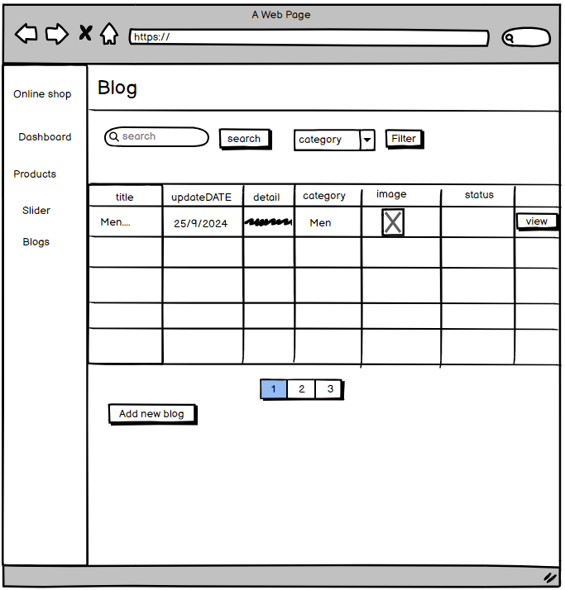

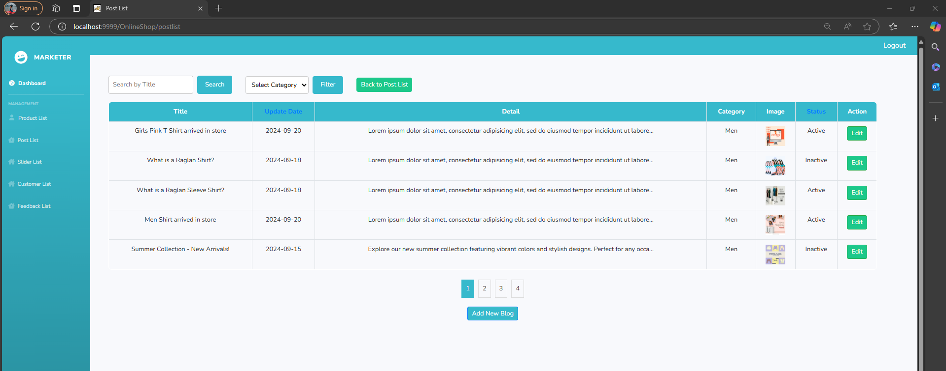

| **Field Name** | **Field Type** | **Description** |
| --- | --- | --- |
| Search | button | Input value title and search |
| Category | ComboBox | Include different categories of the blog |
| employees | ComboBox | Include different employee of the blog |
| Filter | Button | filter by category/status |
| Add new product | Button | Add new the product |
| View | Button | View and edit |

##### Database Access

| **Table** | **CRUD** | **Description** |
| --- | --- | --- |
| Blogs | CRU | View, Create, Update about a specific blog |
| Category | R | View category |
| Blog_image | CRU | View, Create, Update about a specific blog image |
| employee | R | View employee |

##### 

##### Sql commands

1. SELECT * from category
2. SELECT * from blogs

#### 13. Post detail

**UI Design**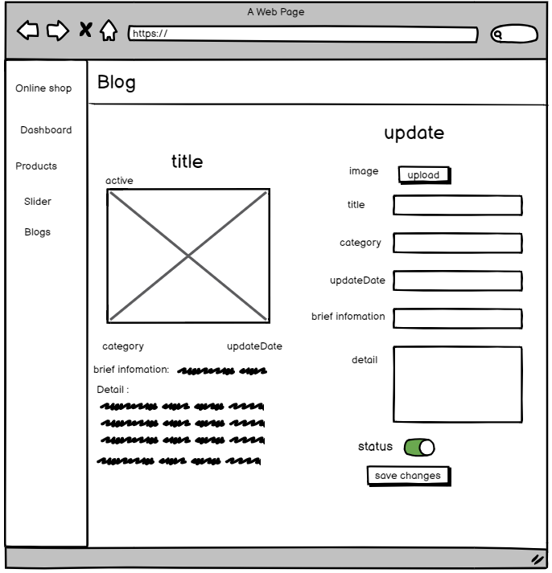

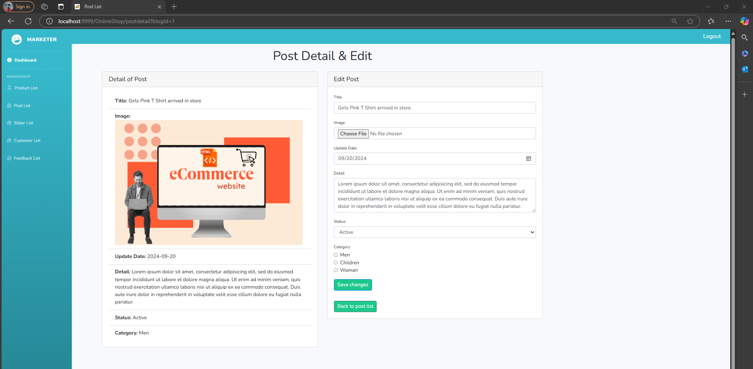

| **Field Name** | **Field Type** | **Description** |
| --- | --- | --- |
| upload | button | upload file image |
| status | select | setting status |
| save changes | button | save new content |

##### Database Access

| **Table** | **CRUD** | **Description** |
| --- | --- | --- |
| Blogs | CRU | View, Create, Update about a specific blog |
| Category | R | View category |
| Blog_image | CRU | View, Create, Update about a specific blog image |

##### 

##### Sql commands

#### 14. Sliders List

#### 

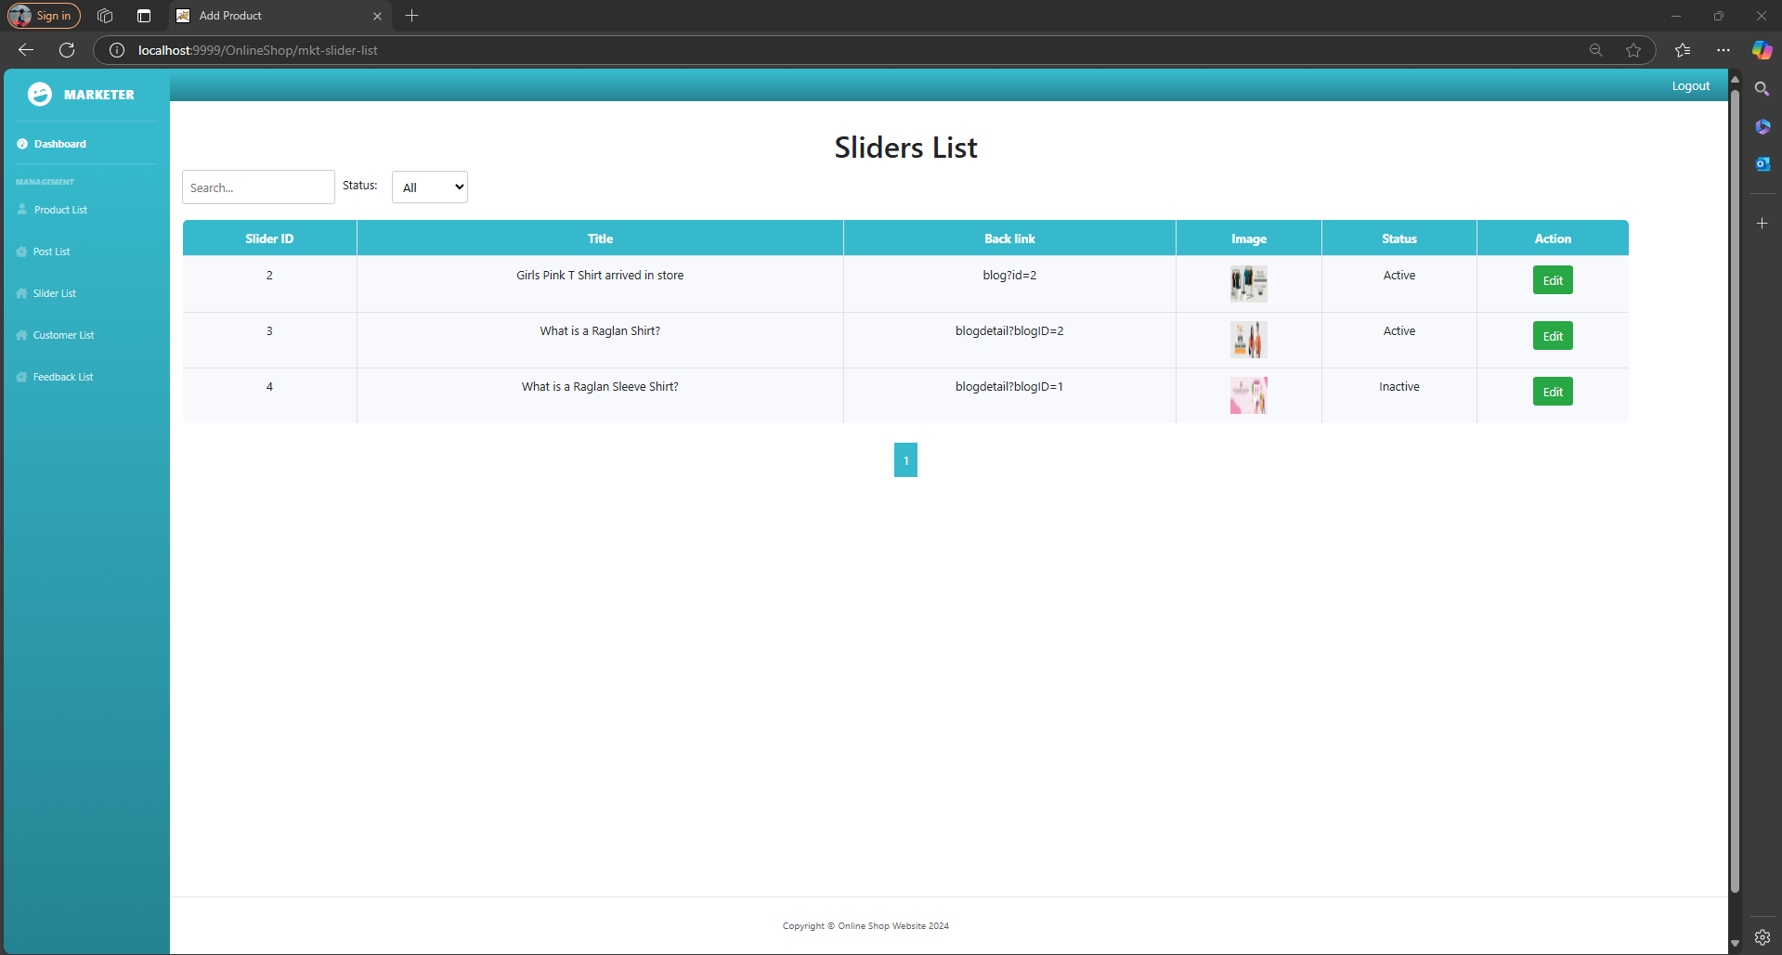

| **Field Name** | **Field Type** | **Description** |
| --- | --- | --- |
| Search | Textbox | Input value title |
| Status | ComboBox | Include different status of the slider |
| Status | ComboBox | view status of the slider |

##### Database Access

| **Table** | **CRUD** | **Description** |
| --- | --- | --- |
| Sliders | R | View slider |

##### 

##### Sql commands

1. SELECT * FROM online_shop.sliders
2. SELECT * FROM online_shop.sliders where title like '%"+key+"%' or back_link like '%"+key+"%'
3. SELECT * FROM online_shop.sliders where status=+status

#### 15.Slider detail

**UI Design**

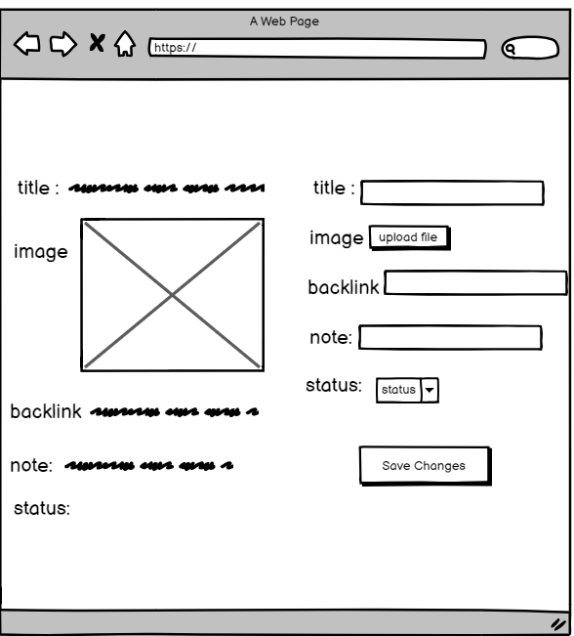

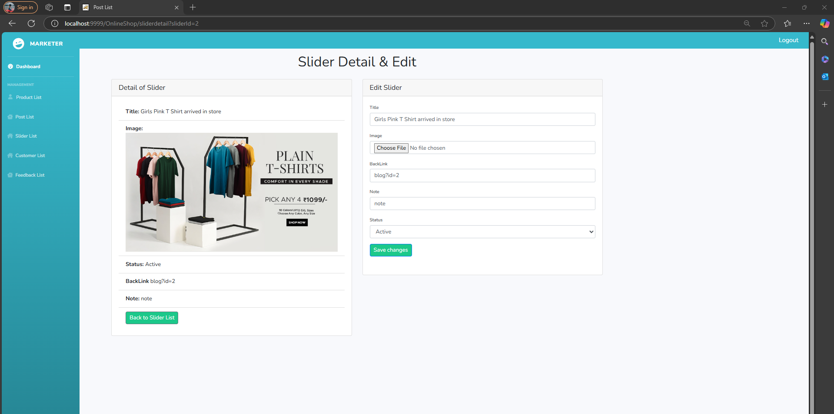

| **Field Name** | **Field Type** | **Description** |
| --- | --- | --- |
| upload | button | upload file image |
| status | switch | setting status |
| save changes | button | save new content |

##### Database Access

| **Table** | **CRUD** | **Description** |
| --- | --- | --- |
| Blogs | CRU | View, Create, Update about a specific blog |
| Category | R | View category |
| Blog_image | CRU | View, Create, Update about a specific blog image |
| employee | R | View employee |

##### 

##### Sql commands

1. SELECT * from category
2. SELECT * from blogs

#### 16. Product Detail (Marketer)

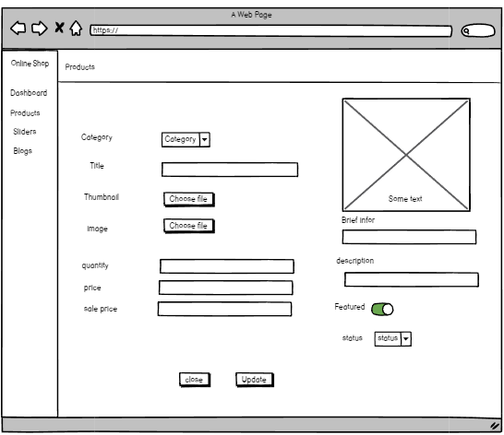

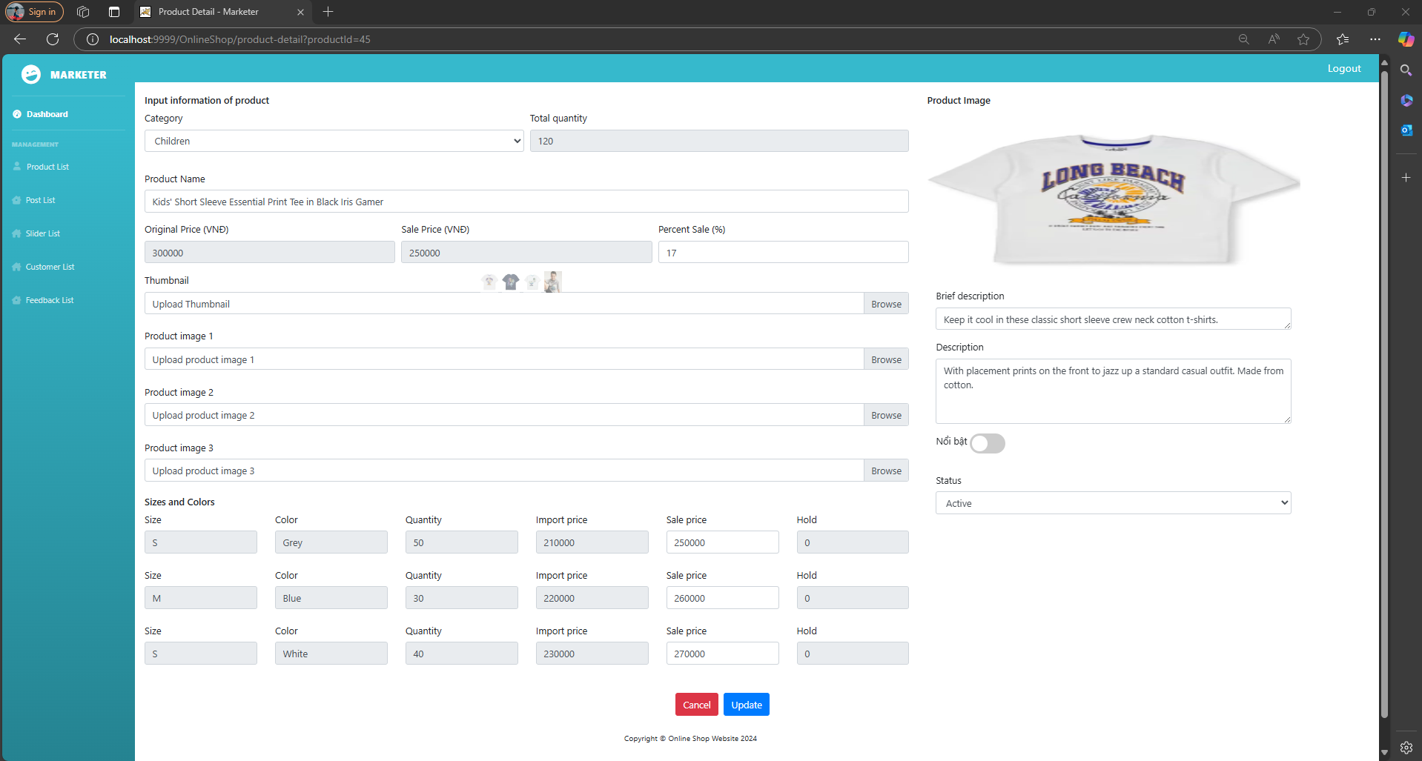

| **Field Name** | **Field Type** | **Description** |
| --- | --- | --- |
| Choose file | Button | upload file image |
| Status | ComboBox | setting status |
| Close | Button | save new content |
| Stage | Toggle | turn on/off feature |
| Category | comboBox | choose category |
| Brief Information | TextBox | input brief information |
| Description | TextBox | input desciption |
| Quantity | TextBox | input quantity |
| Price | TextBox | input price |
| Sale price | TextBox | input sale price |

##### Database Access

| **Table** | **CRUD** | **Description** |
| --- | --- | --- |
| Products | RU | View, Create, Update about a specific product |
| Category | R | View category |
| Product_image | RU | View, Create, Update about a specific product image |
| Product_size | RU | View, Create, Update about a specific product size |
| Product_color | RU | View, Create, Update about a specific product color |

##### 

##### Sql commands:

1. List category

select * from category;

1. Get product by id

select * from product by product_id = ?

1. Get product image by product_id

select * from product_image by product_id = ?

1. Get product size by product_id

select * from product_size by product_id = ?

1. Get product color by product_id

select * from product_color by product_id = ?

1. Update product by product_id

UPDATE `online_shop`.`products`

SET `product_id` = ?,`product_name` = ?,`category_id` = ?,`original_price` = ?,`sale_price` = ?,`number_left` = ?,`create_date` = ?,`image_url` = ?,`description` = ?,`status` = ? WHERE `product_id`= ?; SELECT * FROM online_shop.products;

1. Update color

UPDATE `online_shop`.`product_color`

SET `product_color_id` = ?,`product_color_name` = ?,`product_id` =? WHERE `product_color_id` = ?;

1. Update image

UPDATE `online_shop`.`product_image`

SET `product_image_id` = ?,`image_url` = ?,`product_id` = ? WHERE `product_id` = ?;

1. Update size

UPDATE `online_shop`.`product_size`

SET `product_size_id` =?, `product_size_name` = ?, `product_id` =? WHERE `product_id` = ?;

#### 17. Cart Details

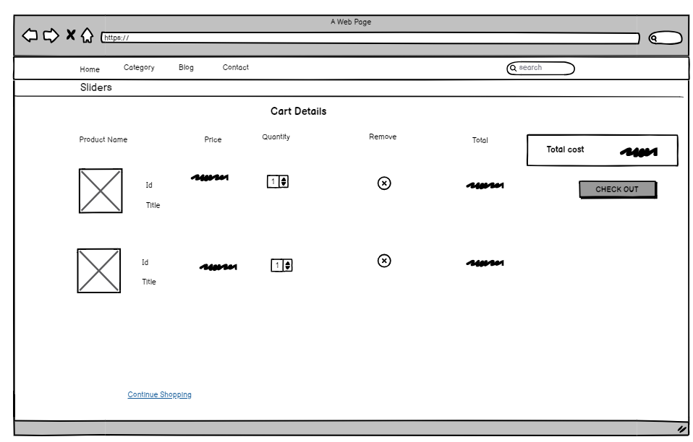

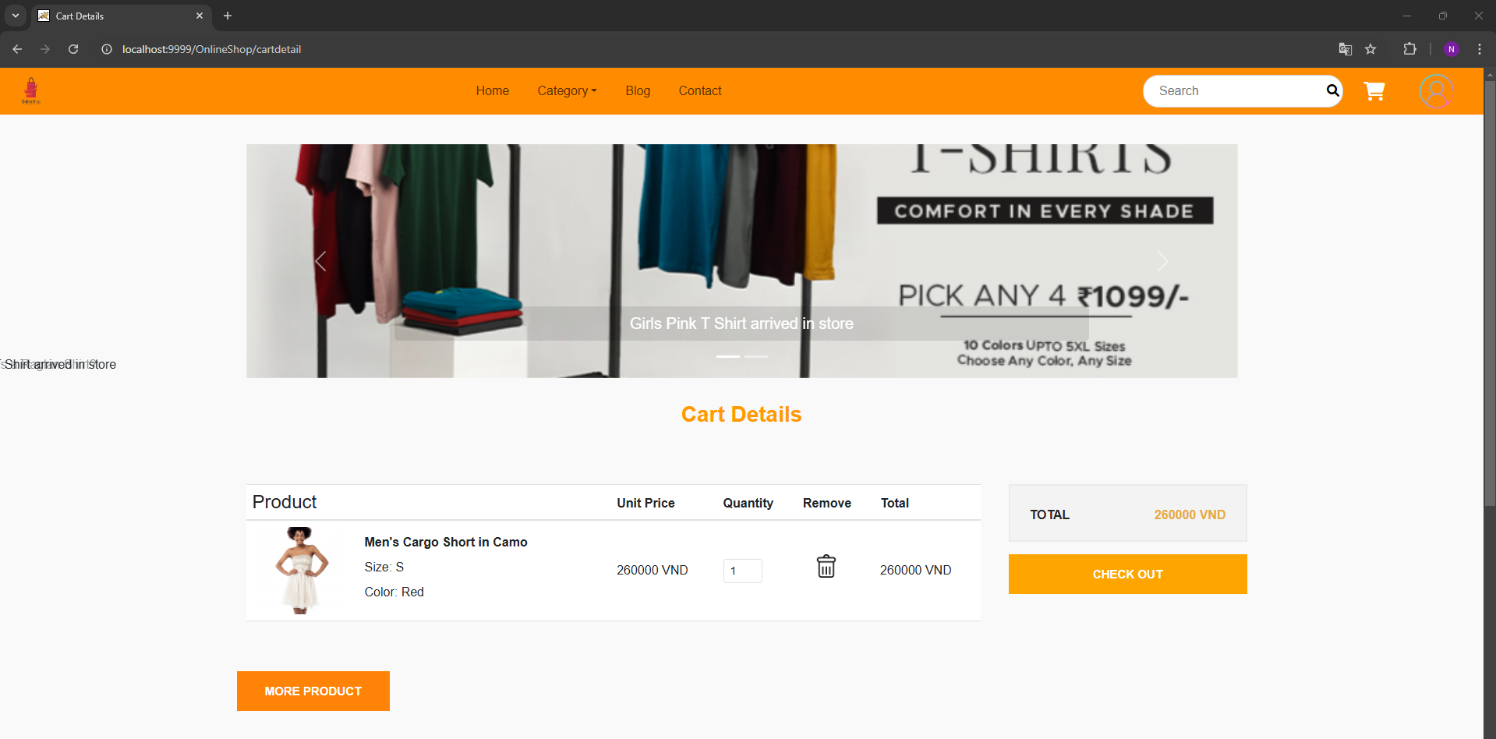

| **Field Name** | **Field Type** | **Description** |
| --- | --- | --- |
| Product Name | Text | name of product |
| Quantity | ComboBox | number of products |
| Check out | Button | redirect to Cart Contact |
| Remove | Button | delete product |
| Total | Text | total price of one product |
| Total Cost | Text | total price of all product |

##### Database Access

| **Table** | **CRUD** | **Description** |
| --- | --- | --- |
| Products | R | View about a specific product |
| Category | R | View category |
| Blogs | R | View about a specific blog |
| Blog_Image | R | View about a specific blog image |
| Sliders | R | View about a specific slider |

##### 

##### Sql commands:

1. Get product by id

SELECT * FROM products WHERE product_id = ?

1. Get all categories

SELECT category_id,name FROM online_shop.category

1. Get Blogs with image

SELECT b.blog_id, b.title, b.detail, b.updateDate, bi.image_url FROM blogs b LEFT JOIN blog_image bi ON b.blog_id = bi.blog_id ORDER BY b.updateDate DESC LIMIT 3

1. Get sliders

Select * from sliders where status = true

1. SELECT * FROM online_shop.product_size WHERE product_size_id = ?
2. SELECT category_id,name FROM online_shop.category where status = 1
3. SELECT b.blog_id, b.title, b.detail, b.updateDate, bi.image_url FROM blogs b LEFT JOIN blog_image bi ON b.blog_id = bi.blog_id ORDER BY RAND()DESC LIMIT 3
4. Select * from sliders where status = true

#### 18. Cart Contact

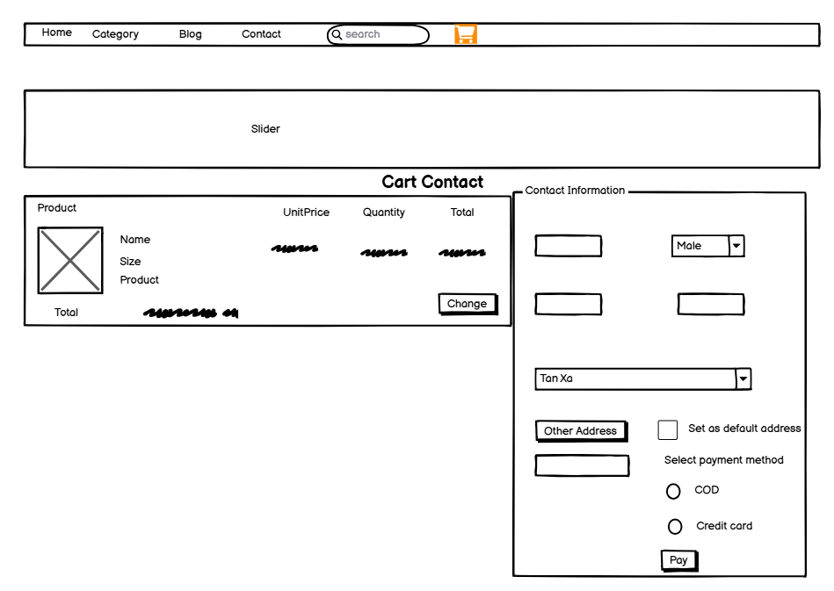

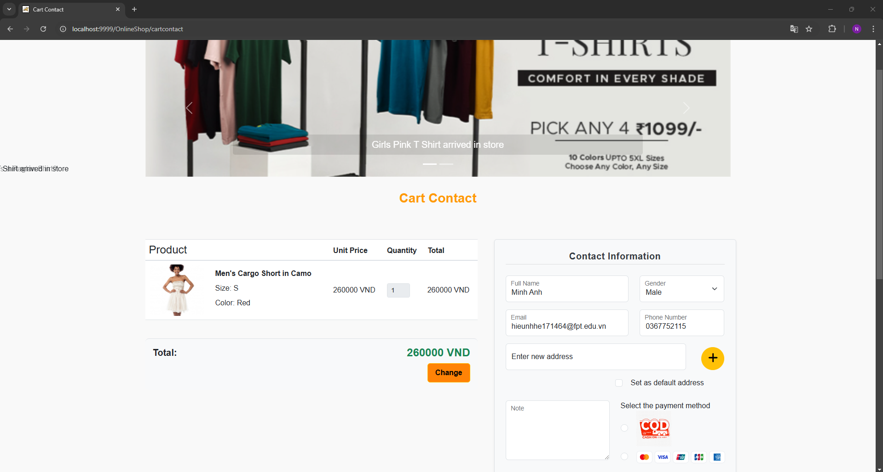

| **Field Name** | **Field Type** | **Description** |
| --- | --- | --- |
| Product Name | Text | name of product |
| Quantity | ComboBox | number of products |
| Check out | Button | redirect to Cart Contact |
| Remove | Button | delete product |
| Total | Text | total price of one product |
| Total Cost | Text | total price of all product |
| Full-name | TextBox | input full-name |
| Email | TextBox | input email |
| Gender | TextBox | input gender |
| Mobile | TextBox | input mobile |
| Note | TextBox | input note |
| Choose payment method | Combobox | choose payment method |
| Finish Order | Button | finish order |

##### Database Access

| **Table** | **CRUD** | **Description** |
| --- | --- | --- |
| Products | R | View about a specific product |
| Category | R | View category |
| Blogs | R | View about a specific blog |
| Sliders | R | View about a specific slider |
| Orders | C | Create order |
| Order_detail | C | Create order detail |

##### 

##### Sql commands:

1. Get product by id

SELECT * FROM products WHERE product_id = ?

1. Get all categories

SELECT category_id,name FROM online_shop.category

1. Get Blogs with image

SELECT b.blog_id, b.title, b.detail, b.updateDate, bi.image_url FROM blogs b LEFT JOIN blog_image bi ON b.blog_id = bi.blog_id ORDER BY b.updateDate DESC LIMIT 3

1. Get sliders

Select * from sliders where status = true

1. Add order

INSERT INTO orders (order_date, total_cost, status, customer_id, address, phone_number) VALUES (?, ?, ?, ?, ?, ?)

1. Add order detail

INSERT INTO order_detail (order_id, product_id, quantity) VALUES(?, ?, ?)

1. SELECT * FROM online_shop.address WHERE cus_id = ?
2. SELECT * FROM online_shop.address WHERE id = ?
3. SELECT * FROM online_shop.orders where order_id =" + orderID
4. SELECT * FROM online_shop.product_size WHERE product_size_id = ?
5. SELECT category_id,name FROM online_shop.category where status = 1
6. SELECT b.blog_id, b.title, b.detail, b.updateDate, bi.image_url " "FROM blogs b " "LEFT JOIN blog_image bi ON b.blog_id = bi.blog_id " "ORDER BY RAND()DESC LIMIT 3
7. Select * from sliders where status = true

#### 19. My Orders

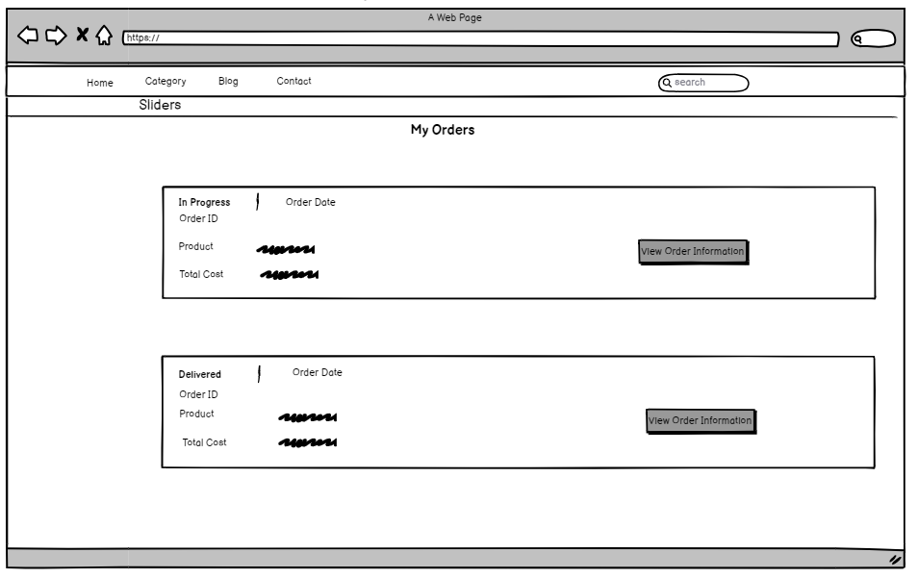

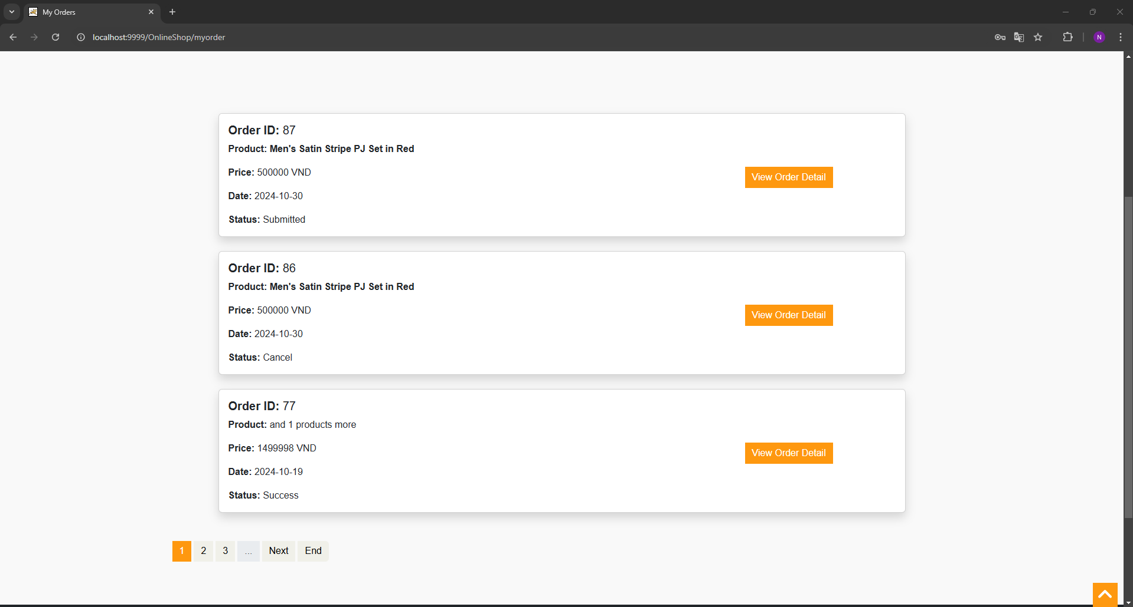

| **Field Name** | **Field Type** | **Description** |
| --- | --- | --- |
| Order Date | text | show order date |
| Status | text | order status |
| Oder ID | text | show order id |
| Product | text | show product name |
| Total Cost | text | show total cost of order |
| View Order Information | button | view order information detail |

##### Database Access

| **Table** | **CRUD** | **Description** |
| --- | --- | --- |
| Products | R | View about a specific product |
| Category | R | View category |
| Blog_Image | R | View about a specific blog image |
| Blogs | R | View about a specific blog |
| Sliders | R | View about a specific slider |
| Orders | R | View about some specific orders |
| Order_detail | R | View about some specific order details |

##### 

##### Sql commands:

1. Get product by id

SELECT * FROM products WHERE product_id = ?

1. Get all categories

SELECT category_id,name FROM online_shop.category

1. Get Blogs with image

SELECT b.blog_id, b.title, b.detail, b.updateDate, bi.image_url FROM blogs b LEFT JOIN blog_image bi ON b.blog_id = bi.blog_id ORDER BY b.updateDate DESC LIMIT 3

1. Get sliders

Select * from sliders where status = true

1. Get first product by order id

SELECT * FROM online_shop.order_detail WHERE order_id = ? LIMIT 1

1. Get number product by order

SELECT COUNT(*) FROM online_shop.order_detail WHERE order_id = ?

1. SELECT * FROM online_shop.orders WHERE customer_id = ? ORDER BY order_date desc
2. SELECT * FROM online_shop.order_detail WHERE order_id = ? LIMIT 1;

#### 20. Add Product (Marketer)

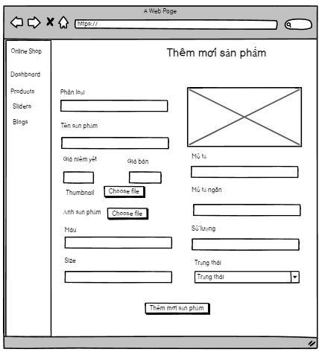

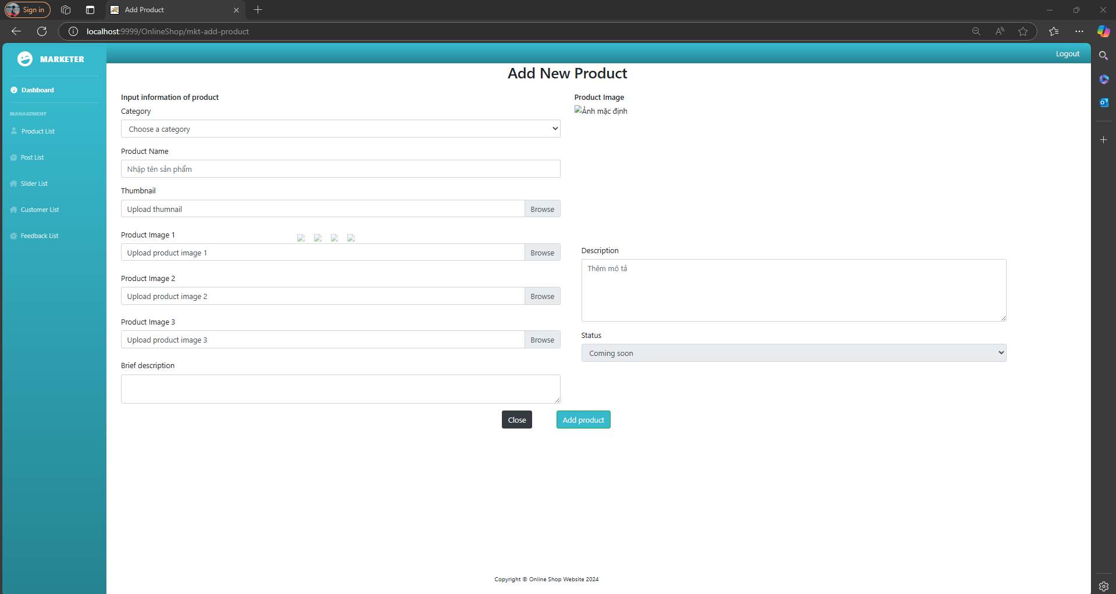

| **Field Name** | **Field Type** | **Description** |
| --- | --- | --- |
| Choose file | Button | upload file image |
| Trạng thái | ComboBox | setting status |
| Thêm mới sản phẩm | Button | create new product |
| Kích cỡ | Textox | input size product |
| Phân loại | comboBox | choose category |
| Mô tả ngắn | TextBox | input brief information |
| Mô tả | TextBox | input desciption |
| Số lượng | TextBox | input quantity |
| Giá niêm yết | TextBox | input price |
| Giá bán | TextBox | input sale price |

##### Database Access

| **Table** | **CRUD** | **Description** |
| --- | --- | --- |
| Products | C | Create about a specific product |
| Category | R | View category |
| Product_image | C | Create about a specific product image |
| Product_size | C | Create about a specific product size |
| Product_color | C | Create about a specific product color |

SQL commands:

1. Insert product

INSERT INTO `online_shop`.`products`

(`product_id`,`product_name`,`category_id`,`original_price`,`sale_price`,`number_left`,`create_date`,`image_url`,`description`,`status`) VALUES(?,?,?,?,?,?,?,?,?,?);

1. Insert product image

INSERT INTO `online_shop`.`product_image` (`product_image_id`,`image_url`,`product_id`)VALUES (?,?,?);

1. Insert product color

INSERT INTO `online_shop`.`product_color`

(`product_color_id`,`product_color_name`,`product_id`) VALUES (?,?,?);

SELECT * FROM online_shop.product_color;

1. Insert product size

INSERT INTO `online_shop`.`product_size`

(`product_size_id`,`product_size_name`,`product_id`) VALUES (?,?,?);

1. select category

select * from category;

1. total product

SELECT COUNT(*) FROM products WHERE 1=1

1. newest product

SELECT MAX(product_id) FROM products;

#### 21. Order Infomation

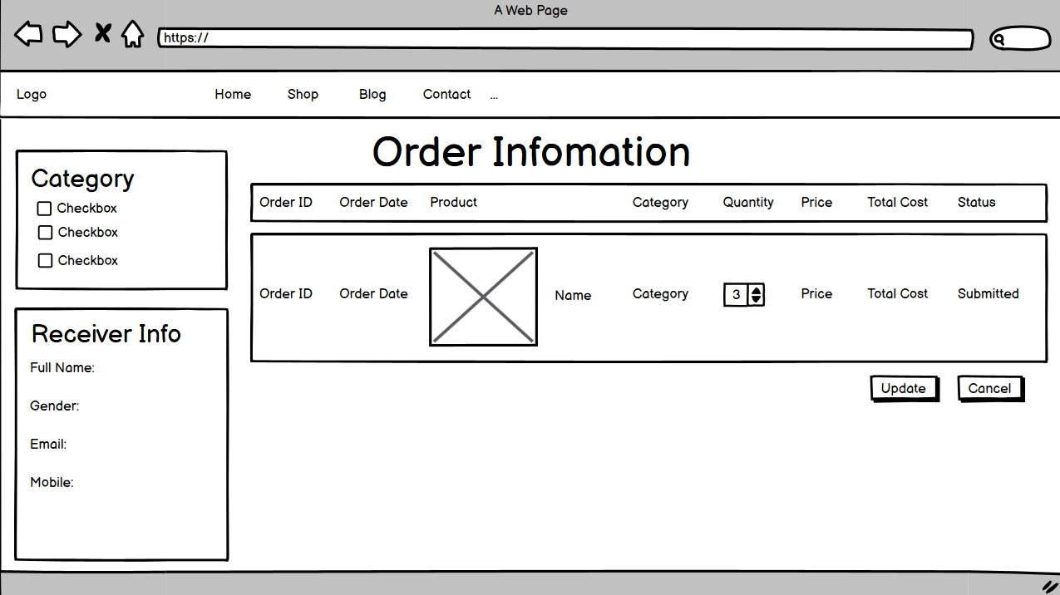

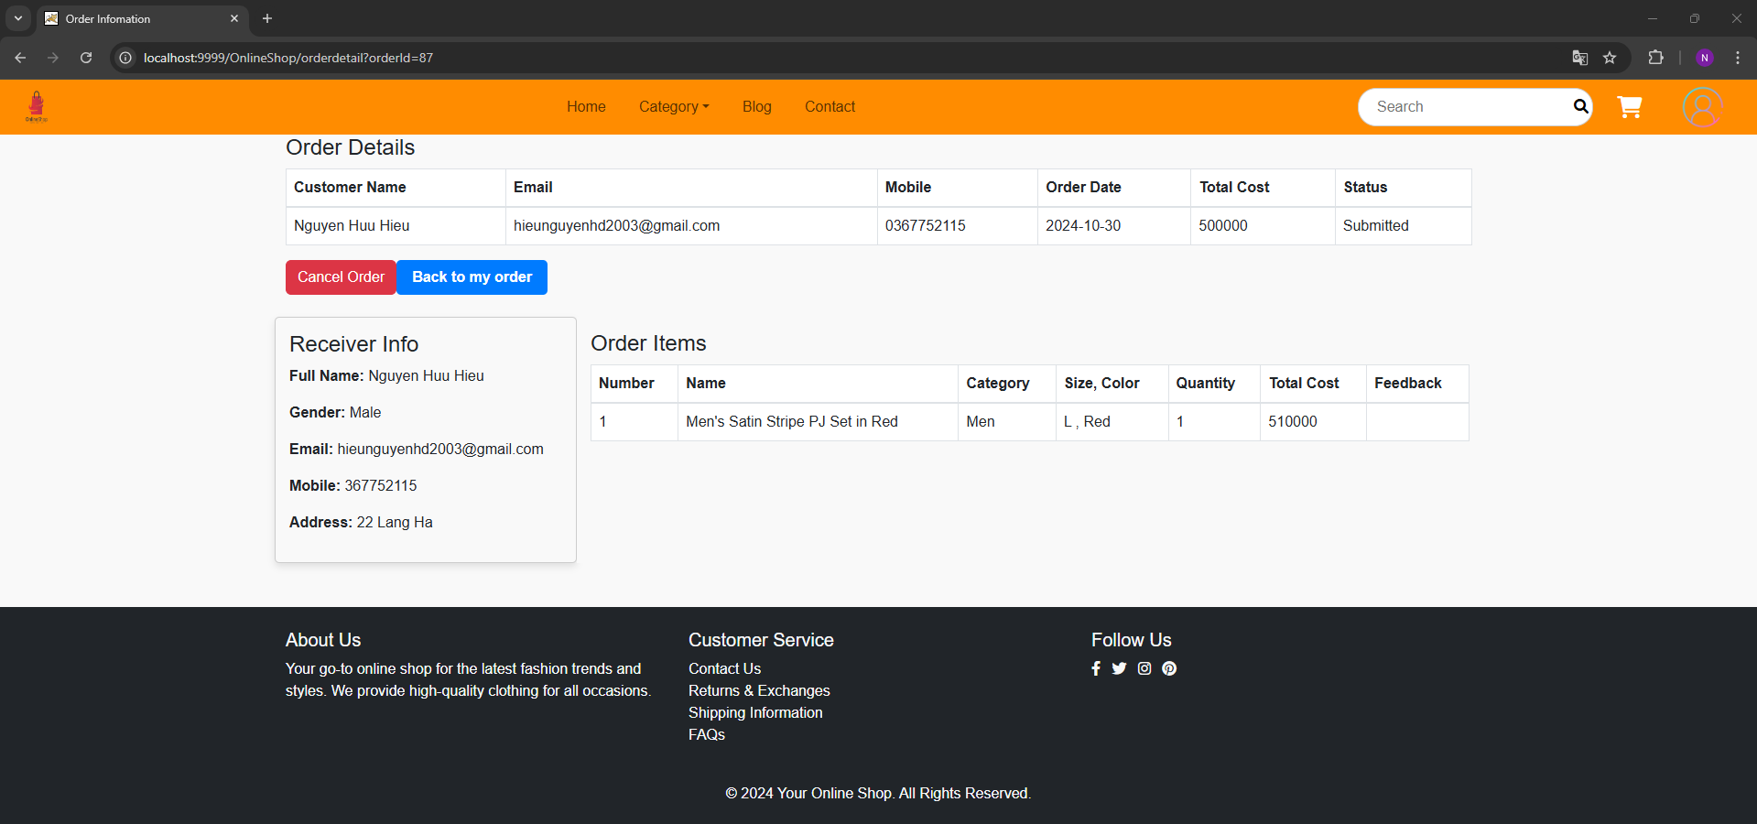

| **Field Name** | **Field Type** | **Description** |
| --- | --- | --- |
| Category | Checkbox | Choose category |
| Receiver Info | Container | Hold receiver information |
| Update | Button | Update order details |
| Cancel | Button | Remove order |

##### Database Access

| **Table** | **CRUD** | **Description** |
| --- | --- | --- |
|  |  |  |
|  |  |  |
|  |  |  |
|  |  |  |
|  |  |  |

#### 22. Cart completion

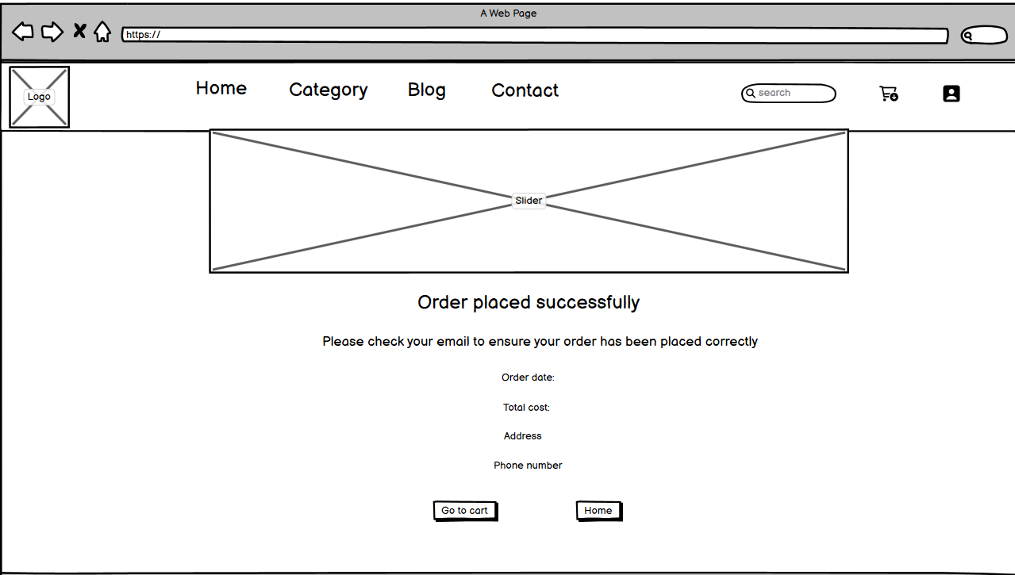

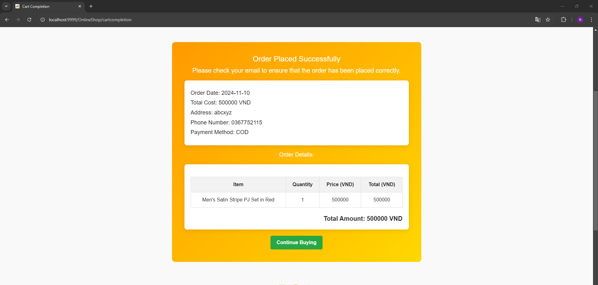

| **Field Name** | **Field Type** | **Description** |
| --- | --- | --- |
| Category | dropdown | Choose category |
| Go to cart | Container | Hold receiver information |
| Home | Button | Update order details |

##### 

##### Database Access

| **Table** | **CRUD** | **Description** |
| --- | --- | --- |
| Order | RU | Read and update order |
| Employee | R | Read all employee |
| Order_detail | R | Read order detail |
| Category | R | Read category |
| Product | RU | Read and update product |
| Role | R | Read roles |
| Payment history | C | Create new payment history |
| Customer | R | Read customer |

##### Sql commands:

1. UPDATE `online_shop`.`orders` SET `status` = 1, `employee_id` = " + employeeID + " WHERE `order_id` = " + orderID
2. SELECT * FROM online_shop.employees where role_id="+roleid
3. SELECT * FROM online_shop.orders where employee_id=" + employeeId
4. SELECT * FROM online_shop.order_detail where order_id =" + orderID
5. SELECT * FROM online_shop.category where category_id='" + id + "'"
6. SELECT * FROM online_shop.products where product_id=" + productID
7. UPDATE `online_shop`.`products` SET `number_left` =" + quantityUpdate + " WHERE `product_id` = " + productID
8. SELECT * FROM online_shop.orders where order_id =" + orderID
9. SELECT * FROM online_shop.customers where customer_id=" + customerID
10. SELECT * FROM online_shop.roles where role_name='Sale'
11. INSERT INTO `payment_history` (payment_date, payment_method, order_id, customer_id)" "VALUES (?, ?, ?, ?)

#### 23. Payment

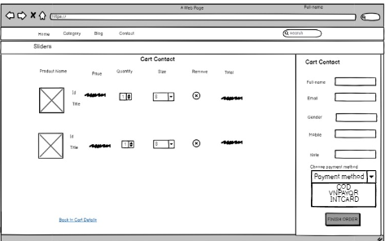

| **Field Name** | **Field Type** | **Description** |
| --- | --- | --- |
| Payment method | dropdown | Choose method to payment: COD/VNPAYQR/INTCARD |

##### Database Access

| **Table** | **CRUD** | **Description** |
| --- | --- | --- |
| Payment History | C | Add new payment history |

##### Sql commands:

1. Insert payment history customer

INSERT INTO `payment_history` (payment_date, payment_method, order_id, customer_id)"

+ " VALUES (?, ?, ?, ?)

#### *24. FeedBack* List

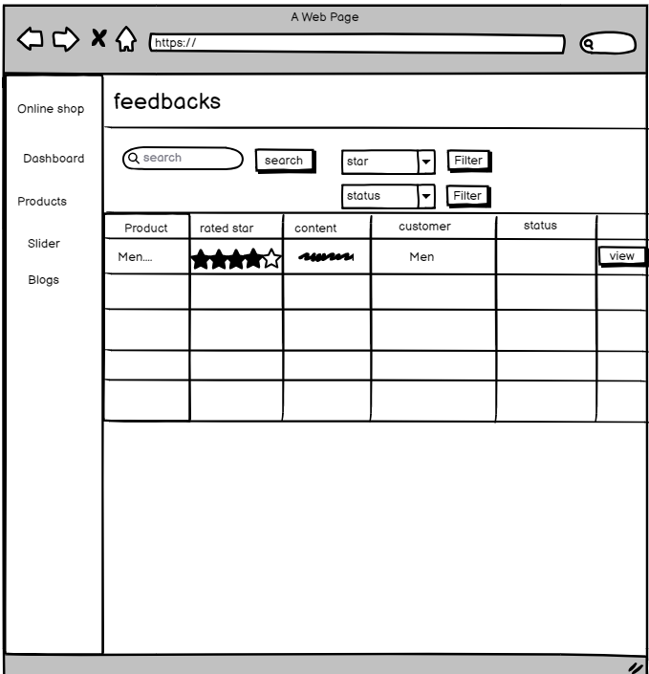

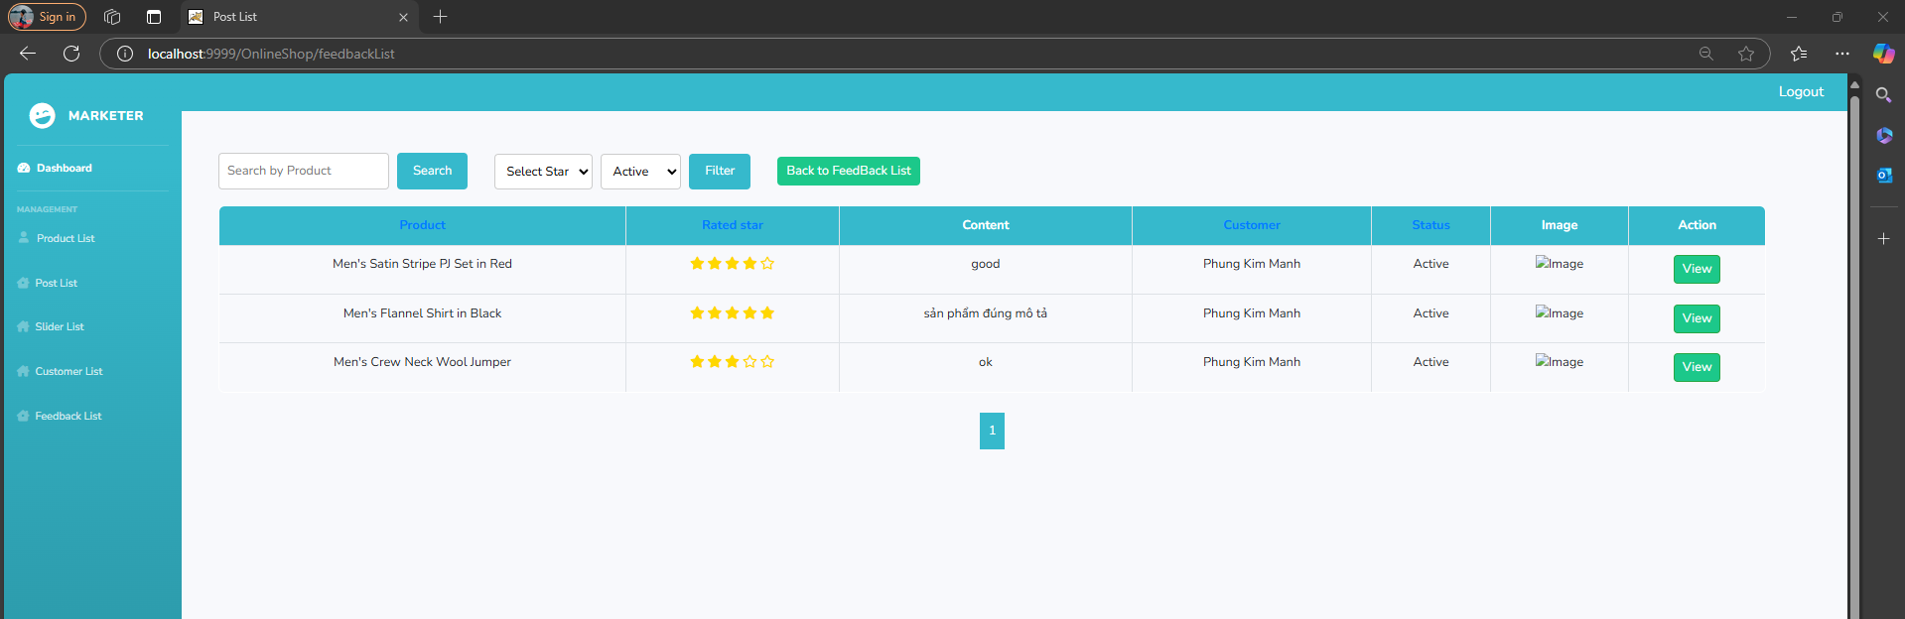

| **Field Name** | **Field Type** | **Description** |
| --- | --- | --- |
| search | button | input product name and search |
| star | select | filter feedback by rated star |
| status | select | filter feedback by status |
| view | button | show feedback detail |

##### Database Access

| **Table** | **CRUD** | **Description** |
| --- | --- | --- |
| search, status, star | R | filter feedback by status, star, product name |

##### Sql commands:

1. Insert payment history customer

INSERT INTO `payment_history` (payment_date, payment_method, order_id, customer_id)"

+ " VALUES (?, ?, ?, ?)

#### 25. Marketing Dashboard

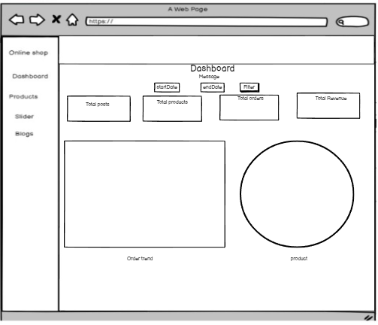

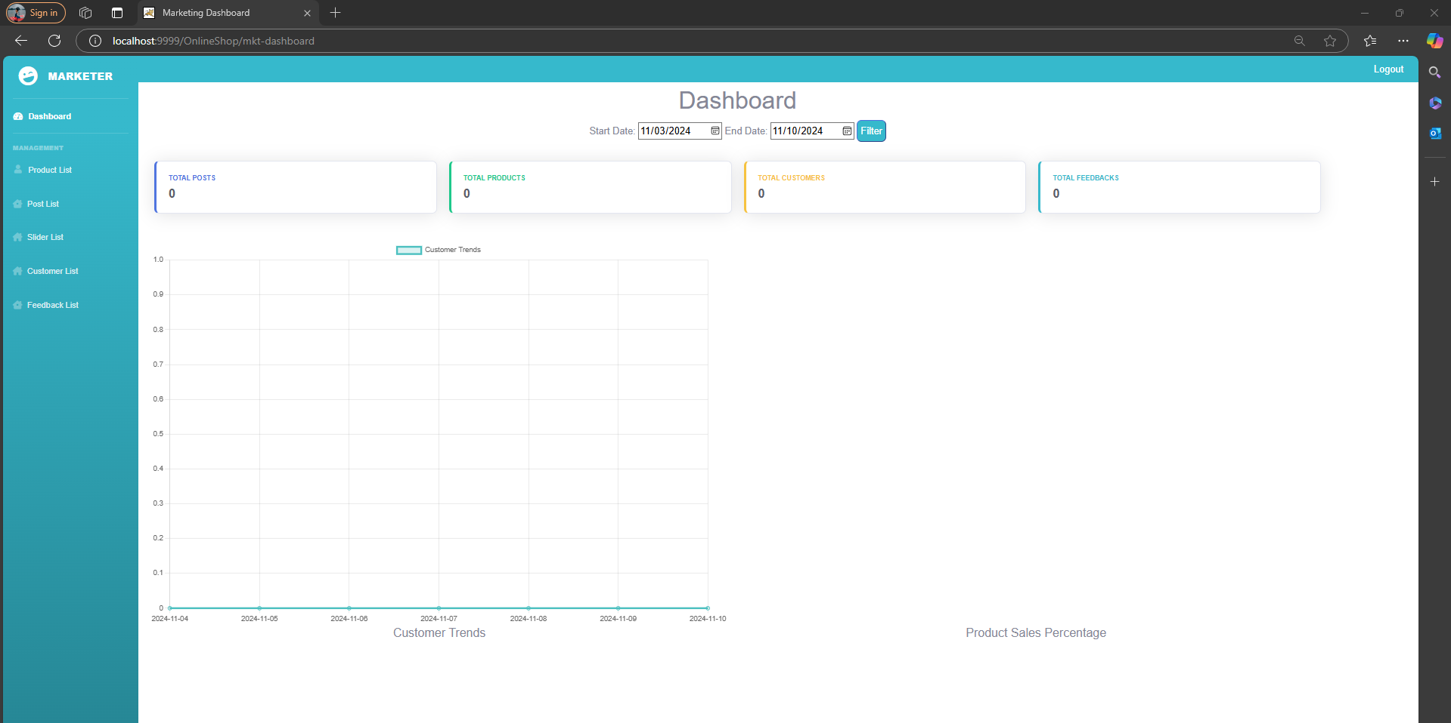

| **Field Name** | **Field Type** | **Description** |
| --- | --- | --- |
| StartDate | Date | Choose start date |
| EndDate | Date | Choose end date |
| Filter | Button | Filter by start, end date |
| Message | Text | Message display exception |

##### Database Access

| **Table** | **CRUD** | **Description** |
| --- | --- | --- |
| Blog | R | Read blog |
| Product | R | read product |
| Order | R | read order |

##### Sql commands:

1. Count blog:

SELECT (SELECT COUNT(*) FROM blogs) AS post_count

1. count order:  
   SELECT DATE(order_date) AS order_date, COUNT(*) AS order_count
2. count product:  
   SELECT COUNT(*) AS product_count FROM products
3. select order by date:  
   SELECT DATE(order_date) AS order_date, COUNT(*) AS order_count FROM orders WHERE order_date BETWEEN ? AND ? GROUP BY DATE(order_date) ORDER BY DATE(order_date)
4. select product sale:  
   SELECT p.product_name, SUM(od.quantity) AS total_sold FROM Order_detail od JOIN Orders o ON od.order_id = o.order_id JOIN Products p ON od.product_id = p.product_id WHERE o.order_date >= ? AND o.order_date <= ? GROUP BY p.product_name

#### 26. Customers List

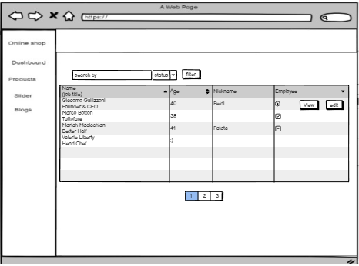

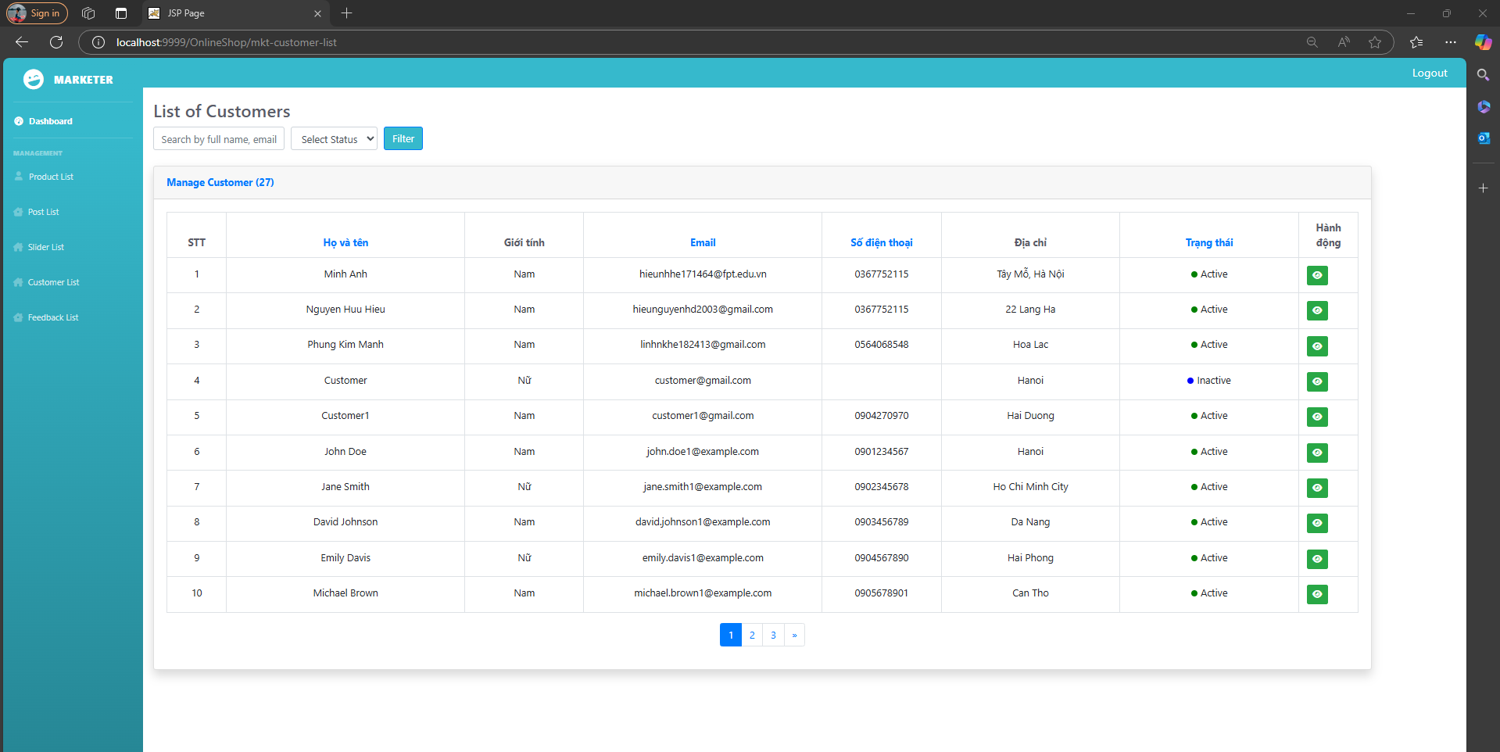

| **Field Name** | **Field Type** | **Description** |
| --- | --- | --- |
| Search | Textbox | input search by full name, email, mobile |
| Status | ComboBox | filter the customers by status |
| Filter | Button | Filter |
| View | Button | View detail customer |
| Edit | Button | Edit customer |

##### Database Access

| **Table** | **CRUD** | **Description** |
| --- | --- | --- |
| Customers | R | Read customer |

##### Sql commands:

1. search customer:  
   SELECT * from customers where email LIKE ? OR full_name LIKE ? OR phone_number LIKE ?
2. filter status

SELECT * from customers where status = ?

1. list customer

select * from customers

1. count customer

SELECT COUNT(*) FROM customers

#### 27. Customer Details

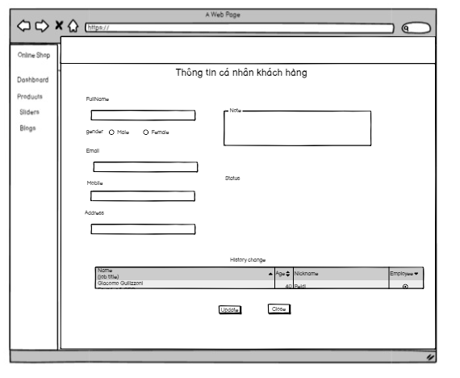

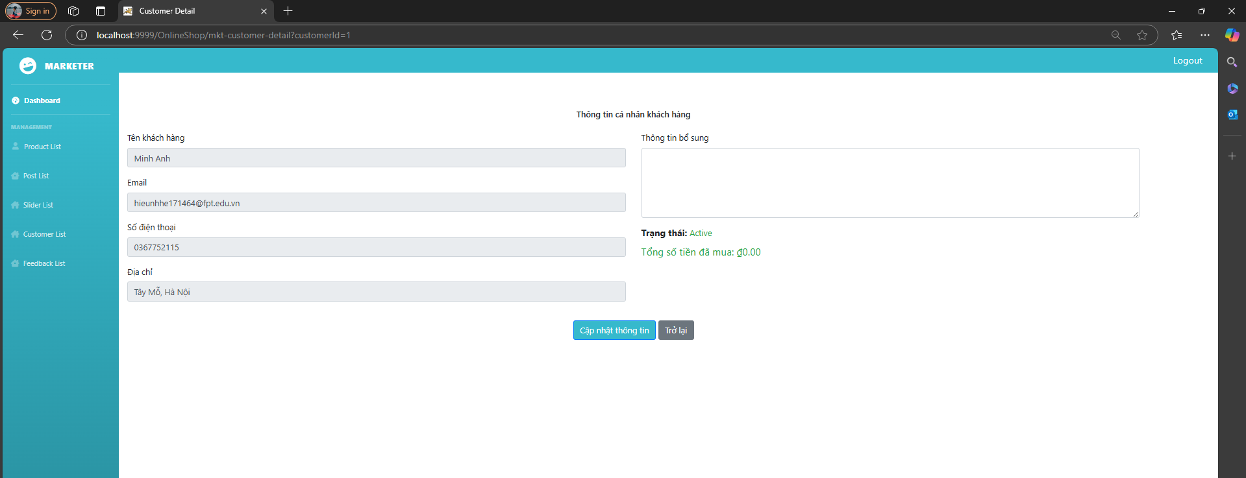

| **Field Name** | **Field Type** | **Description** |
| --- | --- | --- |
| FullName | Text | full name of customer |
| Status | ComboBox | filter the customers by status |
| Update | Button | Update status |
| Email | Text | Email customer |
| Gender | Radio | Gender |
| Edit | Button | Edit customer |

##### Database Access

| **Table** | **CRUD** | **Description** |
| --- | --- | --- |
| Customers | R | Read customer |

##### Sql commands:

1. select customer

SELECT * FROM Customers

1. total customer

SELECT count(*) FROM Customers

1. get customer by condition

SELECT * FROM Customers where status = ? AND full_name like ? OR email like ? OR mobile like ?

1. get total customer by condition

SELECT * FROM Customers where status = ? AND full_name like ? OR email like ? OR mobile like ?

#### 28. Feedback

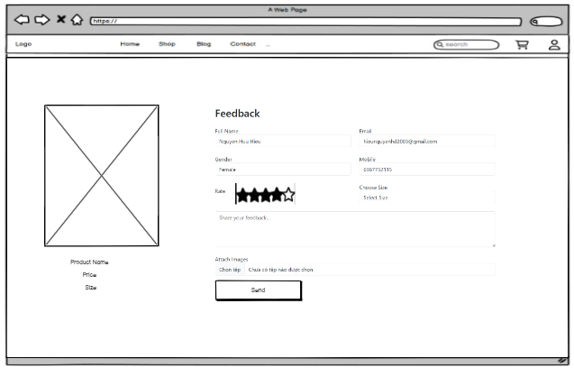

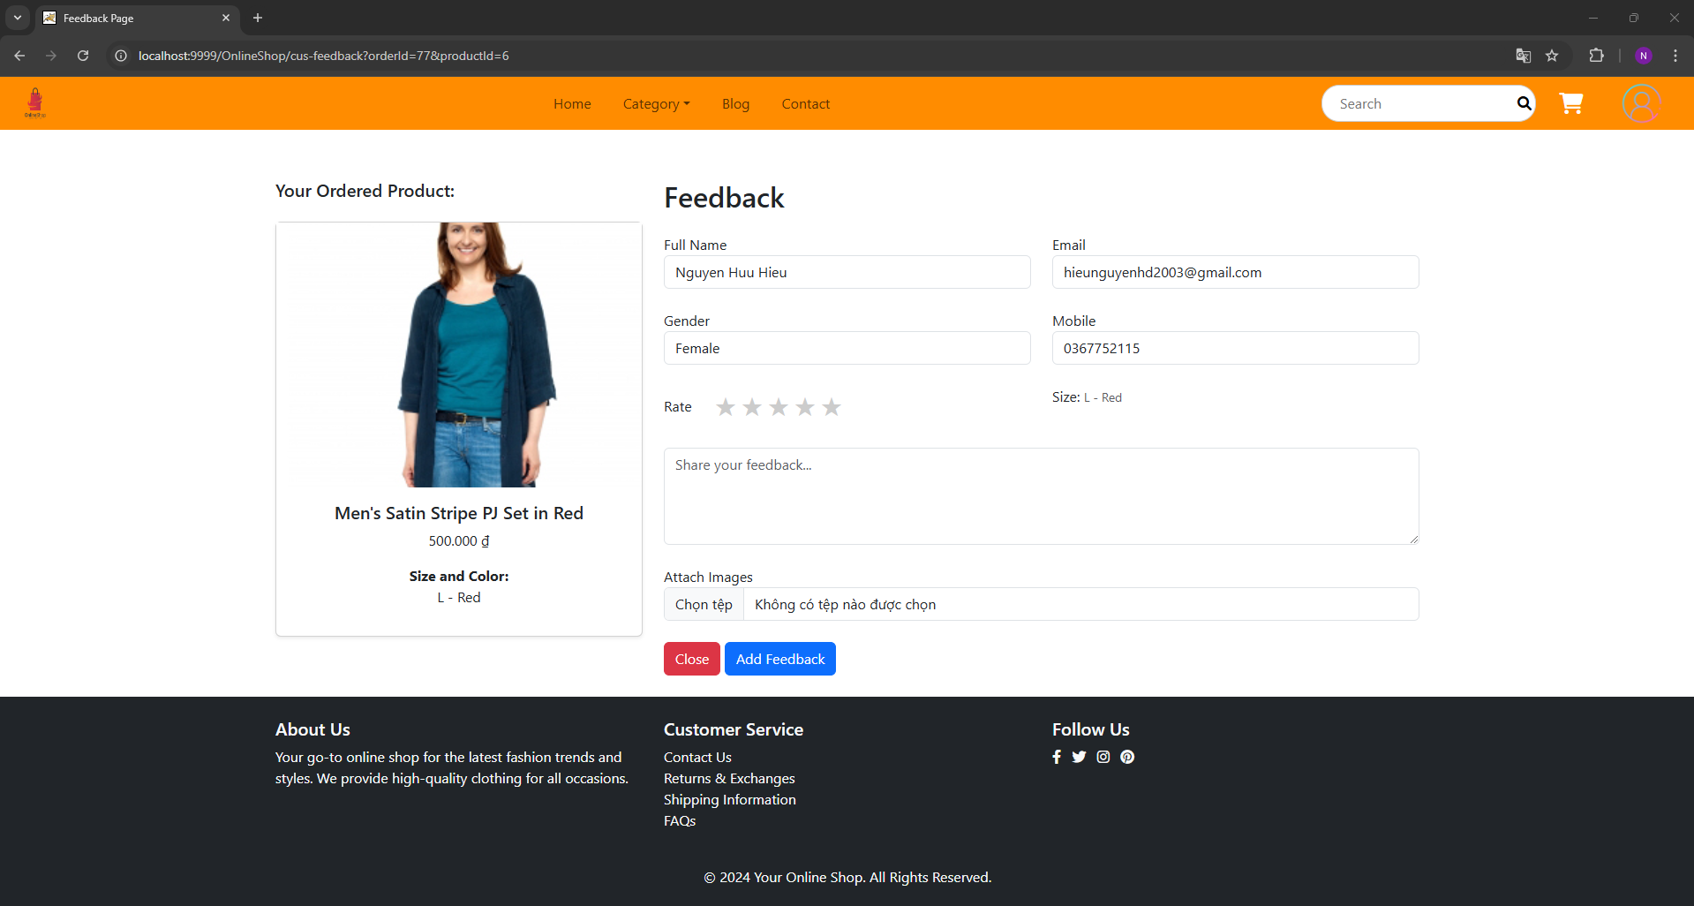

| **Field Name** | **Field Type** | **Description** |
| --- | --- | --- |
| Star | Radio | Star |
| Feedback | Textbox | input feedback about product |
| Send | Button | Send feedback |
| Size | ComboBox | choose size speicfic |

##### Database Access

| **Table** | **CRUD** | **Description** |
| --- | --- | --- |
| Feedbacks | CR | Read customer |

##### 

##### Sql commands:

1. SELECT * FROM Feedback Where ProductId = ? AND CustomerId = ? AND OrderId = ?
2. INSERT INTO `online_shop`.`feedbacks`

(`feedback_id`,`product_id`,`customer_id`,`order_id`,`rated_star`,`status`,`content`) VALUES (?,?,?,?,?,?,?);

1. SELECT p.product_id, p.product_name, p.image_url, p.sale_price, ps.product_size_name FROM order_detail od JOIN products p ON od.product_id = p.product_id JOIN product_size ps ON od.product_size_id = ps.product_size_id WHERE od.order_id = ? AND od.order_id IN (SELECT o.order_id FROM orders o WHERE o.customer_id = ?)

#### 29. Admin Dashboard

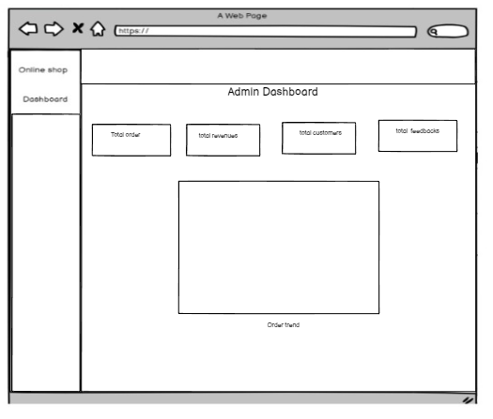

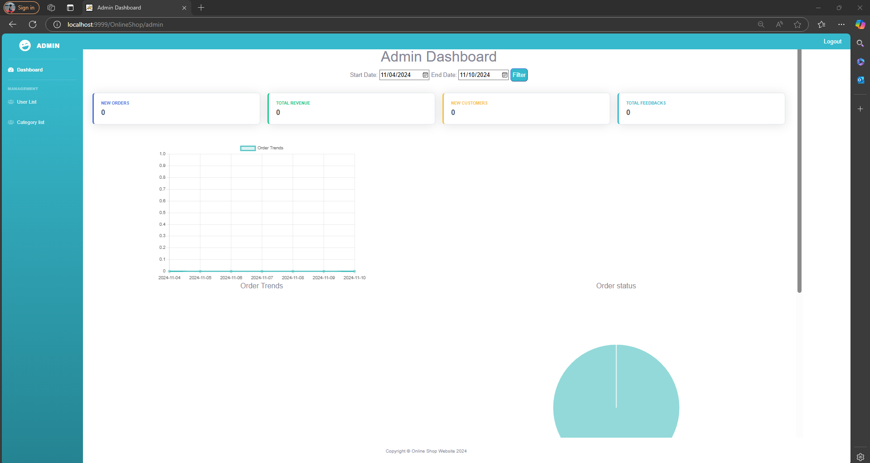

| **Field Name** | **Field Type** | **Description** |
| --- | --- | --- |
| Total order | Text | display the total order |
| Total revenues | Text | display the total revenues |
| Total customers | Text | display the total customers |
| Total feedbacks | Text | display the total feedbacks |
| Order trend | Chart | display trend of order |

##### Database Access

| **Table** | **CRUD** | **Description** |
| --- | --- | --- |
| Orders | R | Read orders |
| Customers | R | Read customers |
| Feedbacks | R | Read feedbacks |

##### Sql commands:

SELECT COUNT(*) AS order_count FROM orders WHERE order_date BETWEEN ? AND ?

SELECT SUM(total_cost) AS total_revenue FROM orders WHERE order_date BETWEEN ? AND ?

SELECT COUNT(*) AS new_customers_count FROM customers WHERE create_at BETWEEN ? AND ?

SELECT COUNT(*) AS feedback_count FROM feedbacks WHERE create_date BETWEEN ? AND ?

SELECT DATE(order_date) AS order_date, COUNT(*) AS order_count "

+ "FROM orders WHERE order_date BETWEEN ? AND ? "

+ "GROUP BY DATE(order_date) ORDER BY DATE(order_date)

SELECT s.status_name, COUNT(*) AS status_count "

+ "FROM orders o join status s on o.status = s.status_id "

+ "WHERE ( o.status = 1 OR o.status = 6 OR o.status = 8 ) AND o.order_date >= ? AND o.order_date <= ? " // Filter by order date

+ "GROUP BY s.status_name

SELECT c.name, SUM(p.sale_price * od.quantity) AS total_revenue "

+ "FROM order_detail od "

+ "JOIN orders o ON od.order_id = o.order_id "

+ "JOIN products p ON od.product_id = p.product_id "

+ "JOIN category c ON p.category_id = c.category_id "

+ "WHERE o.order_date >= ? AND o.order_date <= ? " // Filter by order date

+ "GROUP BY c.name

SELECT COUNT(DISTINCT o.customer_id) AS bought_count "

+ "FROM orders o "

+ "WHERE o.order_date >= ? AND o.order_date <= ?

SELECT COUNT(DISTINCT c.customer_id) AS not_bought_count "

+ "FROM customers c "

+ "WHERE c.customer_id NOT IN (SELECT DISTINCT o.customer_id FROM orders o "

+ "WHERE o.order_date >= ? AND o.order_date <= ?)

SELECT c.name, AVG(f.rated_star) AS average_star, COUNT(f.feedback_id) AS vote_count "

+ "FROM feedbacks f "

+ "JOIN products p ON f.product_id = p.product_id "

+ "JOIN category c ON p.category_id = c.category_id "

+ "WHERE f.create_date >= ? AND f.create_date <= ? " // Filter by feedback date

+ "GROUP BY c.name

#### 30. User List



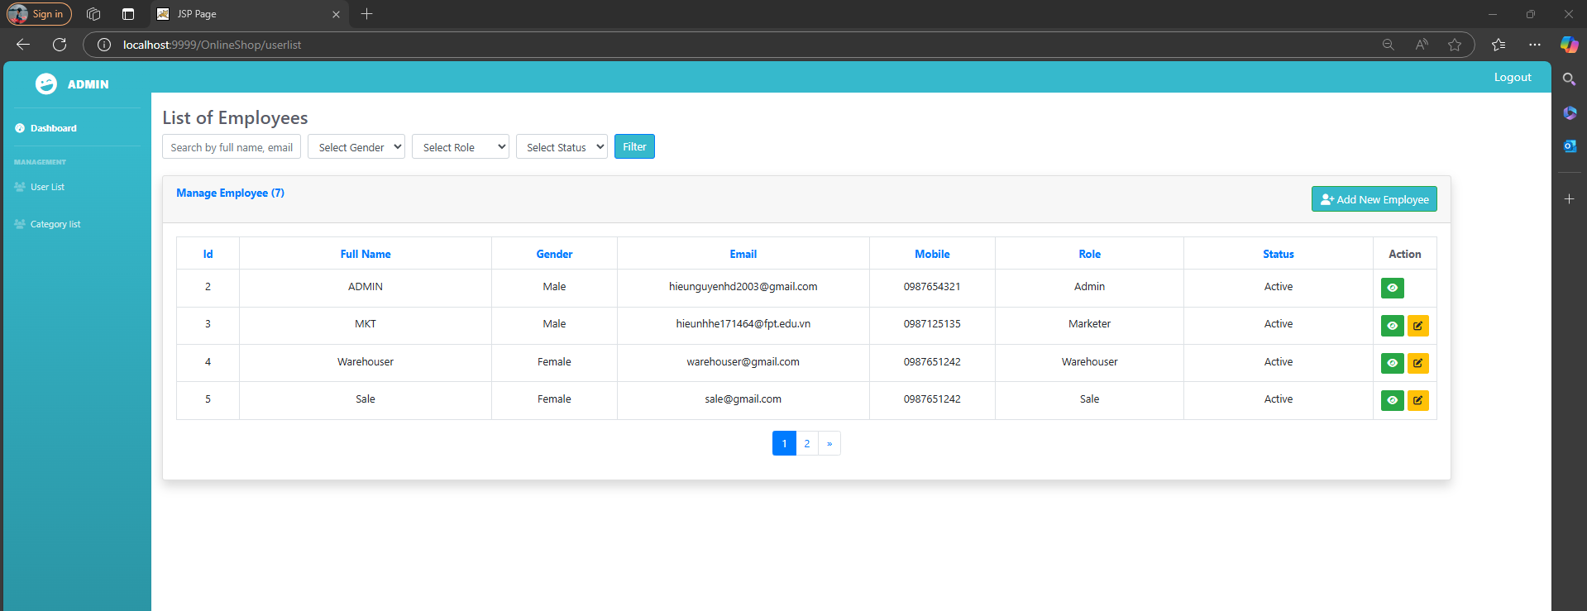

| **Field Name** | **Field Type** | **Description** |
| --- | --- | --- |
| Search | Textbox | input search by full name, email, mobile |
| Status | ComboBox | filter the customers by status |
| Filter | Button | Filter |
| View | Button | View detail customer |
| Edit | Button | Edit customer |

##### Database Access

| **Table** | **CRUD** | **Description** |
| --- | --- | --- |
| Employees | R | Read users |

##### Sql commands:

1. search user:  
   SELECT * from employees where email LIKE ? OR full_name LIKE ? OR email LIKE ? OR mobile LIKE ?
2. filter gender/role/status

SELECT * from employees where gender/role/status = ?

1. list user

select * from users

1. count user

SELECT COUNT(*) FROM employees

#### 31. User Details

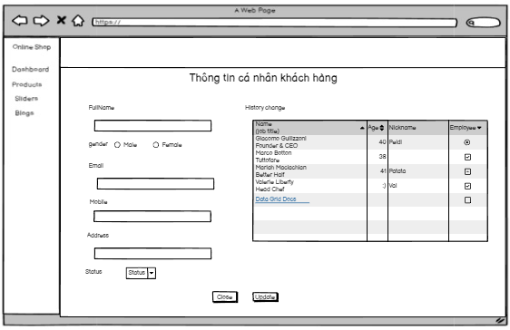

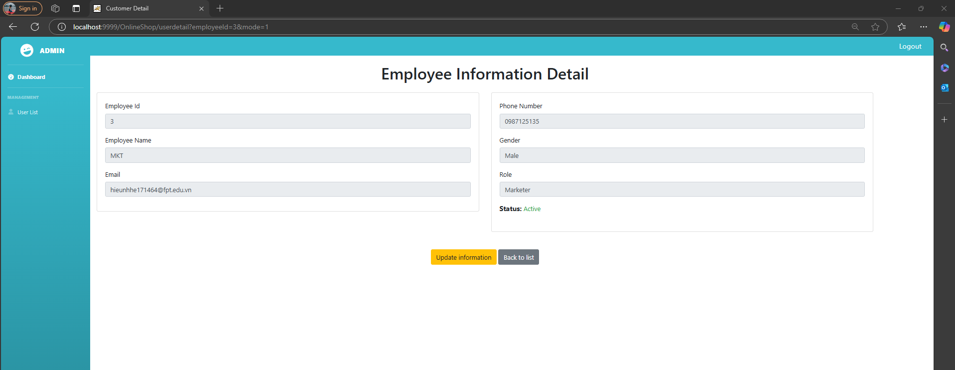

| **Field Name** | **Field Type** | **Description** |
| --- | --- | --- |
| FullName | Text | full name of customer |
| Status | ComboBox | filter the customers by status |
| Update | Button | Update status |
| Email | Text | Email customer |
| Gender | Radio | Gender |
| Edit | Button | Edit customer |

##### Database Access

| **Table** | **CRUD** | **Description** |
| --- | --- | --- |
| Employees | R | Read users |

##### Sql commands:

1. search user:  
   SELECT * from employees where email LIKE ? OR full_name LIKE ? OR email LIKE ? OR mobile LIKE ?
2. filter gender/role/status

SELECT * from employees where gender/role/status = ?

1. list user

select * from users

1. count user

SELECT COUNT(*) FROM employees

#### 33. Orders List

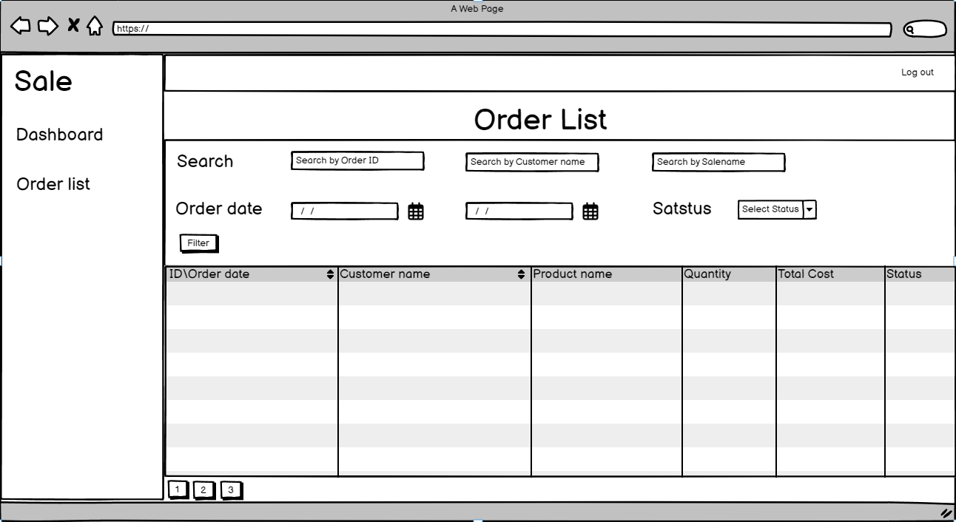

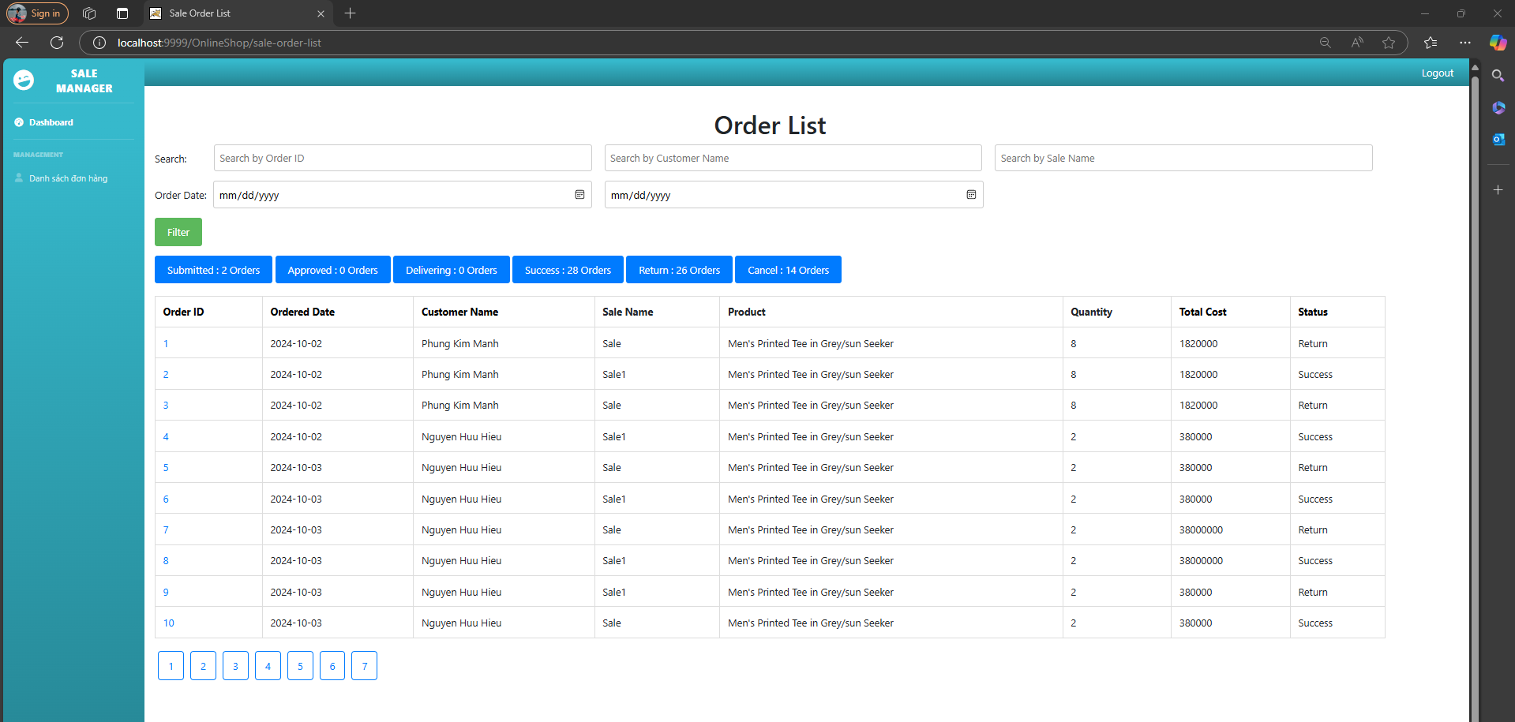

| **Field Name** | **Field Type** | **Description** |
| --- | --- | --- |
| OrderID | Input text | input order id |
| Status | ComboBox | filter by status |
| CustomerName | Input text | input customer name |
| SaleName | Input text | input sale name |
| OrderDateFrom | Input text | input order date from |
| OrderDateTo | Input text | input order date To |
| Filter | Button | start filter date |
| OrderData | DataTable | Show order information |
| ButtonPagination | Button | Separate data by page |

##### 

#### 

##### Database Access

| **Table** | **CRUD** | **Description** |
| --- | --- | --- |
| Customers | R | get customer information |
| Order_detail | R | get Order detail information |
| Category | R | get Category information |
| Products | R | get Product information |
| Employees | R | get employee information |
| Orders | R | get order information |
| Roles | R | get role information |
| Status | R | get status information |

##### 

##### Sql commands:

SELECT * FROM online_shop.customers where customer_id=?

SELECT * FROM online_shop.order_detail where order_id= ?

SELECT * FROM online_shop.category where category_id='?

SELECT * FROM online_shop.products where product_id=?

SELECT * FROM online_shop.employees where employee_id=?

SELECT * FROM online_shop.orders

SELECT * FROM online_shop.orders where employee_id=?

SELECT * FROM online_shop.customers where full_name like '%?%'

SELECT * FROM online_shop.employees where full_name like '%?%'

SELECT * FROM online_shop.orders where 1=1 and customer_id=? and employee_id=? and order_id =? and order_date>= ? and order_date<= ? and status =?

SELECT * FROM online_shop.roles where role_name='Sale'

SELECT * FROM online_shop.status

#### 

#### 34. Orders Detail

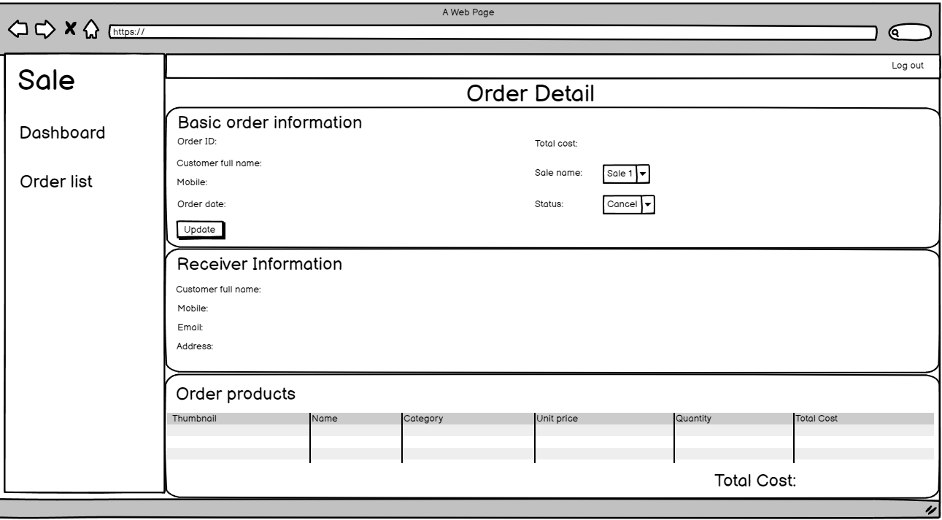

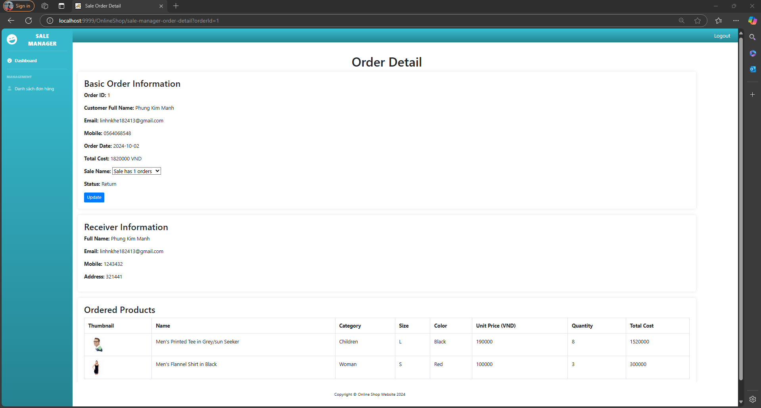

| **Field Name** | **Field Type** | **Description** |
| --- | --- | --- |
| OrderID | Label | Show order id |
| Customer full name | Label | Show customer name |
| Mobile | Label | Show customer mobile |
| Order date | Label | Show order date |
| Total cost | Label | Show total cost |
| Sale name | ComboBox | select update sale name |
| Status | ComboBox | select update status |
| UpdateButton | Button | start update order |
| Email | Label | Show order email |
| OrderData | DataTable | Show order information |

##### 

##### 

##### Database Access

| **Table** | **CRUD** | **Description** |
| --- | --- | --- |
| Customers | R | get customer information |
| Order_detail | R | get Order detail information |
| Category | R | get Category information |
| Products | R | get Product information |
| Employees | R | get employee information |
| Orders | RU | get, update order information |
| Roles | R | get role information |
| Status | R | get status information |

##### Sql commands:

1. SELECT * FROM online_shop.customers where customer_id=?
2. SELECT * FROM online_shop.order_detail where order_id= ?
3. SELECT * FROM online_shop.category where category_id='?
4. SELECT * FROM online_shop.products where product_id=?
5. SELECT * FROM online_shop.employees where employee_id=?
6. SELECT * FROM online_shop.orders where order_id=?
7. SELECT * FROM online_shop.roles where role_name='Sale'
8. SELECT * FROM online_shop.employees where role_id=?
9. UPDATE `online_shop`.`orders` SET `status` = ? WHERE `order_id` = ?
10. UPDATE `online_shop`.`orders` SET `employee_id` = ? WHERE `order_id` = ?
11. SELECT * FROM online_shop.status where role_id like '%?%'
12. SELECT * FROM online_shop.status where status_id=?

#### 

#### 35. Sale Dashboard

# 

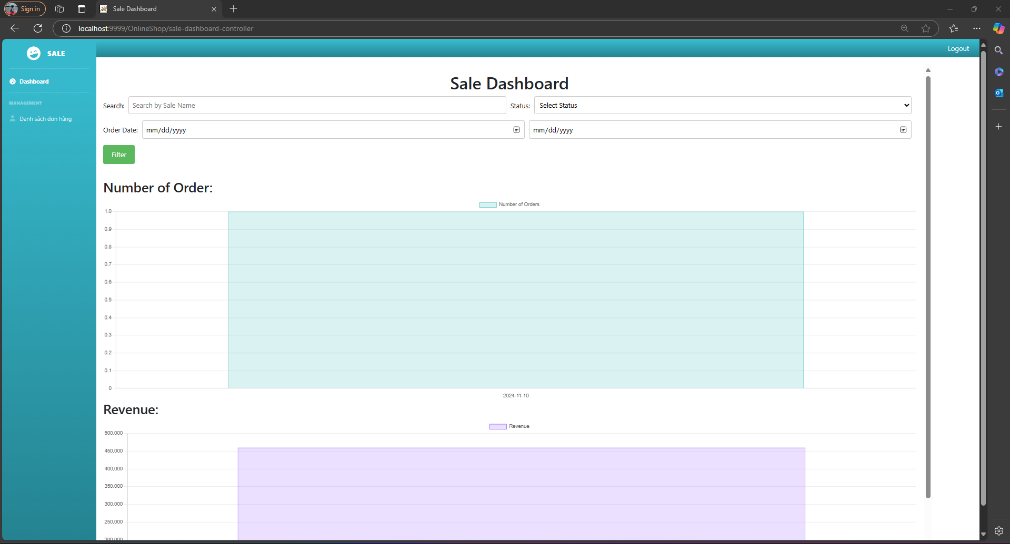

| **Field Name** | **Field Type** | **Description** |
| --- | --- | --- |
| Sale name | Input text | input sale name |
| Status | ComboBox | filter by status |
| OrderDateFrom | Input text | input order date from |
| OrderDateTo | Input text | input order date To |
| Filter | Button | start filter date |
| ChartForNumberOfOrder | Chart | Show trend for number of order |
| ChartForRevenue | Chart | show trend for revenue |

##### 

##### Database Access

| **Table** | **CRUD** | **Description** |
| --- | --- | --- |
| Employees | R | get employee information |
| Orders | R | get, update order information |
| Status | R | get status information |

##### 

##### Sql commands:

1. SELECT * FROM online_shop.employees where full_name like '%?%'
2. SELECT DATE(order_date) AS order_date, COUNT(order_id) AS order_count FROM orders where 1=1 and employee_id=? and status =? and order_date>= ? and order_date<= ? GROUP BY DATE(order_date) ORDER BY DATE(order_date)
3. SELECT DATE(order_date) AS order_date, COUNT(order_id) AS order_count FROM orders GROUP BY DATE(order_date) ORDER BY DATE(order_date)
4. SELECT * FROM online_shop.status
5. SELECT DATE(order_date) AS order_date, SUM(total_cost) AS total_cost FROM orders where 1=1 and employee_id=? and status =? and order_date>= ? and order_date<= ? GROUP BY DATE(order_date) ORDER BY DATE(order_date)

#### 36. Feedback detail

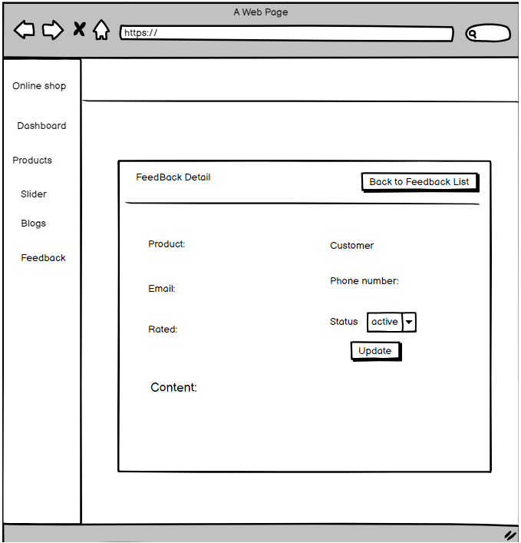

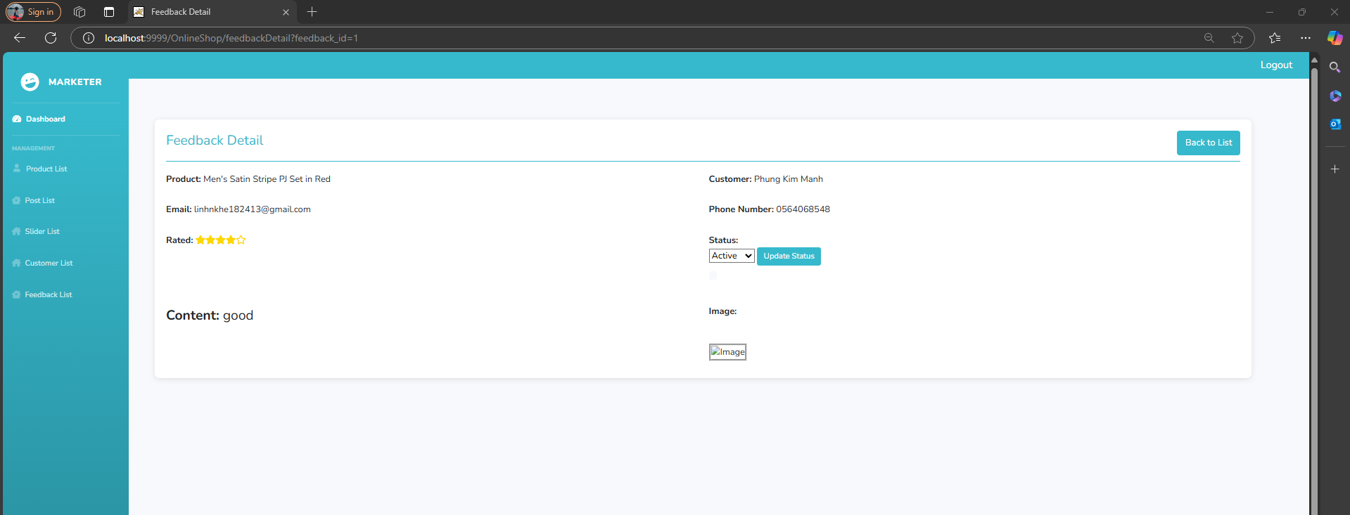

| **Field Name** | **Field Type** | **Description** |
| --- | --- | --- |
| Back to fb list | button | back to feedback list page |
| status | select | choose status |
| update | button | update status |

##### Database Access

| **Table** | **CRUD** | **Description** |
| --- | --- | --- |
| Back to fb list, status | R | view feedback detail |
| update | U | update status of feedback |

##### Sql commands:

1. Insert payment history customer

INSERT INTO `payment_history` (payment_date, payment_method, order_id, customer_id)"

+ " VALUES (?, ?, ?, ?)

#### 37. Order List (Warehouser)

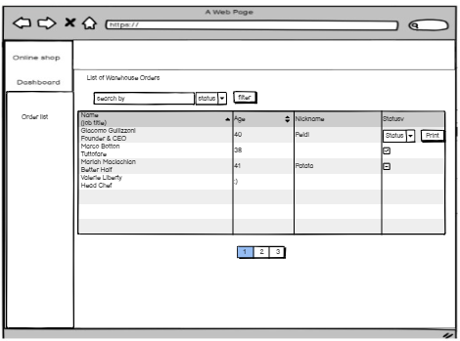

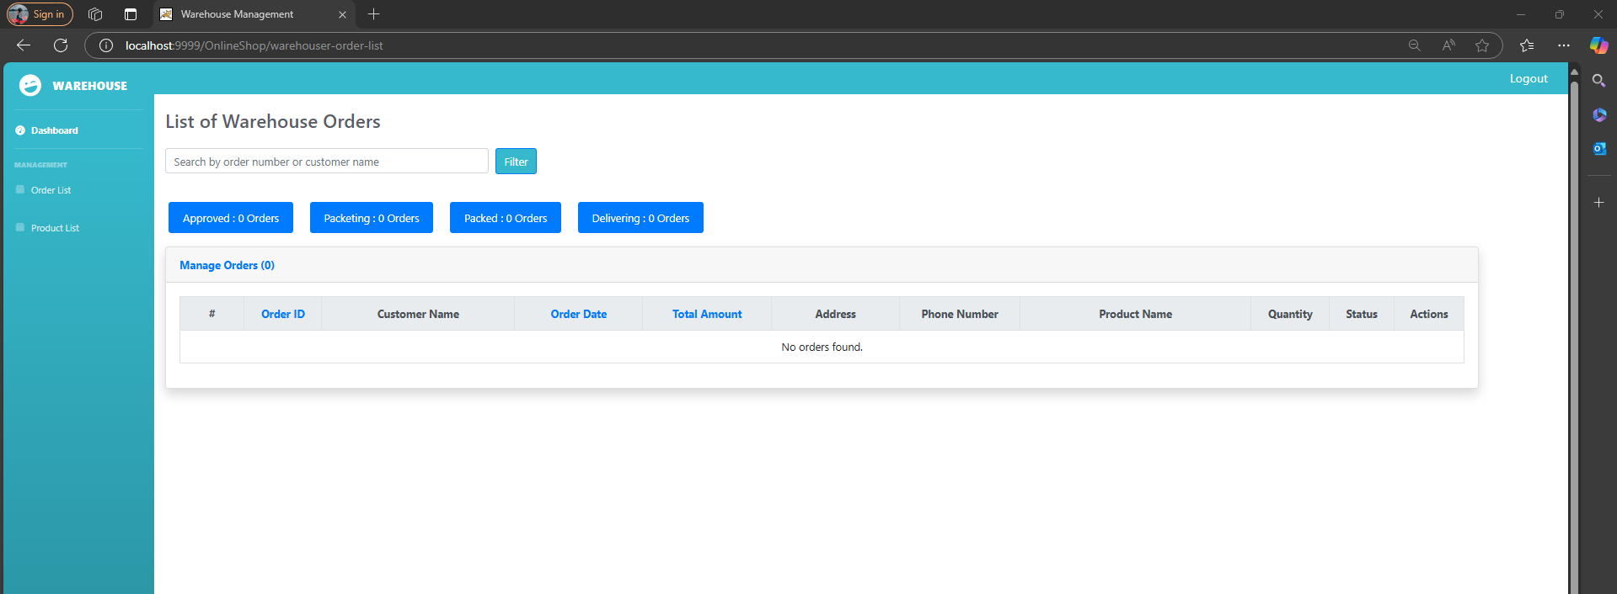

| **Field Name** | **Field Type** | **Description** |
| --- | --- | --- |
| Status | ComboBox | filter by status |
| Filter | Button | start filter date |
| OrderData | DataTable | Show order information |
| ButtonPagination | Button | Separate data by page |
| Search | TextBox | Search by full name, email, mobile |

##### 

#### 

##### Database Access

| **Table** | **CRUD** | **Description** |
| --- | --- | --- |
| Order_detail | R | get Order detail information |
| Category | R | get Category information |
| Products | R | get Product information |
| Orders | R | get order information |
| Status | R | get status information |

##### 

##### Sql commands:

1. SELECT * FROM online_shop.order_detail where order_id= ?
2. SELECT * FROM online_shop.products where product_id=?
3. SELECT * FROM online_shop.orders
4. SELECT * FROM online_shop.orders where 1=1 and and status =?
5. SELECT * FROM online_shop.status
6. SELECT o.order_id, o.order_date, o.total_cost, o.status, o.address, o.phone_number, c.customer_id AS customer_id, c.full_name AS customer_name, od.product_id, od.quantity, p.product_name FROM orders o JOIN customers c ON o.customer_id = c.customer_id JOIN order_detail od ON o.order_id = od.order_id JOIN products p ON od.product_id = p.product_id
7. SELECT COUNT(*) FROM orders o AND (o.order_id LIKE ? OR o.customer_id IN (SELECT c.customer_id FROM customers c WHERE c.full_name LIKE ?)) AND o.status = ?

#### 38. Setting List (admin)

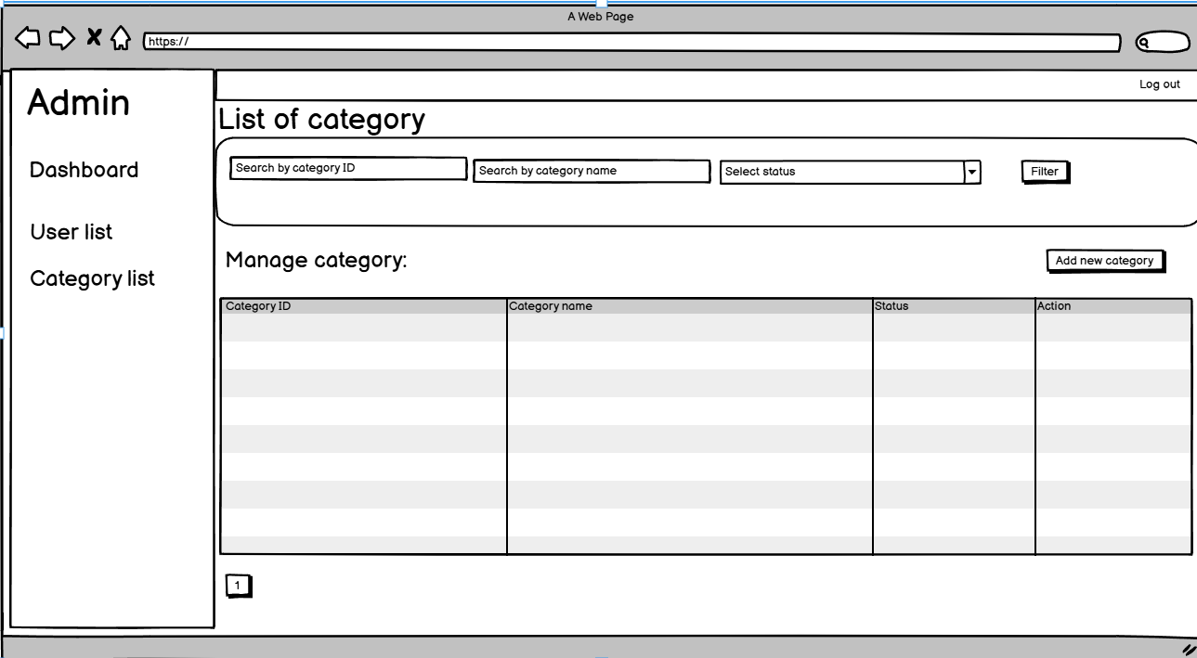

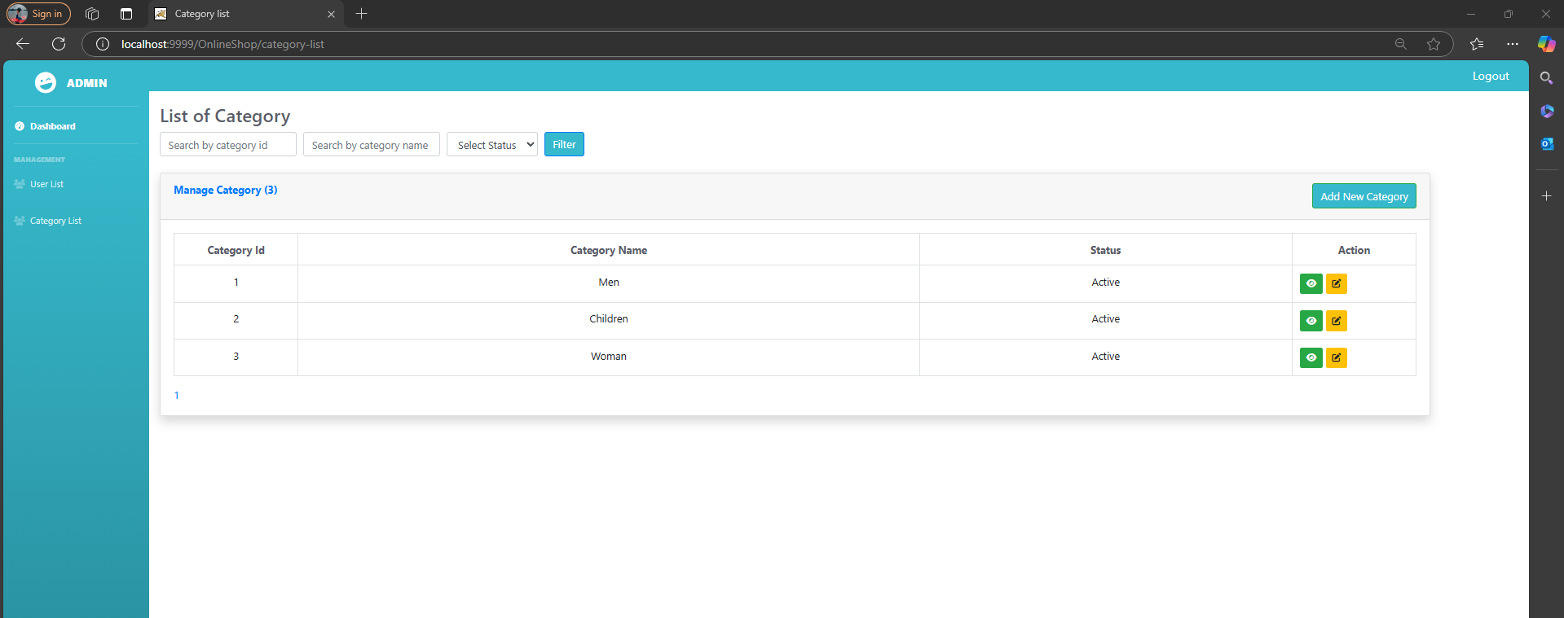

| **Field Name** | **Field Type** | **Description** |
| --- | --- | --- |
| Status | ComboBox | filter by status |
| Filter | Button | start filter date |
| Search by category ID | input text | input category id |
| Search by category name | input text | input category name |
| Category date | table | show category data |

##### Database Access

##### 

| **Table** | **CRUD** | **Description** |
| --- | --- | --- |
| Category | R | get category information |

##### 

##### Sql commands:

SELECT * FROM online_shop.category

SELECT * FROM online_shop.category where 1=1 and category_id=? and name like %?% and status =?

#### 

#### 39. Setting detail (admin)

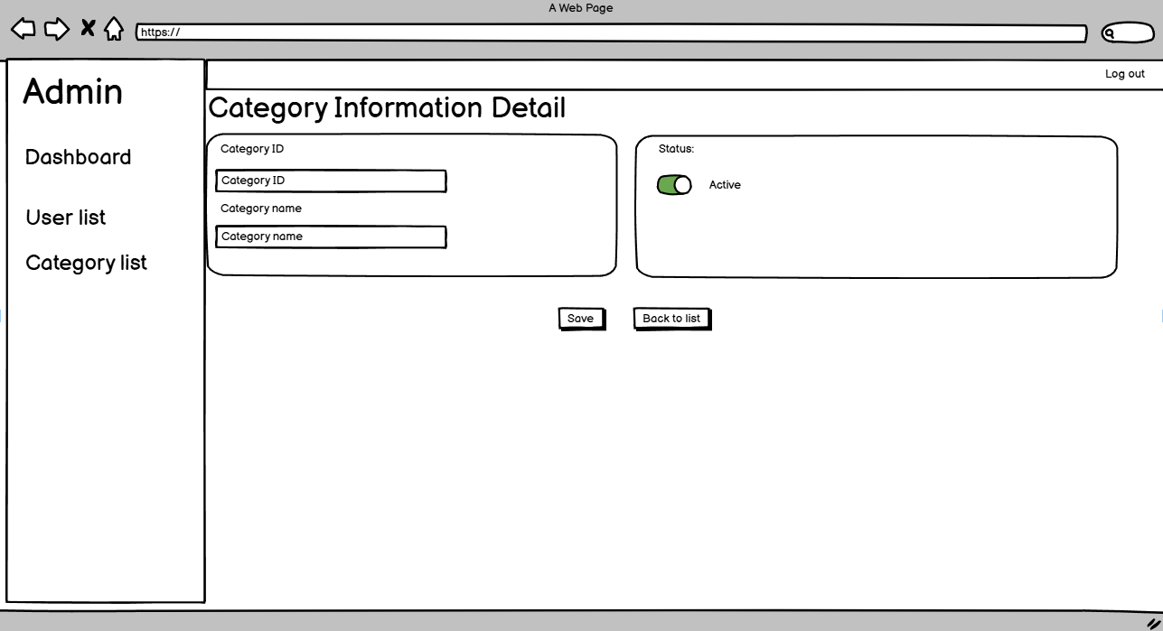

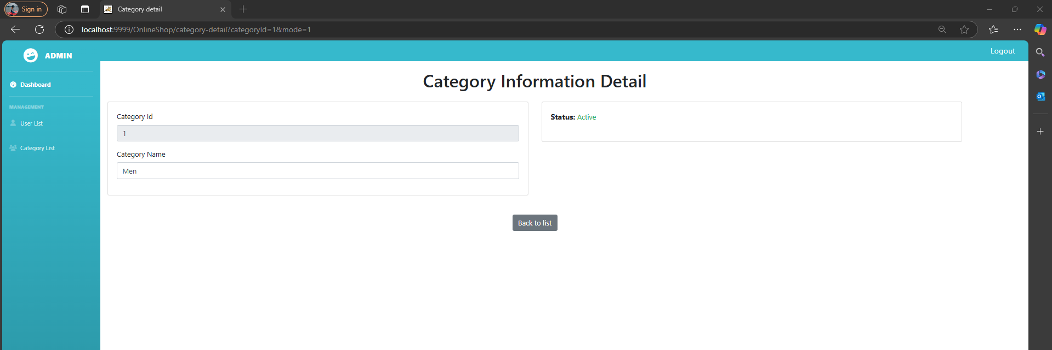

| **Field Name** | **Field Type** | **Description** |
| --- | --- | --- |
| Status | switch box | show status of category |
| Category ID | label | show category ID |
| Category name | label | show category name |
| Save | Button | save button |
| Back to list | button | back to list button |

##### Database Access

##### 

| **Table** | **CRUD** | **Description** |
| --- | --- | --- |
| Category | R,U | get and update category information |

##### 

##### Sql commands:

INSERT INTO `online_shop`.`category` (`name`,`status`) VALUES('?',1);

UPDATE `online_shop`.`category`SET`name` = '?', `status` = "+status+" WHERE `category_id` = ?

SELECT * FROM online_shop.category where category_id=?

#### 40. Product List (Warehouser)

**UI Design**



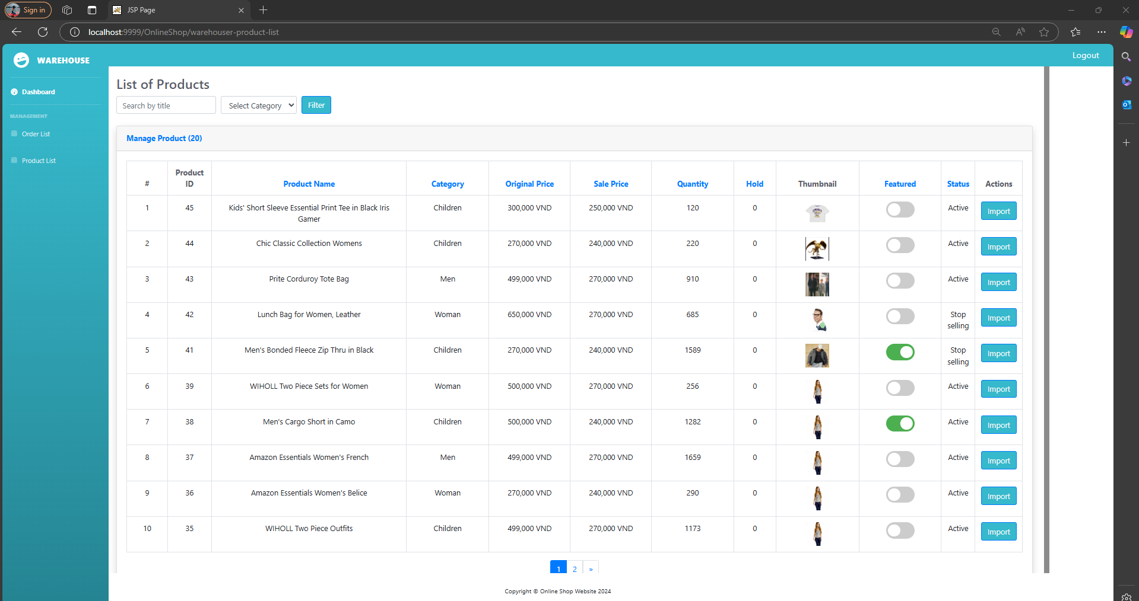

| **Field Name** | **Field Type** | **Description** |
| --- | --- | --- |
| Search | Textbox | Input value title, brief info |
| Category | ComboBox | Include different categories of the product |
| Status | ComboBox | Include different status of the product |
| Filter | Button | filter by category/status |
| Add new product | Button | Add new the product |
| View | Button | View product specific |
| Edit | Button | Edit product specific |
| Hide/Show | Button | Hide/Show product |

##### Database Access

| **Table** | **CRUD** | **Description** |
| --- | --- | --- |
| Products | R | View about a specific product |
| Category | R | View category |

##### Sql commands

1. List category

Select * from category

1. List products paging

SELECT * FROM products limit ? offset ?

#### 41. Import Product(Warehouser)

**

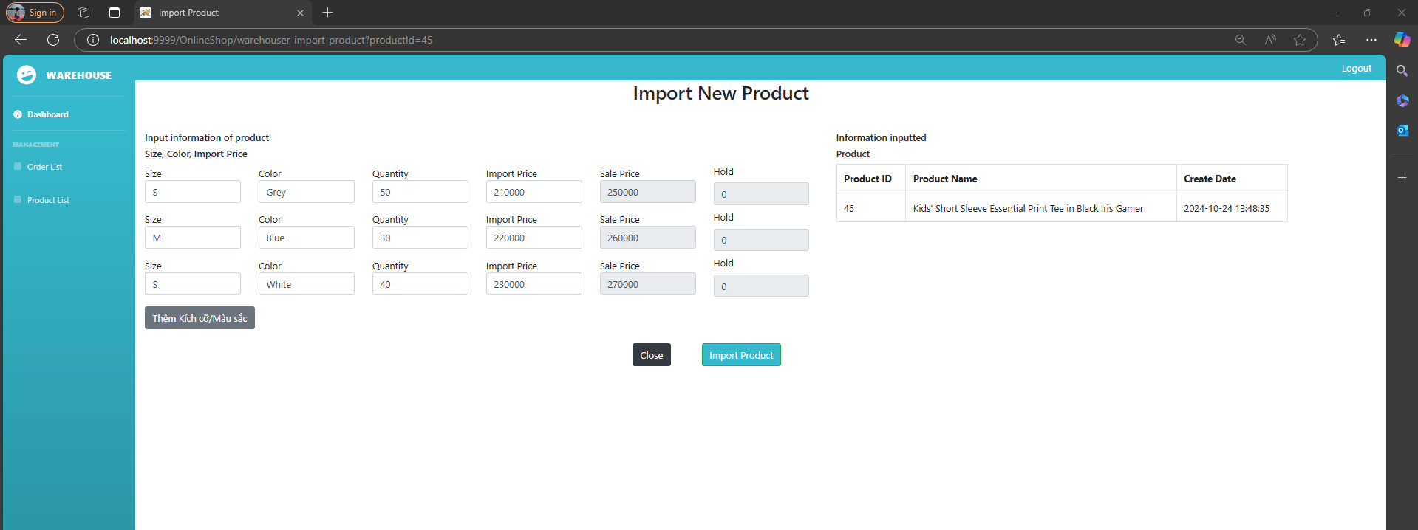

| **Field Name** | **Field Type** | **Description** |
| --- | --- | --- |
| Choose file | Button | upload file image |
| Trạng thái | ComboBox | setting status |
| Thêm mới sản phẩm | Button | create new product |
| Kích cỡ | Textox | input size product |
| Phân loại | comboBox | choose category |
| Mô tả ngắn | TextBox | input brief information |
| Mô tả | TextBox | input desciption |
| Số lượng | TextBox | input quantity |
| Giá niêm yết | TextBox | input price |
| Giá bán | TextBox | input sale price |

##### Database Access

| **Table** | **CRUD** | **Description** |
| --- | --- | --- |
| Products | C | Create about a specific product |
| Category | R | View category |
| Product_image | C | Create about a specific product image |
| Product_size | C | Create about a specific product size |
| Product_color | C | Create about a specific product color |

SQL commands:

1. Insert product

INSERT INTO `online_shop`.`products`

(`product_id`,`product_name`,`category_id`,`original_price`,`sale_price`,`number_left`,`create_date`,`image_url`,`description`,`status`) VALUES(?,?,?,?,?,?,?,?,?,?);

1. Insert product image

INSERT INTO `online_shop`.`product_image` (`product_image_id`,`image_url`,`product_id`)VALUES (?,?,?);

1. Insert product color

INSERT INTO `online_shop`.`product_color`

(`product_color_id`,`product_color_name`,`product_id`) VALUES (?,?,?);

SELECT * FROM online_shop.product_color;

1. Insert product size

INSERT INTO `online_shop`.`product_size`

(`product_size_id`,`product_size_name`,`product_id`) VALUES (?,?,?);

# IV. Appendix

## 1. Assumptions & Dependencies

AS-1: Assumes that the user has a stable network connection.

AS-2: The user understands the complexity of the password.

AS-3: User access the site via smartphones, desktop usage, laptop.

AS-4: Users want a fast, seamless checkout experience. The process should be simple, with minimal steps and the option to check out as a guest

AS-5: Users may be more likely to use cash-on-delivery or local payment methods rather than credit cards or digital wallets

## 2. Limitations & Exclusions

### 2.1. Limited Multilingual Support

Supporting multiple languages requires significant development effort. Focus on a primary language initially and consider adding more later.

## 3. Business Rules

| **ID** | **Category** | **Rule Definition** |
| --- | --- | --- |
| BR-01 | Constraints | Password must have number, the first letter is uppercase, at least one special character . |
| BR-02 | Constraints | Deliveries must be completed between 10:00 A.M. and 2:00 P.M. local time, inclusive. |
| BR-03 | Facts | All meals in a single order must be delivered to the same location. |
| BR-04 | Facts | All meals in a single order must be paid for by using the same payment method. |
| BR-11 | Constraints | If an order is to be delivered, the patron must pay by payroll deduction. |
| BR-12 | Computations | Order price is calculated as the sum of each food item price times the quantity of that food item ordered, plus applicable sales tax, plus a delivery charge if a meal is delivered outside the free delivery zone. |
|  |  |  |

## 4. Non-Functional Requirements

**NF-1**: The websites will feature a user-friendly interface that ensures ease of use.

**NF-2**: The screen layout is streamlined, making it easy for users to navigate and utilize.

**NF-3:** The mobile app Interface should follow the prototypes’ design.

**NF-4**: Buttons are distinct in their features and colors, while maintaining harmony with the overall interface.

## 